104 Administrative Fundamentals

References:

[a] BUPERSINST 1610.10, Navy Performance Evaluation and Counseling System
[b] SECNAVINST 5216.5, Correspondence Manual
[c] NAVPERS 15560C, Navy Military Personnel Manual
[d] Marine Corps Common Skills Handbook, Book 1A (PCN 50600000900)
[e] 10804UM-01, Enlisted Distribution Verification Report User's Manual

104.1 Discuss the following as they apply to the Navy performance evaluation/fitness report and counseling system: [ref. a, encl. 1, pp. 1 thru 5]

Reporting Senior - Commanding officers are reporting seniors by virtue of their command authority. Commanding officers may submit properly authorized fitness and evaluation reports on any member who has reported to them for duty, whether junior or senior to them in grade. The term "commanding officer" includes commanding officers of all services, and their civilian equivalents within the U.S. federal government. Officers in charge are commanding officers if they are in charge of commissioned or established activities listed in the Standard Navy Distribution List (SNDL). When a member is assigned to a non-U.S. government activity, the reporting senior is the member's U.S. administrative commander unless another reporting senior is assigned in orders or directives. These members may receive letter-type reports from the non-U.S. government activity for attachment to FITREPs or EVALs.
Delegated Reporting Seniors - Delegation of reporting senior authority is an actual transfer of that authority, and not merely an authorization to sign "by direction." For this reason, delegation is held to the highest level consistent with effective observation of performance, and commanding officers' oversight responsibilities are carefully defined. For specific direction concerning delegated reporting seniors, refer to the EVAL Manual, Annex B
Immediate Superiors in Command (ISICs) - ISICs are reporting seniors for assigned commanding officers, and are authorized to assume the reporting senior authority of subordinate commanding officers whose capacity to act as reporting seniors becomes impaired.
Enlisted Reporting Seniors - Chief petty officers (E7-E9) may act as reporting seniors for members in the grades of E4 and below only. The next senior officer in the chain of command having reporting authority for the members concerned must sign all other reports

Raters and senior raters - Evaluation reports on E6 and below require the signatures of a rater and senior rater as well as the reporting senior. This ensures that the Navy's senior enlisted and junior officer supervisors are properly included in the enlisted evaluation process. The rater should be a Navy chief petty officer whenever possible, but if none is available within the command, may be a military or civilian supervisor who is an E7 equivalent or higher. Typically, the senior rater will be the member's division officer or department head. The senior rater may be omitted where the reporting senior is the rater's immediate supervisor.

Performance counseling - Counseling methods are up to the commanding officer. It is the CO's program. Performance counseling must be provided at the mid-point of the periodic report cycle, and when the report is signed. The counselor will be a supervisor who participates in the member's EVAL or FITREP preparation. Commanding officers will guide the counseling program and monitor counselor performance and results. The objectives are to provide feedback to the member, and to motivate and assist improvement. Performance counseling starts with a fair assessment of the member's performance and capabilities, to which the member contributes. It identifies the member's strengths and motivates their further improvement. It also addresses important weaknesses, but should not dwell on unimportant ones. It should avoid personality and concentrate on performance. The FITREP and EVAL forms are used as counseling worksheets, and must be signed by the counselor and member. Counselors may use the tick marks next to each performance standard, and/or assign tentative trait grades, and may write comments. Under no circumstances should a future promotion recommendation be promised during counseling.

Types of reports – There are three types of reports.
Regular reports are the foundation of the performance record. Regular reports are submitted periodically according to the schedule in Table I, and on other occasions specified in the EVAL Manual. They must cover, day-for-day, all Naval service on active duty or in drilling Reserve programs, except for enlisted initial entry training and other limited circumstances.
Concurrent reports provide a record of significant performance in an additional duty (ADDU) or temporary additional duty (TEMADD) status. They are optional unless directed by higher authority, and may not be submitted by anyone in the regular reporting senior's direct chain of command
Operational Commander reports are optional, and may only be submitted on commanding officers or officers in charge by operational commanders who are not also their regular reporting seniors. A Concurrent report, but not an Operational Commander report, must be countersigned by the regular reporting senior, who has a limited power to reject it, and may also make it the Regular report for the period concerned

Administrative blocks - The administrative blocks identify the report, define the context in which it was received, and make it more informative to detailers and selection boards. They also permit computerized BUPERS compliance audits to assure fairness to all members and reporting seniors. Each command should have a quality review procedure for FITREPs and EVALs. The BUPERS automated data file will not accept incorrect entries, and reports may then have to be returned to the reporting senior for correction. The BUPERS-supplied report preparation software will prevent many incorrect entries

Guidance on trait grade - The meanings of the trait grades are printed on the form, along with representative performance standards. The 5.0 grade is reserved for performance which is far above standards, and is notable for its exemplary or leadership quality. The 1.0 grade means generally poor performance, which is not improving, or unsatisfactory performance with respect to a single standard. For the majority of sailors and officers, most of the trait grades should be in the 2.0 to 4.0 range. Arbitrarily "two-blocking" the trait grades will be detrimental for two reasons. First, the reporting senior's average trait grade will be available to detailers and selection boards for comparison purposes. Second, it will be difficult for the reporting senior to allocate promotion recommendations if everyone's trait grades are the same.

Comments block - should be based on verifiable facts. Use input from the member and the member's immediate supervisor(s) as well as the raters' and reporting senior's personal observations. Do not use underlining, boldface, italics,** centering **, or other highlighting. Handwritten comments or additions to comments are not allowed, except that reports on E4 and below may be entirely or partially handwritten. Continuation sheets and enclosures are not allowed, except an endorsed statement submitted by the member, a flag endorsement where required, a civilian or foreign letter report, a letter-extension of a Concurrent/Regular report, or a classified letter-supplement. Substantiate all 1.0 grades any promotion recommendation of "Significant Problems," and any recommendation against retention, and treat the report as adverse. Any comment suggesting persistent weaknesses, continuing incapacity, or unsuitability for specific assignment or promotion also must be treated as adverse matter, regardless of grades assigned. Do not include classified matter in the report, and do not submit classified supplements unless absolutely necessary. Include required comments and address special interest items as appropriate. Do not include any of the prohibited comments. Style and content, space is limited. Avoid preambles and get directly to performance. Do not use puffed-up adjectives. Use direct, factual writing, which allows the performance to speak for itself. Bullet style is preferred. Give examples of performance and results. Quantify wherever possible, but don't stress quantity at the expense of quality. Avoid stock comments which make everyone sound alike. Don't rank numerically, e.g.,” Number 3 of 7." Comparisons must be in general terms and supported by evidence, e.g., " Best . . . in the command, as demonstrated by . . . " Be consistent with the trait marks. Comment on poor performance or misconduct where necessary, but be judicious. Remember that the report is a permanent official record. Define acronyms. Avoid recommendations. Use the sections of the report that have been set aside for them.

Promotion recommendation summary groups - Promotion recommendations should be consistent with the performance trait grades, and with the Individual Trait Average displayed on E1-E6 evaluations. Do not make "Early Promote" and "Must Promote" recommendations merely because quotas are available, and do not recommend any member as "Promotable" who could not, if called on, currently perform the basic duties of the next higher grade. Do not automatically place individuals in the "Early Promote" category when they are evaluated singly. Use the same standards for trait grades and recommendations as are used for other members of the command. For enlisted personnel, a recommendation of "Promotable" or above is the commanding officer's official recommendation for advancement, even if made by a delegated reporting senior. The enlisted performance mark for the report period is taken directly from the promotion recommendation, and is 4.0 for "Early Promote," 3.8 for "Must Promote," 3.6 for "Promotable," 3.4 for "Progressing," and 2.0 for "Significant Problems

Misconduct reporting - Adverse or downgraded fitness and evaluation reports may not be directed as punishment or used as an alternative to the proper disposition of misconduct under the Uniform Code of Military Justice (UCMJ). Reports may not mention nonpunitive censure, or investigatory, judicial, or other proceedings which have not been concluded or which have exonerated the member. Subject to these limitations, fitness and evaluation reports should take into account misconduct which has been established through reliable evidence to the reporting senior's satisfaction.

Responsibilities and rights of members - Members shall sign all of their Regular reports, unless impossible to do so, and shall sign other reports where possible. Members shall receive a copy of every report from the reporting senior at the time it is signed. Members have the right to submit statements to the record concerning their reports, either at the time of the report or within 2 years thereafter. Such statements are endorsed by the reporting senior, but cannot be rejected. Members have the right to review their records, and the responsibility to ensure that their records are complete. Members have the right to communicate directly with selection boards, and have various avenues by which to appeal for change or removal of their reports.

104.2 Discuss the formats for the following types of naval correspondence:
[ref. b, pp. 33 thru 82]

Standard letter - Use the standard letter or one of its variations to correspond officially with addressees in DOD. Also use it when writing to addressees outside DOD if you know they have adopted this format. Outside users include the Coast Guard and some contractors who deal widely with the Navy and Marine Corps.

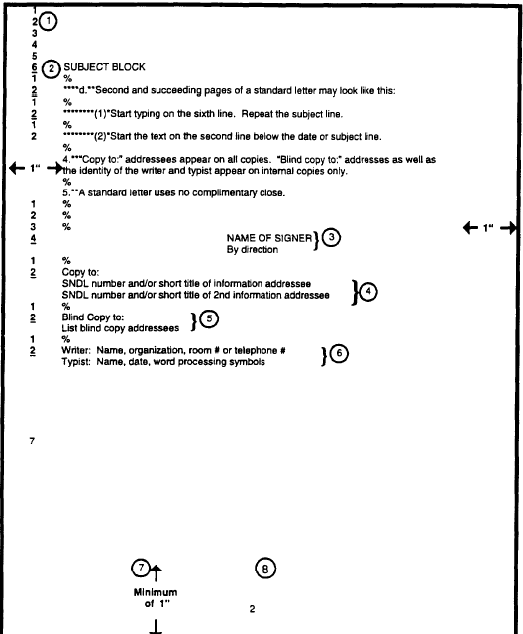
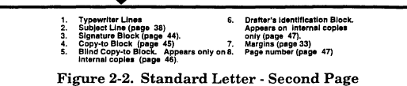
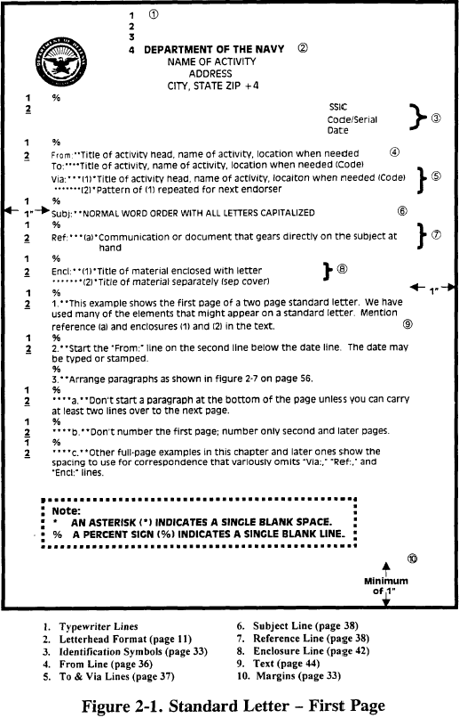

Endorsements - When a letter is transmitted “Via:” your activity, use an
endorsement to forward comments, recommendations, or information. While an endorsement is mostly used for transmitting correspondence through the chain of command, you may also use it to redirect a letter. Don’t use it to reply to a routine letter. Many endorsements simply forward letters without substantive comment to the next “Via:” addressee (if any) or action addressee. An endorsement may comment on the basic letter or any preceding endorsements. It may return the basic letter with a final reply or a request for more information. A “Via:” addressee may alter the order of any remaining “Via:” addressees or add others.

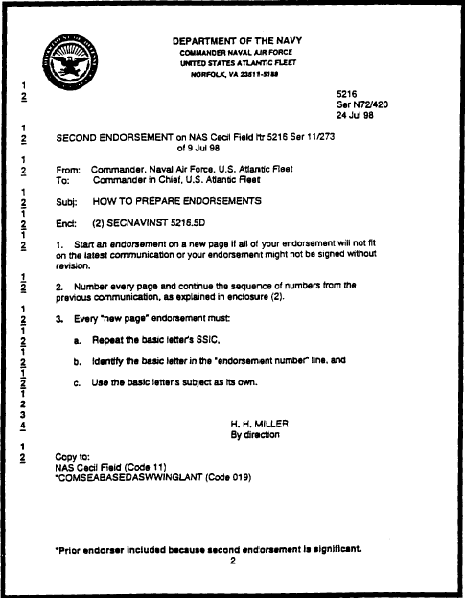
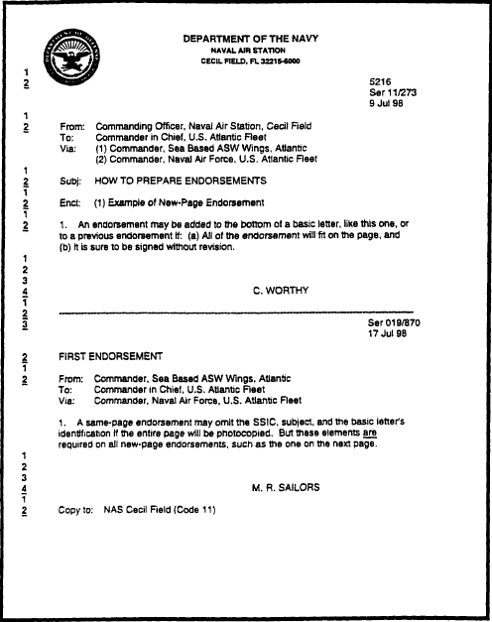

Memorandums – a memorandum provides an informal way to correspond within an activity or between DON activities. Subordinates may use it to correspond directly with each other on routine official business.
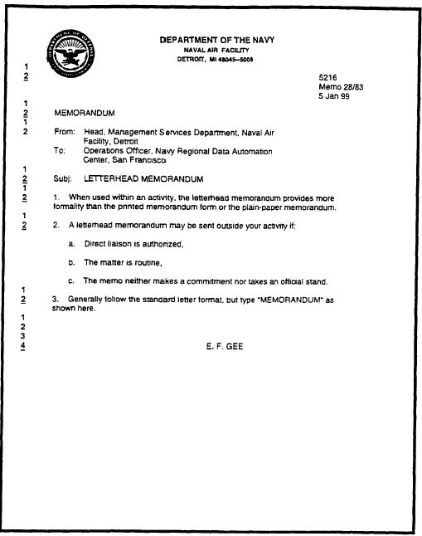
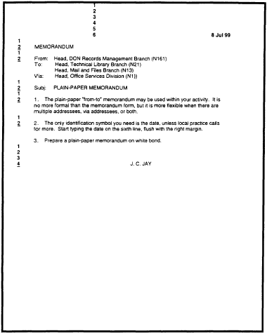

104.3 Discuss the purpose of the following enlisted service record pages:
[ref. c, pp. 1070-270 thru 1070-320]

Page 2 - NAVPERS 1070/602, DEPENDENCY APPLICATION/RECORD
OF EMERGENCY DATA AND DD 93, RECORD OF EMERGENCY DATA
Part I serves as an application for dependency allowances and is used to capture military spouse data.
Part II provides an immediately accessible, up-to-date record of emergency data and is the official document used to determine the following:
Person(s) to be notified in case of emergency or death.
Person(s) to receive the death gratuity when no spouse or child exists.
Person(s) to receive unpaid pay and allowances (arrears of pay) including money accrued during a missing or captured status, unused leave, travel, per diem, transportation of family members, transportation of household goods, and
savings deposits found due from Department of the Navy.
Dependents of member to receive allotment of pay if member is missing or unable to transmit funds.
Commercial insurance companies to be notified in case of death.
National Service Life Insurance, Servicemen’s Group Life Insurance, and Veterans Group Life Insurance in effect.

Page 4 - NAVPERS 1070/604, ENLISTED QUALIFICATIONS HISTORY
NAVPERS 1070/604 for USN and USNR enlisted members is a chronological history of their occupational and training related qualifications and their awards and commendations.

Page 5 - NAVPERS 1070/605, HISTORY OF ASSIGNMENTS
NAVPERS 1070/605 for USN and USNR enlisted members is a chronological record of duty assignments and is maintained throughout member’s active and inactive duty career

Page 13 - NAVPERS 1070/613, ADMINISTRATIVE REMARKS
NAVPERS 1070/613 services as a chronological record of significant miscellaneous entries which are not provided for elsewhere or where more detailed information may be required to clarify entries on other pages of the U.S. Navy Enlisted (Field) Service Record (FSR).

104.4 Explain the purpose of the Uniform Code of Military Justice, who is responsible for upholding it, and who is subject to it. [ref. d, pp. 1-1-1, 1-1-2]

Purpose - Promotes good order and discipline. and provides a basis for the administration of justice for the Armed Forces.

Who is responsible for upholding the UCMJ - All members of the Armed Forces

Who is subject to the UCMJ –
Members of a regular or reserve component of the Armed Forces
Members of the Fleet Reserve and Fleet Marine Corps Reserve
Members of a reserve component while on inactive-duty training
Members of the Army National Guard and the Air National Guard only when federalized
In time of war, all persons serving with or accompanying an Armed Force in the field
Volunteers from the time of their muster or acceptance into the Armed Forces
Inductees from the time of their actual induction into the Armed Forces
Cadets, aviation cadets, and midshipmen
Retired members of a regular component who are entitled to pay
Retired members of a reserve component who are receiving hospitalization from an Armed Force

104.5 Explain the differences in the following types of courts-martial:
[ref. d, pp. 1-1-7, 1-1-8]

Summary - A summary court-martial is composed of one active duty commissioned officer with the rank of captain or higher. The lowest level of authority to convene a summary court-martial is normally a battalion commander or other equivalent; however, under special circumstances, the superiors of a commanding officer of a separate or detached command may grant the authority. A summary court-martial may adjudge any punishment not forbidden by the UCMJ, except confinement for more than 1 month with hard labor, without confinement for more than 45 days, restriction for more than 2 months, or forfeiture of more than 1 month's pay. In the case of sergeants and above, a summary court-martial may not award a reduction of more than one rank and hard labor without confinement. Except aboard ship, you may refuse a summary court-martial and may request a special or general court-martial. However, a conviction at a special or general courts-martial results in a felony conviction. A summary court-martial may not try a commissioned officer, warrant officer, cadet, or midshipman for any capital offenses. You cannot be compelled to accept a summary court-martial. Since a summary court-martial is less formal than the other two types of court-martial, you may refuse to accept trial by summary courts-martial and may request a special court-martial. However, you should be aware that conviction by a special or general court-martial constitutes a felony conviction.

Special court-martial -. A special court-martial can be composed of a military judge alone, or a military judge and not less than three active-duty armed service members. The impartial personnel can be commissioned officers, warrant officers, or enlisted personnel. If you, the accused, are a commissioned officer, no member can be a warrant officer or enlisted person. If you, the accused, are an enlisted person, you may request that at least one third of the members of the court be enlisted. The lowest level of authority to convene a special court-martial is normally a squadron or battalion commander or equivalent. However, under special circumstances, the superiors of a commanding officer of a separate or detached command may grant the authority. A special court-martial may adjudge any punishment not forbidden by the UCMJ, including confinement for 6 months, hard labor without confinement for 3 months, or forfeiture of more than two-thirds pay for 6 months, a bad conduct discharge, and reduction in rank.Normally, a special court-martial may not try any capital offense when there is a mandatory punishment beyond the maximum power of a special court-martial.

General - A general court-martial can be composed of a military judge alone or a military judge and not less than five impartial active-duty armed services personnel. The impartial personnel can be commissioned officers, warrant officers, or enlisted personnel. If you, the accused, are a commissioned officer, no member can be a warrant officer or enlisted person. If you, the accused, are an enlisted person, you may request that at least one third of the court's members be enlisted.The lowest level of authority to convene a general court-martial is usually the commanding general of a division, wing, base, or the equivalent. However, under special circumstances, the commanding officer of a separate or detached command may be granted the authority by his superiors.A general court-martial may adjudge any punishment not forbidden by the UCMJ.

104.6 Explain the following in regards to Non-Judicial Punishment (NJP): [ref. d, p 1-1-11]

The value of NJP to the commander and to the Marine - The purpose of NJP is to give the commander the ability to maintain good order and discipline

When NJP can be administered - NJP is given for minor offenses of the UCMJ. A minor offense is one for which the maximum sentence, if tried by a general court-martial, does not include a dishonorable discharge or confinement of greater than one year.

The right to refuse NJP - Before the imposition of NJP proceedings, the accused may demand trial by court-martial in lieu of NJP

The right and procedures to appeal - The accused may appeal the punishment if he considers it unjust or disproportionate to the offense.
The procedures to appeal;
By submitting a written statement describing why he considers the punishment unjust or disproportionate
Within 5 days of imposition of punishment
Through the chain of command to the next superior authority

104.7 Explain the Marine Corps position on the following policies:
[ref. d, pp. 1-7-13 thru 1-7-21]

Sexual harassment - Sexual harassment is unacceptable and unprofessional behavior for military or civilian personnel that is dealt with through the
leadership and supervisory structure. Leaders and supervisors have a dual responsibility to create and maintain or defend an environment of mutual respect in which civilian and military men and women can function and conduct appropriate and continuous training to promote understanding and eliminate sexual harassment.

Equal opportunity - Provide equal opportunity for all military members without regard to race, color, creed, sex, age, or national origin consistent with the physical and mental capabilities of the individual.
Promote Marines based on merit, not quotas.
Promote Marines who meet the minimum eligibility service and grade criteria (TIS, TIG) for promotion and also
Promote equal opportunity for all Marines.

Hazing - No Marine or service member attached to a Marine command, including Marine detachments, may engage in hazing or consent to acts of hazing being committed upon them. No one in a supervisory position may, by act, word, or omission, condone or ignore hazing if he or she knows or reasonably should have known that hazing may occur. Consent to hazing is not a defense to violating MCO 1700.28. b. Any violation, attempted violation, or solicitation of another to violate MCO 1700.28 subjects involved members to disciplinary action under Article 92 of the Uniform Code of Military Justice (UCMJ).

Fraternization - Defined as duty relationships and social and business contacts between and among Marines of different grades. These relationships are inconsistent with the traditional standards of good order, discipline, and mutual respect that have always existed between Marines of senior and lesser grade. Fraternization violates good order and discipline, which is the essential quality of behavior within the Armed Forces. Marines will behave in a manner that is consistent with traditional standards of good order and discipline, mutual respect, and the customs of the Marine Corps
Describe behavior that would be considered fraternization - Any behavior which would present the appearance of undue familiarity or informality between and among the ranks.
EXAMPLES: Calling seniors by their first name, officers dating enlisted personnel.
  - State the purpose and discuss the contents of the Enlisted Distribution Verification (EDVR). [ref. e, pp.1-1, 1-2]

The EDVR is a monthly statement of an activity's enlisted personnel account. It lists all individuals assigned and provides:
A summary by distribution community of the present and future manning status of the activity.
A common reference for communicating manning status between an activity and its Manning Control Authority (MCA).
A statement of account for verification by the Personnel and Pay Services Unit
Identification Code (PPSUIC) activity.
A permanent historical record of an activity's enlisted personnel account.

Contents:
EDVR sections 1 through 3 contain information that has been extracted from the account because it requires special attention or action by the activity. To assist activities in managing enlisted personnel, these sections also identify future personnel events. Additionally, EDVR section 3 contains an alphabetic listing of
all enlisted members assigned to the activity.

EDVR section 4 contains the total personnel account of the activity, including those members reflected in sections 1 through 3.

EDVR section 5 contains the Personnel Status Summary.

EDVR section 6 contains Distribution Navy Enlisted Classification Code (DNEC) Management.

EDVR section 7 contains NEC Billet and Personnel Inventory.

EDVR section 8 contains a list of individuals who are qualified in Navy Enlisted Classification Codes (NECs).

EDVR sections 9 and 10 contain the Diary Message Summary and Duty Preference Listing, respectively.

EDVR section 11 contains individual security data, citizenship code, involuntary extension months, Pay Entry Base Date (PEBD), Time in Rate (TIR), Advancement Effective Date, and FORMAN Status and Action Date.

EDVR section 12 contains a listing of both officer and enlisted personnel in an embarked or Temporary Additional Duty (TAD) status to augment normal manning. This listing also includes commands that are embarked onboard another command.
Exception. The EDVR for activity accounts with a MCA code of "X" (Others, Patients and Students) will not contain information in EDVR sections 1, 2 and 5 through 8. This type of account will only contain information in EDVR sections 3, 4, 9, 10, 11 and 12.Report

