112 Marine Corps Operations Fundamentals

References:

[a] Headquarters Marine Corps, Department of Aviation Website (http://www.hqmc.usmc.mil/)
[b] US Navy Ships Website (http://www.fas.org/man/dod-101/sys/ship/)
[c] Joint Publication 3-07, Joint Doctrine for Military Operations Other Than War
[d] MCWP 3-35.3, Military Operations on Urbanized Terrain (PCN 14300003500)
[e] MCCP 1, Operation Maneuver From the Sea (PCN 14500000100)

112.1 Discuss the primary function and mission of the following Marine Corps aviation platforms: [ref. a]

AH-1W Cobra
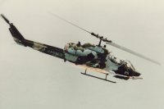
Primary function: Attack helicopter
Length: 58 feet (17.67 meters)
Height: 13.7 feet (4.17 meters)
Rotor Diameter: 48 feet (14.62 meters)
Speed: 147 knots (169.05 miles per hour) in basic combat attack configuration
Range: 256 nautical miles (294.4 miles) in basic combat attack configuration
Ceiling: 18,700 feet (5703.5 meters) in basic combat attack configuration (limited to 10,000 feet (3050 kilometers) by oxygen requirements)
Crew: 2 officers
Armament: One 20MM turreted cannon with 750 rounds; four external wing stations that can fire 2.75"/5.0" rockets and a wide variety of precision guided missiles, to include TOW/Hellfire (point target/anti-armor), Sidewinder (anti-air) and Sidearm (anti-radar).
Mission: Fire support and security for forward and rear area forces, point target/anti-armor, anti-helicopter, armed escort, supporting arms control and coordination, point and limited area air defense from enemy fixed-wing aircraft,
Features: The AH-1W Super Cobra is a Marine Corps attack helicopter capable of operating in day, night and limited visibility. The AH-1W provides enroute escort for our assault helicopters and their embarked forces. The AH-1W is a two-place, tandem-seat, twin-engine helicopter capable of land- or sea-based operations. The Cobra provides fire support and fire support coordination to the landing force during amphibious assaults and subsequent operations ashore
CH-46E Sea Knight
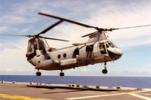
Primary function: Medium lift assault support helicopter
Length:
Rotors unfolded: 84 feet, 4 inches (25.69 meters)
Rotors folded: 45 feet, 7.5 inches (13.89 meters)
Width:
Rotors unfolded: 51 feet (15.54 meters)
Rotors folded: 14 feet, 9 inches (4.49 meters)
Height: 16 feet, 8 inches (5.08 meters)
Range: 132 nautical miles (151.8 miles) for an assault mission
Speed: 145 knots (166.75 miles per hour)
Crew: 4 - pilot, copilot, crew chief, and 1st mechanic/aerial gunner
Payload:
9-16 passengers/combat troops
Medical evacuation: 15 litters and 2 attendants
Cargo: 2,000 - 4,000 pounds (2270 kilograms) internal or external load
Mission: The mission of the CH-46E Sea Knight helicopter in a Marine Medium Helicopter (HMM) squadron is to provide all-weather, day/night, night vision goggle (NVG) assault transport of combat troops, supplies, and equipment during amphibious and subsequent operations ashore. Troop assault is the primary function and the movement of supplies and equipment is secondary. Additional tasks are: combat and assault support for evacuation operations and other maritime special operations; over-water search and rescue augmentation; support for mobile forward refueling and rearming points; aeromedical evacuation of casualties from the field to suitable medical facilities
Background: The CH-46 Sea Knight was first procured in 1964 to meet the medium-lift requirements of the Marine Corps in Viet Nam with a program buy of 600 aircraft. The aircraft continues to serve the Marine Corps in combat and peacetime environments. However, normal airframe operational and attrition rates have taken these assets to the point where a medium lift replacement is required. Safety and capability upgrades such as the Engine Reliability Improvement Program, the Communication and Navigation Control System, and Dynamic Component Upgrade allow continued safe and effective operation of the Sea Knight fleet while the MV-22 Osprey is fielded as the medium lift replacement aircraft for the Marine Corps.

CH-53D Sea Stallion
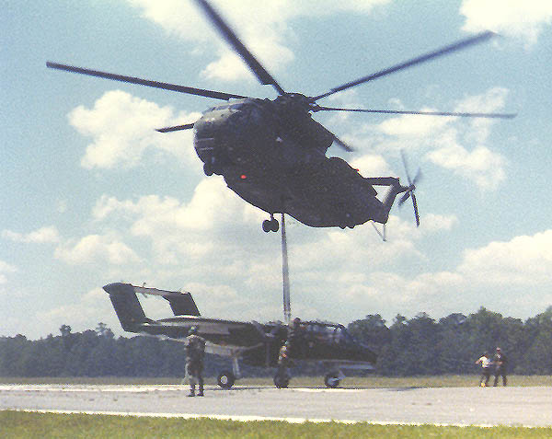
Primary function: Transportation of equipment and supplies during the ship-to-shore movement of an amphibious assault and during subsequent operations ashore. Length: 88 feet 6 inches (26.96 meters)
Height: 24 feet 11 inches (7.59 meters)
Rotor diameter: 72 feet 2.7 inches (22.01 meters)
Speed: 130 knots (149.5 miles per hour)
Range: 690 miles (600 nautical miles)
Armament: Two XM-218 .50 cal machineguns
Crew: 4 - pilot, copilot, crew chief, and 1st mechanic/aerial gunner
Mission: The CH-53D Sea Stallion is designed for the transportation of equipment, supplies and personnel during the assault phase of an amphibious operation and subsequent operations ashore. Capable of both internal and external transport of supplies, the CH-53D is shipboard compatible and capable of operation in adverse weather conditions both day and night. The CH-53D is now filling a role in the Marine Corps' medium lift helicopter fleet.
Features: The twin-engine helicopter is capable of lifting 7 tons (6.35 metric tons). Improvements to the aircraft include an elastomeric rotor head, external range extension fuel tanks, crashworthy fuel cells, ARC-210 radios, integrated global positioning system (GPS), and defensive electronic countermeasure equipment. The helicopter will carry 37 passengers in its normal configuration and 55 passengers with centerline seats installed.
Background: The CH-53D is a more capable version of the CH-53A introduced into the Marine Corps in 1966. Used extensively both afloat and ashore, the Sea Stallion was the heavy lift helicopter for the Marine Corps until the introduction of the CH-53E triple engine variant of the H-53 family into the fleet in 1981. The CH-53D has performed its multi-role mission lifting both equipment and personnel in training and combat, most recently in Operation Desert Storm, where the helicopter performed with distinction. Now primarily based in Hawaii, the CH-53D augments the medium lift mission and is scheduled to be replaced by MV-22 in the middle of this decade.

CH-53E Super Sea Stallion
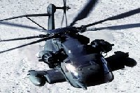
Primary function: Transportation of heavy equipment and supplies during the ship-to-shore movement of an amphib assault and during subsequent operations ashore.
Length: 99 feet 5 inches (2.64 meters)
Height: 28 feet 4 inches (.81 meters)
Rotor diameter: 79 feet (24.07 meters)
Speed: 172.5 miles per hour (150 knots)
Range: without refueling: 621 miles, with aerial refueling: indefinite
Armament: Two XM-218 .50 caliber machineguns.
Crew: 4 - pilot, copilot, crew chief, and 1st mechanic/aerial gunner
Mission: As the Marine Corps' heavy lift helicopter designed for the transportation of material and supplies, the CH-53E is compatible with most amphibious class ships and is carried routinely aboard LHA (Landing, Helicopter, Assault: an amphibious assault ship) and LHD (Landing, Helicopter, Dock: an amphibious assault ship) type ships. The helicopter is capable of lifting 16 tons (14.5 metric tons) at sea level, transporting the load 50 nautical miles (57.5 miles) and returning. A typical load would be a 16,000 pound (7264 kilogram) M198 howitzer or a 26,000 pound (11,804 kilogram) Light Armored Vehicle. The aircraft also can retrieve downed aircraft including another CH-53E. The 53E is equipped with a refueling probe and can be refueled in flight giving the helicopter indefinite range.
Features: The CH-53E is a follow-on for its predecessor, the CH-53D. Improvements include the addition of a third engine to give the aircraft the ability to lift the majority of the Fleet Marine Force's equipment, a dual point cargo hook system, improved main rotor blades, and composite tail rotor blades. The helicopter seats 37 passengers in its normal configuration and has provisions to carry 55 passengers with centerline seats installed. It can carry external loads at increased airspeeds due to the stability achieved with the dual point system. Precision navigation is provided by an integrated global positioning system (GPS) and augmented by the Helicopter Night Vision System Forward Looking Infrared sensor.
Background: With four and one half hours' endurance, the CH-53E Super Stallion can mass combat power at long distances over rugged terrain, day or night. The Super Stallion has established itself as the prime workhorse of the Marine Corps’ forward deployed units and has become a critical pillar in the expeditionary logistics capability for the future The CH-53E has consistently proven its worth to the Fleet commanders with its versatility and range. During Operation Eastern Exit two CH-53Es launched from amphibious ships and flew 463 nautical miles (532.45 miles) at night, refueling twice enroute, to rescue American and foreign allies from the American Embassy in the civil war-torn capital of Mogadishu, Somalia in January of 1990. Two CH-53Es rescued Air Force Capt. Scott O'Grady in Bosnia in June 1995, and the aircraft has been involved in multiple non-combatant evacuation.
UH-1N Huey
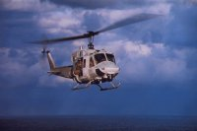
Primary function: Utility helicopter
Length: 57.3 feet (17.46 meters)
Height: 14.9 feet (4.54 meters)
Rotor Diameter: 48 feet (14.62 meters)
Speed: 121 knots (139.15 miles per hour) at sea level
Range: 172 nautical miles (197.8 miles)
Crew:
Officer: 2
Enlisted: 2
Armament: M-240 7.62mm machine gun or the GAU-16 .50 caliber machine gun or the GAU-17 7.62mm automatic gun. All three weapons systems are crew-served, and the GAU-2B/A can also be controlled by the pilot in the fixed forward firing mode. The helicopter can also carry two 7-shot or 19-shot 2.75" rocket pods.
Mission: Airborne command and control, combat assault, medical evacuation, maritime special operations, supporting arms control and coordination, fire support and security for forward and rear area forces.
Features: The UH-1N is a twin-piloted, twin-engine helicopter used in command and control, resupply, casualty evacuation, liaison and troop transport. The Huey provides utility combat helicopter support to the landing force commander during ship-to-shore movement and in subsequent operations ashore.
The aircraft can be outfitted to support operations such as command and control with a specialized communication package (ASC-26), supporting arms coordination, assault support, medical evacuation for up to six litter patients and one medical attendant, external cargo, search and rescue using a rescue hoist, and reconnaissance and reconnaissance support. The currently fielding of the 2nd generation Navigational Thermal Imagining System/Forward Looking Infrared Radar for the UH-1N will increase its night mission capability

MV-22B Osprey
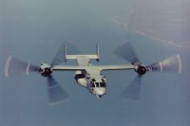
Primary function: Amphibious assault transport of troops, equipment and supplies from assault ships and land bases.
Description: The V-22 Osprey is a multi-engine, dual-piloted, self-deployable, medium lift, vertical takeoff and landing (VTOL) tiltrotor aircraft designed for combat, combat support, combat service support, and Special Operations missions worldwide. It will replace the Corps' aged fleet of CH-46E and CH-53D medium lift helicopters
Mission: Marine Corps Assault Support
Variants: The CV-22 will be utilized by the Air Force and SOCOM for Special Operations missions maintaining maximum commonality with the MV-22. Aircraft avionics peculiar to Air Force/SOCOM unique mission requirements constitute primary aircraft differences. The Navy will use the HV-22 for Combat Search and Rescue and fleet logistics support
Deployed to: Program is currently in Low Rate Initial Production.
MV-22s will be deployed to all Marine Corps medium lift active duty and reserve tactical squadrons, the medium lift training squadron (FRS), and the executive support squadron (HMX).
Dimensions:
Spread: Length..57' 4"..Width..18' 5"..Height..22' 1
Folded: Length..63' 0"..Width..84' 7" Height ..18' 1"
Cruise Airspeed
MV-22 240 kts (258 kts)
CV-22 230 kts
Planned Inventory:
350 MV-22 (USMC)
50 CV-22 (USAF)
48 HV-22 (USN)

EA-6B Prowler
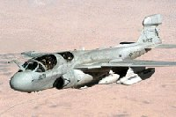
Primary function: Airborne Electronic Warfare (EW) support to Fleet Marine Forces to include electronic attack (EA), tactical electronic support (ES), electronic protection (EP) and high speed anti-radiation missile (HARM)
Length: 59 feet (17.98 meters)
Height: 15 feet (4.57 meters)
Wing span: 53 feet (16.15 meters)
Speed: Maximum .99 mach; cruise .72 mach
Range:
Unrefueled in combat configuration: 850 nautical miles (977.5 miles)
Refueled: unlimited (crew fatigue factor - approximately 8 hours)
Armament: ALQ-99 Tactical Jamming System (TJS); USQ-113 Communications Jammer, High Speed Anti-Radiation Missile (HARM)
Sensors: ALQ-99 On-board System (OBS), USQ-113 Communications Receiver
Crew: 4
Mission: The EA-6B's ALQ-99 OBS is used to collect tactical electronic order of battle (EOB) data which can be recorded and processed after missions to provide updates to various orders of battle. The ALQ-99 TJS is used to provide active radar jamming support to assault support and attack aircraft, as well as ground units. Additional suppression of enemy air defenses (SEAD) capability is available with the employment of HARM. The USQ-113 communications jammer can detect and jam a wide range of communication frequencies to further degrade air defense and ground units capabilities.
Features: Marine Prowlers may be land-based from prepared airfields, or operate from expeditionary airfields (EAF). They may also be sea-based, operating from aircraft carriers. Marine Prowlers are unique in their integration with the Tactical Electronic Reconnaissance Processing and Evaluation System (TERPES). TERPES provides post-mission analysis of EA-6B ES data for reporting and updating orders of battle for EA-6B and MAGTF mission planning. It also provides post-mission analysis of jamming and HARM employment for reporting, assessing and storing mission data.

AV-8B Harrier II
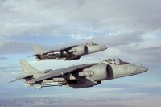
Primary function: Attack and destroy surface targets under day and night visual conditions.
Length: 46.3 feet (14.11 meters)
Wing span: 30.3 feet (9.24 meters)
Cruise speed: Subsonic to transonic
Ferry range: 2100 nautical miles(2416.64 miles)
Combat radius:
close air support: 163 nautical miles (187.45 miles) with 30 minutes time on station
interdiction: 454 nautical miles (522.45 miles)
Armament: Seven external store stations, comprising six wing stations for AIM-9 Sidewinder and an assortment of air-to-ground weapons, external fuel tanks and AGM-65 Maverick missiles; one centerline station for a DECM pod. A GAU-12 25MM six-barrel gun pod and accompanying ammunition pod can be mounted either side of centerline and has a 300 round capacity with a lead computing optical sight system (LCOSS) gunsight.
Crew: 1
Mission: The mission of the VMA STOVL squadron is to attack and destroy surface and air targets, to escort helicopters, and to conduct other such air operations as may be directed. Specific tasks of the AV-8B HARRIER II include:
- Conduct close air support using conventional and specific weapons
- Conduct deep air support, to include armed reconnaissance and air interdiction, using conventional and specific weapons.
- Conduct offensive and defensive antiair warfare. This includes combat air patrol, armed escort missions, and offensive missions against enemy ground-to-air defenses, all within the capabilities of the aircraft.
- Be able to operate and deliver ordnance at night and to operate under instrument flight conditions.
- Be able to deploy for extended operations employing aerial refueling.
- Be able to deploy to and operate from carriers and other suitable seagoing platforms, advanced bases, expeditionary airfields, and remote tactical landing sites.
Features: The AV-8B V/STOL strike aircraft was designed to replace the AV-8A and the A-4M light attack aircraft. The Marine Corps requirement for a V/STOL light attack force has been well documented since the late 1950's. Combining tactical mobility, responsiveness, reduced operating cost and basing flexibility,
both afloat and ashore, V/STOL aircraft are particularly well-suited to the special combat and expeditionary requirements of the Marine Corps. The AV-8BII+ features the APG-65 Radar common to the F/A-18, as well as all previous systems and features common to the AV-8B Harrier II
KC130F/R/T Hercules
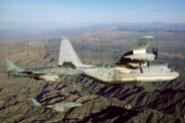
Primary function: In-flight refueling; tactical transport.
Length: Aircraft: 97 feet, 9 inches (22.16 meters).
Cargo compartment: 41 feet (12.49 meters).
Width of Cargo compartment: 10feet, 3 inches (3.12 meters).
Height: Aircraft: 38 feet, 4 inches (11.68 meters).
Cargo compartment: 9 feet (2.74 meters).
Wing span: 132 feet, 7 inches (40.39 meters).
Speed: 315 knots (362.25 miles per hour).
Range: Tanker mission: 1000 nautical mile (1150 mile) radius with 45,000 pounds of fuel (20,430 kilograms) (KC-130R/T).
Cargo mission: 2875 nautical miles (3306.25 miles) with 38,258 pounds (17,369 kilograms) of cargo (KC-130R/T) or 92 combat troops or 64 paratroopers or 74 litters.
Landing distance: Less than 2,600 feet .
Crew: 2 pilots, 1 navigator/systems operator, 1 flight engineer, 1 first mechanic, 1-2 loadmaster
Mission: The KC-130 is a multi-role, multi-mission tactical tanker/transport which provides the support required by Marine Air Ground Task Forces. This versatile asset provides in-flight refueling to both tactical aircraft and helicopters as well as rapid ground refueling when required. Additional tasks performed are aerial delivery of troops and cargo, emergency resupply into unimproved landing zones within the objective or battle area, airborne Direct Air Support Center, emergency medevac, tactical insertion of combat troops and equipment, evacuation missions, and support as required of special operations capable Marine Air Ground Task Forces
Features: The KC-130 is equipped with a removable 3600 gallon (136.26 hectoliter) stainless steel fuel tank that is carried inside the cargo compartment providing additional fuel when required. The two wing-mounted hose and drogue refueling pods each transfer up to 300 gallons per minute (1135.5 liters per minute) to two aircraft simultaneously allowing for rapid cycle times of multiple-receiver aircraft formations (a typical tanker formation of four aircraft in less than 30 minutes). Some KC-130s are also equipped with defensive electronic and infrared countermeasures systems. Development is currently under way for the incorporation of interior/exterior night vision lighting, night vision goggle heads-up displays, global positioning system, and jam-resistant radios.
F-18A/B/C Hornet
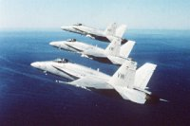
Primary function: Intercept and destroy enemy aircraft under all-weather conditions and attack and destroy surface targets.
Length: 56 feet (17.06 meters)
Wing span: 37.5 feet (11.43 meters)
Cruise speed: High subsonic to supersonic
Ferry range: Over 2,000 nautical miles (2300 miles)
Combat radius:
Fighter mission: 400 nautical miles (460 miles)
Attack mission: 575 nautical miles (661.25 miles)
Armament: Nine external wing stations, comprising two wingtip stations for an assortment of air-to-air and air-to-ground weapons, including AIM-7 Sparrows, AIM-9 Sidewinders, AMRAAMs, AGM-84 Harpoons and AGM-65 Maverick missiles; two inboard wing stations for external fuel tanks or air-to-ground stations; two nacelle fuselage stations for Sparrows or AN/AAS-38 Forward Looking Infrared Radar (FLIR) pods; and a center station for fuel tank or air-to-ground weapons. Air-to-ground weapons include all GBU series bombs, JSOW, JDAM, Mk 80 series general-purpose bombs, and CBU-59 cluster bombs. AN M61 20mm six-barrel gun is mounted in the nose and has a McDonnell Douglas director gunsight.
Crew: 1
Mission: Specific F/A-18A/C tasks include:
- Intercept and destroy enemy aircraft in conjunction with ground or airborne fighter control under all-weather conditions.
- Conduct day and night close air support under the weather.
- Conduct day and night precision deep air support, under the weather. Deep air support consists of radar search and attack, interdiction, and strikes against enemy installations using all types of weapons compatible with assigned aircraft.
- Conduct armed escort of friendly aircraft.
- Conduct day and night suppression of enemy air defense (SEAD)
- Be able to operate from carriers, advanced bases, and expeditionary airfields.
- Be able to deploy or conduct extended range ops employing aerial refueling.
Features: The Marine Corps F/A-18A/C strike fighter multi-mission aircraft was designed to replace the F-4 Phantom. The F/A-18A/C Hornet is missionized for traditional fighter, attack, and close air support roles through selection of external pods/equipment to accomplish specific mission objectives. Any aircraft can quickly be configured to perform either fighter or attack missions, or both, thus providing the Marine Air Ground Task Force (MAGTF) commander more flexibility in employing his tactical aircraft in a rapidly changing scenario. Marine F/A18s may be land-based from prepared airfields, or they can operate from expeditionary airfields (EAF). They may also be sea-based, operating from the decks of aircraft carriers.
F-18D Hornet
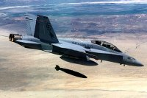
Primary function: Attack and destroy surface targets, day or night, under all weather conditions; conduct multi-sensor imagery reconnaissance; provide supporting arms coordination; and intercept and destroy enemy aircraft under all weather conditions.
Length: 56 feet (17.06 meters
Wing span: 37.5 feet (11.43 meters)
Cruise speed: High subsonic to supersonic
Ferry range: Over 2,000 nautical miles (2300 miles)
Combat radius: Fighter mission: 400 nautical miles (460 miles)
Attack mission: 575 nautical miles (661.25 miles)
Armament: Nine external wing stations, comprising two wingtip stations for AIM-9 Sidewinder air-to-air missiles; two outboard wing stations for an assortment of air-to-air and air-to-ground weapons, including AIM-7 Sparrows, AIM-9 Sidewinders, AMRAAMs, AGM-84 Harpoons and AGM-65 Maverick
missiles; two inboard wing stations for external fuel tanks or air-to-ground stations; two nacelle fuselage stations for Sparrows or AN/AAS-38 Forward Looking Infrared Radar (FLIR) pods; and a center station for fuel tank or air-to-ground weapons such as GBU laser guided bombs, JDAM, JSOW, Mk 80 series general purpose bombs, and CBU-59 cluster bombs. An M61 20mm six-barrel gun is mounted in the nose and has a McDonnell Douglas director gunsight.
Crew: 2
Mission: Specific F/A-18D tasks include:
- Conduct day and night deep air support, in all weather. Deep air support consists of armed reconnaissance, radar search and attack, interdiction, and strikes against enemy installations, using all types of weapons compatible with assigned aircraft.
- Conduct multi-sensor imagery reconnaissance to include pre-strike and post-strike target damage assessment and visual reconnaissance.
- Conduct day and night supporting arms coordination to include forward air control, tactical air coordination and artillery/naval gunfire spotting.
- Intercept and destroy enemy aircraft in conjunction with ground and airborne fighter direction.
- Conduct battlefield illumination and target illumination.
- Conduct armed escort of friendly aircraft.
- Be able to operate from carriers, advanced bases, and expeditionary airfields.
- Be able to deploy or conduct extended range ops employing aerial refueling.
Features: Marine F/A-18D aircraft are unique within the Department of the Navy because the Marine Corps employs the F/A-18D as a tactical strike aircraft while the Navy uses it as a trainer. Marine F/A-18Ds may be land-based from prepared airfields, or they can operate from expeditionary airfields (EAF). They may also be sea-based, operating from the decks of Navy aircraft carriers.
112 .2 Discuss the primary mission of each of the following classes of ships used to support the Marine Corps mission: [ref. b]

LHA
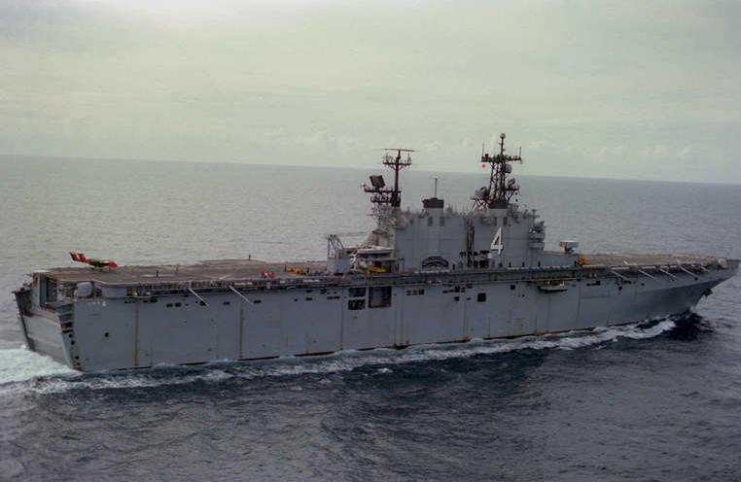
The primary war-fighting mission of the LHA-1 Tarawa class is to land and sustain United States Marines on any shore during hostilities. The ships serve as the centerpiece of a multi-ship Amphibious Readiness Group (ARG). Some 3,000 Sailors and Marines contribute to a forward-deployed ARG composed of approximately 5,000 personnel.

LHD
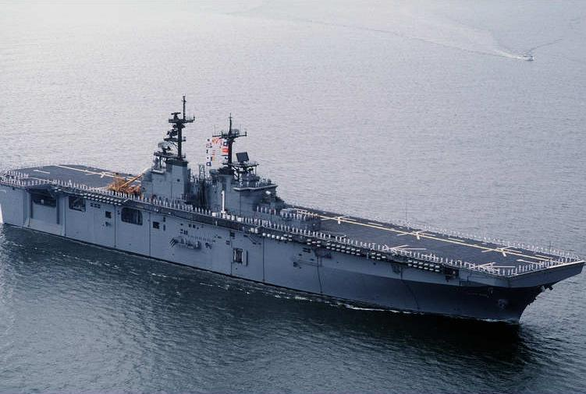
The Wasp-class LHD are the largest amphibious ships in the world. The LHD is an improved follow-on to the five ship Tarawa-class LHAs, sharing the basic hull and engineering plant. The LHD l has an enhanced well deck, enabling it to carry three LCACs (vice one LCAC in the LHAs). The flight deck and elevator scheme is also improved, which allows the ship to carry two more helicopters than its predecessor, the LHA.

LPD
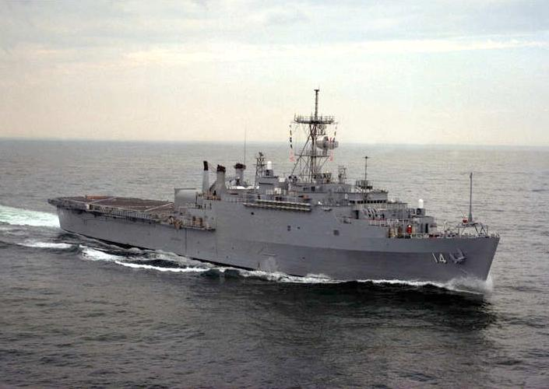
The LPD 4 Austin class of ship combines the functions of three different classes of ships; the landing ship (LSD), the tank landing ship (LST), and the attack cargo ship (LKA). The Amphibious Transport, Dock, is used to transport and land Marines, their equipment and supplies by embarked landing craft or amphibious vehicles augmented by helicopters in amphibious assault. These ships are configured as a flagship and provide extensive command, control and communications facilities to support an Amphibious Task Force Commander and Landing Force Commander. In an amphibious assault, the ship would normally function as the Primary Control Ship that would be responsible for coordinating boat waves and vectoring landing craft to the beach.

LSD
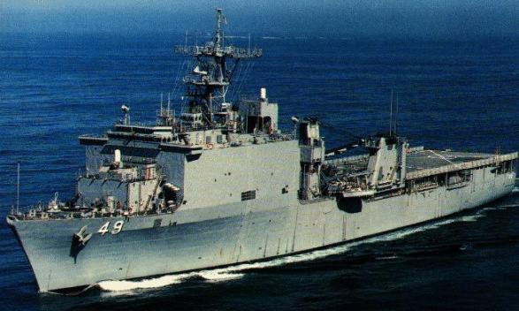
The primary mission of the Harpers Ferry (Cargo Variant) ship is to dock, transport and launch the Navy's Landing Craft, Air Cushion (LCAC) vessels and other amphibious craft and vehicles with crews and Marines into potential trouble spots around the world. The ship also has the capability to act as primary control ship during an Amphibious Assault

LCAC
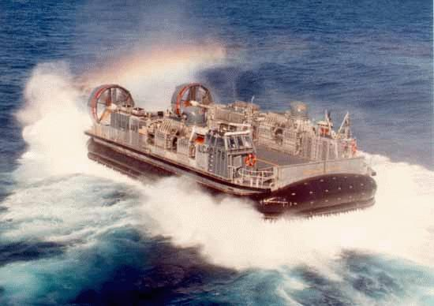
The Landing Craft, Air Cushion (LCAC) Transport weapons systems, equipment, cargo and personnel of the assault elements of the Marine Air/Ground Task Force both from ship to shore and across the beach. The landing craft air cushion (LCAC) is a high-speed, over-the-beach fully amphibious landing craft capable of carrying a 60-75 ton payload. Capable of operating from existing and planned well deck ships, it is used to transport weapons systems, equipment, cargo and personnel from ship to shore and across the beach. The advantages of air-cushion landing craft are numerous. They can carry heavy payloads, such as an M-1 tank, at high speeds. Their payload and speed mean more forces reach the shore in a shorter time, with shorter intervals between trips
T-AH (sealift)
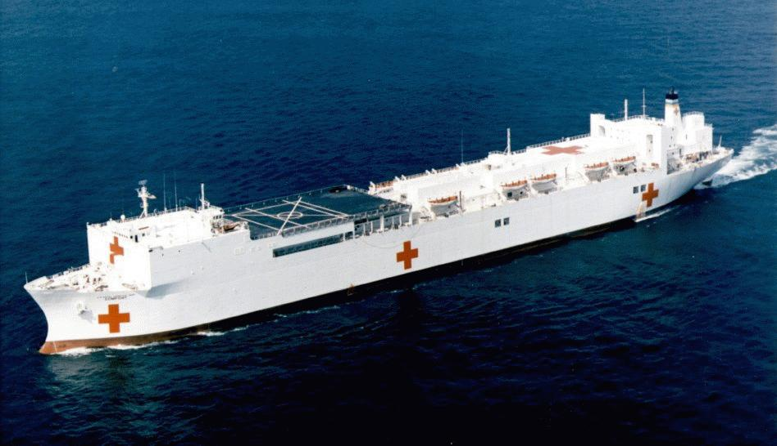
Two hospital ships [HSS] operated by Military Sealift Command are designed to provide emergency, on-site care for US combatant forces deployed in war or other operations. Hospital ships have two missions. First, to provide a mobile, flexible, rapidly responsive afloat medical capability to provideacute medical and surgical care in support of amphibious task forces, Marine Corps, Army, and Air Force elements, forward deployed Navy elements. Secondly, to provide a full-service hospital asset for use by other government agencies involved in the support of disaster relief and humanitarian operations worldwide. The HSS mission in joint operations is to minimize the effects of wounds, injuries, and disease on unit effectiveness, readiness, and morale. This mission is accomplished by a proactive preventive medicine (PVNTMED) program and a phased health care system (echelons of care) that extends from actions taken at the point of wounding, injury, or illness to evacuation from a theater for treatment at a hospital in the continental United States (CONUS). One measure of this system's effectiveness is its ability to save life and limb, to reduce the disease and nonbattle injury (DNBI) rate, and to return patients to duty quickly and as far forward in the theater as possible. Another measure is the system's ability to stabilize patients for evacuation to the Communications Zone (COMMZ) or out of the theater as appropriate, within the operational evacuation policy guidelines, and with minimum delay.nts of the fleet and fleet activities located in areas where hostilities may be imminent

T-AK (sealift)
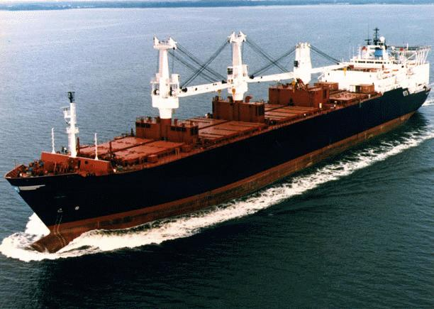
Each of the five ships of the TAK-3000 Cpl. Louis J. Hauge Jr. class carries a full range of Marine Corps cargo, enough cargo to support a Marine Air Ground Task Force for 30 days. Each ship has lift-on/lift-off capabilities, as well as roll-on/roll-off capabilities. Navy lighterage carried onboard consists of causeways, both powered and unpowered, and small boats to move them around. They are certified to land up to CH-53E helicopters. Baugh also has breakbulk cargo capacity, which is used for carrying general cargo. The ships are prepositioned in Diego Garcia.
Thirteen MSC prepositioning ships are specially configured to transport supplies for the US Marine Corps. Known as the Maritime Prepositioning Force, the 13 ships were built or modified in the mid-1980s and are on location in the western Pacific Ocean, the Indian Ocean and the Mediterranean Sea. The 13 Maritime Prepositioning Ships, or MPS, contain nearly everything the Marines need for initial military operations from tanks and ammunition to food and fuel to spare parts and engine oil

112 .3 Discuss the difference between war and Military Operations Other Than War (MOOTW). [ref. c, pp. I-1, I-2 ]

War. When instruments of national power are unable to achieve national objectives or protect national interests any other way, the US national leadership may decide to conduct large-scale, sustained combat operations to achieve national objectives or protect national interests, placing the United States in a wartime state. In such cases, the goal is to win as quickly and with as few casualties as possible, achieving national objectives and concluding hostilities on terms favorable to the United States and its multinational partners

Military Operations Other Than War. MOOTW focus on deterring war, resolving conflict, promoting peace, and supporting civil authorities in response to domestic crises. As Figure I-1 indicates, MOOTW may involve elements of both combat and noncombat operations in peacetime, conflict, and war situations. MOOTW involving combat, such as peace enforcement, may have many of the same characteristics of war, including active combat operations and employment of most combat capabilities. All military operations are driven by political considerations. However, MOOTW are more sensitive to such considerations due to the overriding goal to prevent, preempt, or limit potential hostilities. In MOOTW, political considerations permeate all levels and the military may not be the primary player. As a result, these operations normally have more restrictive rules of engagement (ROE) than in war. As in war, the goal is to achieve national objectives as quickly as possible and conclude military operations on terms favorable to the United States and its allies. However, the purposes of conducting MOOTW may be multiple, with the relative importance or hierarchy of such purposes changing or unclear; for example, to deter potential aggressors, protect national interests, support the United Nations (UN) or other regional organizations, satisfy treaty obligations, support civil authorities, or provide humanitarian assistance (HA). The specific goal of MOOTW may be peaceful settlement, assistance rendered to civil authorities, or providing security for HA. The Department of Defense (DOD) is often in a support role to another agency, such as the Department of State (DOS) in HA operations. However, in certain types of operations DOD is the lead agency, such as in peace enforcement operations (PEO). These operations usually involve interagency coordination and may also involve nongovernmental organizations (NGOs) or private voluntary organizations (PVOs). Finally, although MOOTW are generally conducted outside of the United States, some types may be conducted within the United States in support of civil authorities consistent with established law.

112.4 Explain the following types of MOOTW and give examples of each:
[ref. c, pp. III-1 thru III-15]

Arms control is a concept that connotes any plan, arrangement, or process, resting upon explicit or implicit international agreement. Arms control governs any aspect of the following: the numbers, types, and performance characteristics of weapon systems (including the command and control, logistic support arrangements, and any related intelligence gathering mechanism); and the numerical strength, organization, equipment, deployment or employment of the armed forces retained by the parties (it encompasses disarmament). Additionally, it may connote those measures taken for the purpose of reducing instability in the military environment. Although it may be viewed as a diplomatic mission, the military can play an important role. For example, US military personnel may be involved in verifying an arms control treaty; seizing WMD (nuclear, biological, and chemical or conventional); escorting authorized deliveries of weapons and other materials (such as enriched uranium) to preclude loss or unauthorized use of these assets; or dismantling, destroying, disposing of weapons and hazardous material. All of these actions help reduce threats to regional security. Other examples include military support for the Conventional Armed Forces in Europe Treaty by conducting and hosting site inspections, participating in military data exchanges, and implementing armament reductions. Finally, the US military’s implementation of Vienna Document 1992 confidence and security building measures such as unit/formation inspections, exercise notifications/observations, air and ground base visits, and military equipment demonstrations are further examples of arms control.

Combating terrorism involves actions taken to oppose terrorism from wherever the threat. It includes antiterrorism (defensive measures taken to reduce vulnerability to terrorist acts) and counterterrorism (offensive measures taken to prevent, deter, and respond to terrorism). Antiterrorism programs form the foundation for effectively combating terrorism. The basics of such programs include training and defensive measures that strike a balance among the protection desired, the mission, infrastructure, and available manpower and resources. The US Government may provide antiterrorism assistance to foreign countries under the provisions of Chapter II of the Foreign Assistance Act of 1961. Joint Pub 3-07.2, “JTTP for Antiterrorism,” provides detailed guidance on this subject. Counterterrorism provides response measures that include preemptive, retaliatory, and rescue operations. Normally, counterterrorism operations require specially trained personnel capable of mounting swift and effective action. DOD provides specially trained personnel and equipment in a supporting role to governmental lead agencies. Counterterrorism is a principal special operations mission (see Joint Pub 3-05, “Doctrine for Joint Special Operations.”). DOS, Department of Justice (DOJ) (specifically, the Federal Bureau of Investigation), or the Department of Transportation (DOT) (specifically the Federal Aviation Administration) receive lead agency designation according to terrorist incident location and type. DOS is the lead agency for incidents that take place outside the United States; DOJ is the lead agent for incidents that occur within the United States; and DOT is the lead agent for incidents aboard aircraft “in flight” within the special jurisdiction of the United States. The Assistant to the President for National Security Affairs resolves any uncertainty on the designation of lead agency or responsibilities.

Enforcement of sanctions/maritime intercept operations are operations which employ coercive measures to interdict the movement of certain types of designated items into or out of a nation or specified area. These operations are military in nature and serve both political and military purposes. The political objective is to compel a country or group to conform to the objectives of the initiating body. The military objective is to establish a barrier which is selective, allowing only those goods authorized to enter or exit. Depending on geography, sanction enforcement normally involves some combination of air and surface forces. Assigned forces should be capable of complementary mutual support and full communications compatibility. An example of sanctions enforcement is Operation SUPPORT DEMOCRACY conducted off the coast of Haiti beginning in 1993

Enforcing Exclusion Zones. An exclusion zone is established by a sanctioning body to prohibit specified activities in a specific geographic area. Exclusion zones can be established in the air (no-fly zones), sea (maritime), or on land. The purpose may be to persuade nations or groups to modify their behavior to meet the desires of the sanctioning body or face continued imposition of sanctions, or use or threat of force. The measures are usually imposed by the UN, or other international bodies of which the United States is a member. However, they may also be imposed unilaterally by the United States. Exclusion zones are usually imposed due to breaches of international standards of human rights or flagrant abuse of international law regarding the conduct of states. Situations which may warrant such action include: The persecution of the civil population by a government, to deter an attempt by a hostile nation to acquire territory by force. The sanctions may create economic, political, military, or other conditions where the intent is to change the behavior of the offending nation. Examples of enforcement of exclusion zones are Operation SOUTHERN WATCH in Iraq, initiated in 1992, and Operation DENY FLIGHT in Bosnia, initiated in 1993.

Ensuring freedom of navigation and overflight These operations are conducted to demonstrate US or international rights to navigate sea or air routes. Freedom of navigation is a sovereign right according to international law. International law has long recognized that a coastal state may exercise jurisdiction and control within its territorial sea in the same manner that it can exercise sovereignty over its own land territory. International law accords the right of “innocent” passage to ships of other nations through a state’s territorial waters. Passage is “innocent” as long as it is not prejudicial to the peace, good order, or security of the coastal state. The high seas are free for reasonable use of all states. Freedom of navigation by aircraft through international airspace is a well-established principle of international law. Aircraft threatened by nations or groups through the extension of airspace control zones outside the established international norms will result in legal measures to rectify the situation. These norms are developed by the International Civil Aviation Organization. An example is the Berlin air corridors that existed from 1948 until 1990, allowing air access to West Berlin. The ATTAIN DOCUMENT series of operations against Libya in 1986 are examples of freedom of navigation operations, both air and sea, in the Gulf of Sidra.

Humanitarian assistance. HA operations relieve or reduce the results of natural or manmade disasters or other endemic conditions such as human pain, disease, hunger, or privation in countries or regions outside the United States. HA provided by US forces is generally limited in scope and duration; it is intended to supplement or complement efforts of host-nation (HN) civil authorities or agencies with the primary responsibility for providing assistance. DOD provides assistance when the relief need is gravely urgent and when the humanitarian emergency dwarfs the ability of normal relief agencies to effectively respond The US military can respond rapidly to emergencies or disasters and achieve order in austere locations. US forces can provide logistics; command, control, communications, and computers; and the planning required to initiate and sustain HA operations. HA operations may be directed by the NCA when a serious international situation threatens the political or military stability of a region considered of interest to the United States, or when the NCA deems the humanitarian situation itself sufficient and appropriate for employment of US forces. DOS or the US ambassador in country is responsible for declaring a foreign disaster or situation that requires HA. Within DOD, the Undersecretary of Defense for Policy has the overall responsibility for developing the military policy for international HA operations. HA operations may cover a broad range of missions. An HA mission could also include securing an environment to allow humanitarian relief efforts to proceed. US military forces participate in three basic types of HA operations: those coordinated by the UN, those where the United States acts in concert with other multinational forces, or those where the United States responds unilaterally. Examples o f h u m a n i t a r i a n assistance are Operations SEA ANGEL I, conducted in 1991, and SEA ANGEL II, conducted in 1992, to provide assistance in the aftermath of devastating natural disasters in Bangladesh.

Military support to civil authorities These operations provide temporary support to domestic civil authorities when permitted by law, and are normally taken when an emergency overtaxes the capabilities of the civil authorities. Support to civil authorities can be as diverse as temporary augmentation of air traffic controllers and postal workers during strikes, restoration of law and order in the aftermath of riots, protection of life and federal property, or providing relief in the aftermath of a natural disaster. Authority for additional support to law enforcement officials is contained in DOD Directive 5525.5, “DOD Cooperation with Civilian Law Enforcement Officials,” and permits such support as loan of equipment, use of facilities, training, and transfer of information. Support is constrained in some instances by the Economy Act (31 US Code Section 1535) which may require the requesting agency to provide reimbursement. Limitations on military forces in providing support to civil authorities include, among others, the Posse Comitatus Act, Title 18, US Code Section 1385--Use of Army and Air Forces as Posse Comitatus. This Act prohibits the use of federal military forces to enforce or otherwise execute laws unless expressly authorized by the Constitution or Act of Congress. Statutory exceptions to the Posse Comitatus Act which allow active duty military members to respond to civil disturbances are included under Title 10 Sections 331 to 333: Request from a State (331), Enforcement of Federal Law (332), and Protection of Civil Rights (333). Additional important exceptions to Posse Comitatus are found in Title 10 Sections 371-380. Examples of military support to civil authorities are disaster relief provided during Hurricanes Andrew in Florida and Iniki in Hawaii in 1992, and deployment of troops during a civil disturbance in California in 1992. Under DOD Directive 3025.1, “M i l i t a r y S u p p o r t to C i v i l Authorities,” the Secretary of the Army is designated the Executive Agent for MSCA.

Nation assistance/support to counterinsurgency is civil or military assistance (other than HA) rendered to a nation by US forces within that nation’s territory during peacetime, crises or emergencies, or war, based on agreements mutually concluded between the United States and that nation. Nation assistance operations support an HN by promoting sustainable development and growth of responsive institutions. The goal is to promote long-term regional stability. Nation assistance programs often include, but are not limited to, security assistance, FID, and HCA. All nation assistance actions are integrated through the US Ambassador’s Country Plan. Security Assistance. Security assistance refers to a group of programs by which the United States provides defense articles, military training, and other defense-related services to foreign nations by grant, loan, credit, or cash sales in furtherance of national policies and objectives. Some examples of US security assistance programs are Foreign Military sales, Foreign Military Financing Program, International Military Education and Training Program, Economic Support Fund, and commercial sales licensed under the Arms Export Control Act.• Security Assistance Surges. Security assistance surges accelerate release of equipment, supplies, or services when an allied or friendly nation faces an imminent military threat. Security assistance surges are military in nature and are focused on providing additional combat systems (weapons and equipment) or supplies, but may include the full range of security assistance, to include financial and training support.

Noncombatant evacuation operations These operations normally relocate threatened noncombatants from a foreign country. Although principally conducted to evacuate US citizens, NEOs may also include selective evacuation of citizens from the HN as well as citizens from other countries. NEO methods and timing are significantly influenced by diplomatic considerations. Under ideal circumstances there may be little or no opposition; however, commanders should anticipate opposition and plan the operation like any combat operation. NEOs are similar to a raid in that the operation involves swift insertion of a force, temporary occupation of objectives, and ends with a planned withdrawal. It differs from a raid in that force used is normally limited to that required to protect the evacuees and the evacuation force. Forces penetrating foreign territory to conduct a NEO should be kept to the minimum consistent with mission accomplishment and the security of the force and the extraction and protection of evacuees. Pursuant to Executive Order 12656, the DOS is responsible for the protection and evacuation of American citizens abroad and for guarding their property. This order also directs the DOD to advise and assist the DOS in preparing and implementing plans for the evacuation of US citizens. The US Ambassador, or Chief of the Diplomatic Mission, is responsible for the preparation of Emergency Action Plans that address the military evacuation of US citizens and designated foreign nationals from a foreign country. The conduct of military operations assist implementation of Emergency Action Plans is the responsibility of the geographic combatant commander. Evacuation operations are characterized by uncertainty. Evacuation operations may be directed without warning because of sudden changes in a country’s government, reoriented political or military relationship with the United States, a sudden hostile threat to US citizens from elements within or external to a foreign country, or in response to a natural disaster. Joint Pub 3-07.5,“JTTP for Noncombatant Evacuation Operations,” provides detailed guidance. Examples of NEO are EASTERN EXIT, conducted in 1991, when US and foreign national personnel were evacuated from Somalia, and QUICK LIFT, also conducted in 1991, when personnel were evacuated from Zaire.

Peace Operations. are military operations to support diplomatic efforts to reach a long-term political settlement and categorized as peacekeeping operations (PKO) and peace enforcement operations. PO are conducted in conjunction with the various diplomatic activities necessary to secure a negotiated truce and resolve the conflict. Additional types of MOOTW (e.g., HA and NEO) may complement peace operations. Military PO are tailored to each situation and may be conducted in support of diplomatic activities before, during, or after conflict. Peacekeeping Operations. PKO are military operations undertaken with the consent of all major parties to a dispute, designed to monitor and facilitate implementation of an agreement (cease fire, truce, or other such agreements) and support diplomatic efforts to reach a long-term political settlement. An example of PKO is the US commitment to the Multinational Force Observers in the Sinai since 1982. Joint Pub 3-07.3, “JTTP for Peace Operations,” (in draft) provides additional information on peacekeeping Peace Enforcement Operations. PEO are the application of military force, or threat of its use, normally pursuant to international authorization, to compel compliance with resolutions or sanctions designed to maintain or restore peace and order. PEO missions include intervention operations, as well as operations to restore order, enforce sanctions, forcibly separate belligerents, and establish and supervise exclusion zones for the purpose of establishing an environment for truce or cease-fire. Unlike PKO, such operations do not require the consent of the states involved or of other parties to the conflict. Examples of PEO are Operation POWER PACK conducted in the Dominican Republic in 1965 and the secondary effort in Somalia (UNITAF), 1992-1993. Relationship of Peace Operations to Diplomatic Activities. US military peace operations support political objectives and diplomatic objectives. Military support improves the chances for success in the peace process by lending credibility to diplomatic actions and demonstrating resolve to achieve viable political settlements. In addition to PO, the military may conduct operations in support of the following diplomatic peace activities: Preventive Diplomacy. Preventive diplomacy consists of diplomatic actions taken in advance of a predictable crisis to prevent or limit violence. Military support to diplomacy may, for example, take the form of a preventive deployment. An example is Operation ABLE SENTRY, where US Forces deployed in 1993 to Macedonia in support of the UN effort to limit the fighting in the Former Republic of Yugoslavia. Peacemaking. Peacemaking is the process of diplomacy, mediation, negotiation, or other forms of peaceful settlements that arranges an end to a dispute, and resolves issues that led to conflict. Military activities that support peacemaking include military-to- military relations and security assistance. Peace Building. Peace building consists of post-conflict actions, predominantly diplomatic and economic, that strengthen and rebuild governmental infrastructure and institutions in order to avoid a relapse into conflict. Military support to peace building may include, for example, units rebuilding roads, reestablishing or creating government entities, or the training of defense forces.

Protection of shipping. When necessary, US forces provide protection of US flag vessels, US citizens (whether embarked in US or foreign vessels), and their property against unlawful violence in and over international waters. With the consent of the flag state this protection may be extended to foreign flag vessels under international law. Protection of shipping includes coastal sea control, harbor defense, port security, counter mine operations, and environmental defense, in addition to operations on the high seas. It requires the coordinated employment of surface, air, space, and subsurface units, sensors, and weapons, as well as a command structure both ashore and afloat, and a logistics base. Protection of shipping is accomplished by a combination of operations. Area operations, either land-based or sea-based, are designed to prevent a hostile force from obtaining a tactical position from which to attack friendly or allied shipping This includes ocean surveillance systems that provide data for threat location and strike operations against offending bases or facilities. Threats not neutralized by area operations must be deterred or addressed by escort operations. Generally, escorts are associated with convoys, although individual ships or a temporary grouping of ships may be escorted for a specific purpose. Mine countermeasures operations are integral to successful protection of shipping and are an essential element of escort operations. An example of protection of shipping is Operation EARNEST WILL, the reflagging of Kuwaiti ships in 1987. Environmental defense operations provide for coordinated Coast Guard/DOD response to major pollution incidents both at home and overseas. These incidents have the potential for grave damage to natural resources, the economy, and military operations.

Recovery operations are conducted to search for, locate, identify, rescue, and return personnel or human remains, sensitive equipment, or items critical to national security. These operations are generally sophisticated activities requiring detailed planning in order to execute them, especially when conducting them in denied areas. They may be clandestine, covert, or overt. Other recovery operations may be conducted in friendly areas, particularly when the HN does not have the means to provide technical assistance in conducting the recovery. An example of a recovery operation is OPERATION FULL ACCOUNTING conducted to account for and recover the remains of US service members lost during the Vietnam War.

Show of force operations These operations, designed to demonstrate US resolve, involve increased visibility of US deployed forces in an attempt to defuse a specific situation that if allowed to continue may be detrimental to US interests or national objectives. US forces deployed abroad lend credibility to US promises and commitments, increase its regional influence, and demonstrate its resolve to use military force if necessary. In addition, the NCA order shows of force to bolster and reassure friends and allies. Show of force operations are military in nature but often serve both political and military purposes. These operations can influence other governments or politico-military organizations to respect US interests as well as international law. A show of force involves the appearance of a credible military force to underscore US policy interests or commitment to an alliance or coalition Political concerns dominate a show of force. Military forces conduct these operations within legal and political constraints. The force coordinates its operations with the country teams affected. A show of force can involve a wide range of military forces including joint US military or multinational forces. Additionally, a show of force may include or transition to joint or multinational exercises. As an example of a show of force, Operation JTF-Philippines was conducted by US forces in 1989 in support of President Aquino during a coup attempt against the Philippine government. During this operation, a large special operations force was formed, USAF fighter aircraft patrolled above rebel air bases, and two aircraft carriers were positioned off the Philippines

Strikes and raids Strikes are offensive operations conducted to inflict damage on, seize, or destroy an objective for political purposes. Strikes may be used for punishing offending nations or groups, upholding international law, or preventing those nations or groups from launching their own offensive actions. A raid is usually a small-scale operation involving swift penetration of hostile territory to secure information, confuse the enemy, or destroy installations. It ends with a planned withdrawal upon completion of the assigned mission. An example of a strike is Operation URGENT FURY, conducted on the island of Grenada in 1983. An example of a raid is Operation EL DORADO CANYON conducted against Libya in 1986, in response to the terrorist bombing of US Service members in Berlin. Joint Pub 3-02, “Joint Doctrine for Amphibious Operations,” provides specific guidance on amphibious raids.

112 .5 Define Military Operations on Urbanized Terrain (MOUT) and discuss the Marine Corps’ role in urban warfare. [ref. d, pp. 1-1, 1-2]

Throughout history, military planners have viewed cities as centers of gravity. As such, in war, cities are something to be either protected or taken away, depending upon one’s perspective (MCDP 1, Warfighting). Cities house the population centers, transportation hubs, seats of government, sources of wealth, centers for industry, information networks, and key nodes of communication within a nation. Recent forecasts based on population statistics and the worldwide migration trend from agrarian to industrialized societies predict that 85 percent of the world’s population will reside in urbanized areas by the year 2025. As the world trend toward urbanization increases, the military significance of cities is likely to increase proportionally. Urbanized areas, themselves, may be significant sources of future conflict. Cities historically are where radical ideas ferment, dissenters find allies, mixtures of people cause ethnic friction, and discontented groups receive media attention. Adversaries may focus on the capture of radio and television stations in an attempt to influence public opinion and attain their political goals. Our political leaders may take advantage to neutralize or stabilize some extremely volatile political situations, or to provide assistance to allies in need of support, by deploying U.S. forces into urban environments.

The Marine Corps Role in Urban Warfare. As the Nation’s force in readiness, forward deployed with expeditionary forces, Marines must be prepared to fight on urbanized terrain. In the past two decades, MAGTFs ranging in size from MEFs (Saudi Arabia, Desert Shield/Desert Storm; Somalia, Restore Hope) through Marine expeditionary units (MEUs) (Beirut, Lebanon; Grenada, Urgent Fury; Somalia, Eastern Exit and Restore Hope) have participated in MOUT. The task-organization and combined-arms aspect of the MAGTF makes it well suited for combat onurbanized terrain. The results of geographical studies show that 60 percent of politically significant urban areas outside allied or former Warsaw Pact territory are located along or within 25 miles of a coastline; 75 percent are within 150 miles; 87 percent are within 300 miles; 95 percent are within 600 miles; and all are within 800 miles. U.S. embassies and diplomatic facilities are primarily located in cities where the host country’s political and economic leadership is concentrated. The Marine Corps will continue to play a prominent role in future evacuations of U.S. citizens, as well as the conduct of peace, counterinsurgency, and contingency operations centered on urbanized areas. Today’s Marine air-ground task forces (MAGTFs) are deployed as part of naval expeditionary forces (NEFs) that maintain a global forward presence for rapid crisis response. These integrated combined-arms forces are part of the Nation’s proven contingency and naval power projection force. Therefore, Marines may find themselves rapidly deployed and employed in actions across the spectrum of military operations. Many of these trouble spots will likely be located in or around large urban centers. In the years since World War II, the United States has employed military force more than 200 times. Of these, four out of five involved naval forces, and the majority of the naval efforts included Marines embarked in amphibious ships. The reasons are straightforward: availability and adaptability. Availability derives from the loiter time of forward deployed forces embarked on amphibious shipping. Adaptability comes from the Marine Corps’ MAGTF organization, doctrine, training, and equipment, which prepare us for expeditionary missions from the sea in support of a variety of missions, including forcible entry. Enhancing our adaptability are the maritime prepositioning forces (MPFs). MPFs provide a rapid buildup of combat and logistics equipment that is joined with Marines on a distant shore, creating a substantial combat force. Despite our availability and adaptability, the prospect of urban warfare combined with an amphibious assault is a complex task which requires special preparation. At the outset of a developing situation, forward-deployed expeditionary forces can move quickly within range of a crisis that threatens the political stability of a country. Urban intervention operations must often be planned and executed in a matter of hours or days (rather than weeks or months) to take advantage of the internal turmoil surrounding a developing crisis. Navy and Marine forces should anticipate deployment to urbanized areas on a day-to-day basis

112 .6 Discuss the following examples of MOUT [ref. d, pp. 1-9 thru 1-12]

Stalingrad (1942-1943) The tenacious Soviet defense of Stalingrad cost the attacking Germans dearly in every way and set up conditions for a decisive counteroffensive. This classic urban battle involved large forces and resulted in innovative urban combat techniques and the creation of the highly successful storm groups (task-organized assault units). (Length of battle: greater than 30 days) (Casualties: 1,630,000+)

Berlin (1945) The long, bloody Soviet offensive to seize the German capital city effectively concluded the last battle of World War II in Europe. Bitter fighting occurred, but the defense was never well coordinated due in part to poor preparation by the Germans. (Length of battle: 14 - 30 days) (Casualties: estimated in the thousands)

Seoul (1950) Following the Inchon landing, U.S. and Republic of Korea (ROK) forces recaptured the South Korean capital from the North Koreans. The fighting was unusual in that combat was largely centered on seizure of street barricades rather than buildings. (Length of battle: 6 - 13 days) (Casualties: Marines, 2,383; others, estimated in the thousands)

Quang Tri I and II (1972) An objective of the North Vietnamese 1972 winter-spring offensive was the capture of Quang Tri, the northernmost major city in South Vietnam. The NVA overwhelmed the Army, Republic of Vietnam (ARVN) defenders (I). Later, the city was recaptured (II) by a smaller ARVN force using extensive artillery and air support. The large conventional forces involved on both sides made Quang Tri I and II the major urban battles of the Vietnam War. (Length of battle: Quang Tri I, 6 - 13 days; Quang Tri II, 30 days or greater) (Casualties: battles combined, 30,000+)

Beirut II (1982) The siege of Beirut culminated the Israeli campaign to evict the Palestine Liberation Organization (PLO) from Lebanon. Fighting under domestic and world political pressures, the IDF besieged the PLO, selectively applying heavy ground and air firepower in conjunction with psychological warfare and limited-objective ground operations. The fighting resulted in a negotiated PLO evacuation from the city. (Length of battle: greater than 30 days) (Casualties: 2,300+)

112.7 Discuss the noncombatant's impact on urban warfare. [ref. d, p. 6-1]

Large concentrations of civilians can greatly impede tactical operations. Noncombatants may have the following effects on military operations:

Mobility. Noncombatants civilians, attempting to escape the battlespace, can block military movement. Commanders plan routes to be used by civilians and seek the assistance of the civil police in refugee control.

Firepower. The presence of noncombatants can restrict the use of firepower. Areas may be designated no-fire areas to prevent noncombatant casualties. Other areas may be limited to small-arms fire and grenades. The control of fire missions may be complicated by the requirement for positive target identification. Detailed guidance on the use of fires in the presence of noncombatants is promulgated by the MAGTF commander. In the absence of guidance, the general rules of the law of land warfare apply.

Security. The presence of noncombatants increases security requirements in an urban environment to preclude: Noncombatants entering defensive areas, pilferage of equipment, sabotage, terrorism

Obstacle Employment. The presence and movement of Noncombatants will influence the MAGTFs commander's obstacle plan. Minefields may not be allowed on designated refugee routes or, if allowed, must be guarded until the passage of refugees is completed. The use of boobytraps may be curtailed until noncombatants have been evacuated. Commanders need to review and understand current national and international treaties concerning the employment of mines and boobytraps.

112 .8 Discuss the principles of the Operational Maneuver from the Sea (OMFTS)
[ref. e, p. 11]

Operational Maneuver from the Sea
- Focuses on an operational objective.
- Uses the sea as maneuver space.
- Generates overwhelming tempo and momentum.
- Pits strength against weakness.
- Emphasizes intelligence, deceptions, and flexibility.
- Integrates all organic, joint, and combined assets.

