113 Nuclear, Biological, and Chemical (NBC) Defense Fundamentals

References:

[a] Marine Corps Common Skills Handbook, Book 1B (PCN 50600000900)
[b] MCRP 3-37A, NBC Field Handbook (PCN 14400004300)
[c] NAVEDTRA 14295, Hospital Corpsman

113.1 Explain the shape, colors, and purposes of the standard North Atlantic Treaty Organization (NATO) Nuclear, Biological, and Chemical (NBC) contamination markers and the information contained on them. [ref. a, pp. 1-20-1 thru 1-20-3]

Chemical
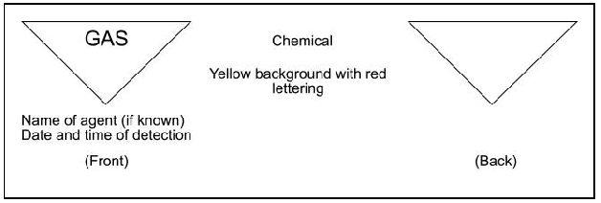

Biological 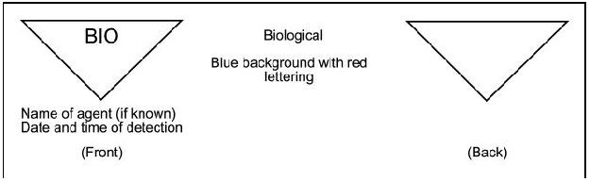

Radiological
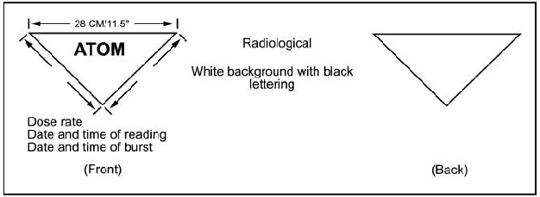

Chemical Minefield
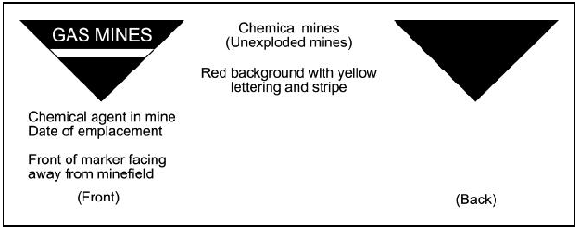

113.2 Discuss the purpose of the M-40 field protective mask. [ref. a, p. 1-20-5]

The M40 field protective mask is designed to protect the wearer from field concentrations of chemical and biological agents. The mask consists of a faceblank, a filter canister (which is used to cleanse contaminated air), dual voicemitter assemblies, inlet and outlet valves, and a water drinking system

113.3 Identify the following NBC alarms: [ref. a, pp. 1-20-19, 1-20-20]

Vocal - alarm for chemical/biological attack.is GAS-GAS-GAS. the word gas is repeated three times

Visual - The arms are extended straight out to the side and the hands made into a fist. As the word GAS is said, bend the arms at the elbows so the fists are placed to the ears, then repeat three times
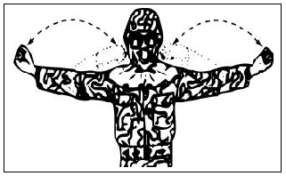
Percussion - Metal on metal. Metal triangles are used to give the NBC alarm by striking them repeatedly. Sirens, intermittent horns, biological/chemical alarm systems, or other devices as outlined by unit's standard operating procedures (SOP)

112.4 Discuss the proper way to don and clear a gas mask.
[ref. a, pp. 1-20-20 thru 1-20-24]

Upon receiving the command or detecting a contamination presence
- Stop breathing, close your mouth and eyes.
CAUTION: This does not mean take one last breath.
- Place the rifle between your legs.
- Remove the headgear and place it on the weapon.
NOTE: Make sure that you remove glasses if you are wearing them.
CAUTION: Do not wear contact lenses with any field protective mask. Wearing contact lenses with the optical inserts will over correct your vision.
- Remove the mask from its carrier
- Allow the hood to hang down in front of the mask.
- Put your chin into the chin pocket of the facepiece. The mask is stored with the head harness pulled over the front of the mask
- Clear the field protective mask by covering the outlet valve with the palm of one hand. Exhale sharply so the air escapes around the edges of the facepiece. Cover the air inlet port of the canister with the palm of your free hand, and then breathe in. The facepiece should collapse against your face and remain there while holding your breath
If Then
Facepiece collapses Consider it airtight.
Facepiece does not collapse Check for hair, clothing, or other interference
between the facepiece and your face. Repeat
steps to clear the mask until there is an airtight
seal
- Adjust the M40 mask.
Grasp the tab, then pull the head harness over your head. Make sure the square harness patch is centered comfortably in the rear of your head.
CAUTION: Make sure that unit NBC personnel properly fit your mask. The temple and forehead straps are adjusted during fitting.
Maintain the seal while holding the facepiece to your face with one hand.
Use your free hand to tighten the cheek straps one at a time
Make sure that straps lie flat against your head.
- Should a leak or an improper seal be suspected,
Clear the field protective mask as outlined in performance step 2.f.
Recheck facepiece for leaks.
WARNING: Check the mask for leaks each time you put it on. Air should circulate over the eyelenses inside the mask. If air flows in from around the edges of the mask, you may have a leak.
Run your finger around the edges of the mask to check for bulging material.
When time permits, have another Marine check the facepiece.
- Resume breathing normally.
CAUTION: The mask must be donned, cleared, and sealed within 9 seconds. An additional 6 seconds is given to put the hood in place

113.5 Explain Mission Oriented Protective Posture (MOPP) levels. [ref. a, p. 1-20-27]

The need to balance protection with the threat, temperature, and urgency of the mission led to the concept of MOPP.
- Commanders can raise or lower the amount of protection through six levels of MOPP—MOPP Ready through MOPP 4.
- In addition, commanders have a mask-only option.
- Protection increases with progression from MOPP Ready through MOPP 4, but efficiency decreases correspondingly.
- The elements of MOPP gear that take the longest to put on and that degrade mission performance the least are put on first.
- The MOPP gear elements that can be put on quickly and degrade performance of individual tasks the most are put on last.
- MOPP Ready is when a Marine carries his or her protective mask. MOPP level 0 is the condition that exists when a Marine has all of his or her MOPP gear available but is not wearing it.

113.6 Explain the uses of M9 and M8 paper. [ref. a, pp. 1-20-39, 1-20-40]

When identifying chemical agents, use the most expedient method. Using M8 or M9 detectors will take only seconds, whereas using the M256A1 will take approximately 15 minutes. Disadvantages of M8 and M9 over the M256A1 are their inability to test for vapor hazards and the limited number of agents detected.
M9 detector paper.
- M9 detector tape is usually issued 1 roll per squad or gun team and is worn around the ankles, wrists, and biceps on the exterior of protective clothing. Its purpose is to detect the presence of chemical agents, but will not identify the agent.
- Open package of M9 tape.
-Unroll a small portion of detector tape.
-Blot, do not rub, the M9 tape on suspect liquid. Its use is primarily on barely visible droplets.
-observe for a color change.
- When in contact with contamination, the color will appear as a light pink to a reddish brown or violet tint
M8 detector paper.
- M8 paper is issued with your field protective mask and the M256A1 chemical agent detector kit as an SL-3 component. Its use is primarily on suspected liquid forms such as puddles, small drops, or barely visible droplets.
- Remove and open M8 paper from the M256A1 kit or mask carrier, tearing off and discarding the plastic bag
- Test the liquid. Tear out a sheet of M8 paper (use half a sheet if it is perforated). Expose M8 paper to suspected liquid agent.
CAUTION: Make sure the M8 paper is held in the down position to prevent liquid contaminants from running onto protective glove
Blot—do not rub the M8 on suspected contamination. Compare any color changes by observing the colors shown on the inside cover of the book of M8 paper.

The chart below identifies the color associated with the agent when using the M8 paper.

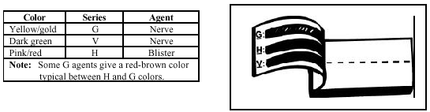
NOTES: Where decontaminants have been used, positive results must be confirmed by tests with the sampler-detector. Some decontaminants will produce false positive test on M8 paper.
Check the decontaminant itself with a sampler-detector because some decontaminants will produce false indications on the sampler- detector. Never assume that an area is uncontaminated. When in doubt, re-test the area with an M256A1 kit and report the findings

113.7 Identify the equipment available, carried, and worn for the following MOPP levels: [ref. a, p. 1-20-27]

MOPP level zero is the condition that exists when a Marine has all of his or her MOPP gear available but is not wearing it.
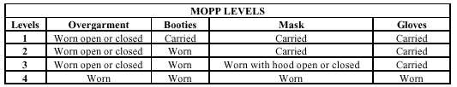

113.8 Discuss the three levels of decontamination. [ref. b, pp. 3-34, 3-35]

Immediate Decon minimizes casualties, saves lives, and limits the spread of contamination. Immediate decon is carried out by individuals upon becoming contaminated. There are three immediate techniques: skin decon, personnel wipe down, and operator’s spray down.

Operational Decon sustains operations, reduces the contact hazard, and limits the spread of contamination to eliminate the necessity or reduce the duration of wearing MOPP gear. Operational decon is carried by individual and/or units. It is restricted to specific parts of operationally essential equipment/material and/or working areas, in order to minimize contact and transfer hazards and to sustain operations. Further decon may be required to reduce contamination to negligible risk levels. There are two operational decon techniques: vehicle wash down and MOPP gear exchange
Thorough Decon reduces or eliminates the need for individual protective clothing. Thorough decon is carried out by units with assistance from chemical units to reduce contamination on personnel, equipment/material, and/or working areas to the lowest possible level (negligible risk) to permit the reduction or removal of individual protective equipment and maintain operations with minimal degradation. This may include decontamination of terrain as required. There are three thorough decon techniques: detailed troop decon, detailed equipment decon, and detailed aircraft decon.

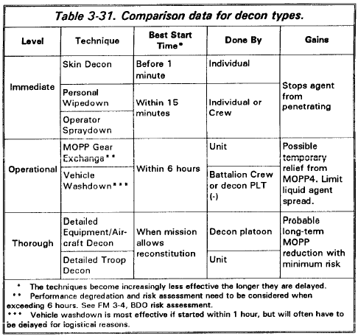

113.9 Discuss the immediate actions required for a nuclear attack without warning.
[ref. a, pp. 1-20-63 thru 1-20-65]

Take immediate action for a nuclear attack without warning - Upon seeing a brilliant flash of light, an exceptionally loud explosion, or when the alarm is sounded, immediate action must be taken. When possible, look for protective cover. WARNING: Never hesitate in taking immediate action.
React without weapon - Immediately drop face down, with head toward blast, if possible. If cover is available, use it. A log, large rock, or any depression in the earth’s surface provides some protection. Close your eyes. Protect or cover exposed skin by putting hands and arms under or near the body and keeping your helmet on. Keep your head down
React with weapon - Immediately drop face down, with head toward blast, if possible. If cover is available, use it. A log, large rock, or any depression in the earth’s surface provides some protection. Close your eyes. Protect or cover exposed skin by putting hands and arms under or near the body and keeping your helmet on. Make sure your weapon is placed under your body or beside you with the strap/sling wrapped tightly around your arm and the muzzle angled away from your face. Keep your head down. Remain face down for 90 seconds or until all debris has stopped falling. Use any protection available such as fighting holes, whenever possible. Fighting holes provide excellent protection against nuclear weapon effects. Other examples of hasty protection may include ditches, culverts, hills, large rocks, or armored vehicles. Put anything between yourself and the nuclear weapon's blast.

113.10 Discuss the immediate actions required for a chemical or biological attack without warning. [ref. a, pp. 1-20-67 thru 1-20-71]

React to a gas attack in 15 seconds or less.
- Stop breathing, close your mouth and eyes.
CAUTION: This does not mean take one last breath.
- Place the rifle between your legs.
- Remove the headgear and place it on the weapon.
NOTE: Make sure that you remove glasses if you are wearing them.
CAUTION: Do not wear contact lenses with any field protective mask. Wearing contact lenses with the optical inserts will over correct your vision.
- Remove the mask from its carrier
- Allow the hood to hang down in front of the mask.
- Put your chin into the chin pocket of the facepiece. The mask is stored with the head harness pulled over the front of the mask
- Clear the field protective mask by covering the outlet valve with the palm of one hand. Exhale sharply so the air escapes around the edges of the facepiece. Cover the air inlet port of the canister with the palm of your free hand, and then breathe in. The facepiece should collapse against your face and remain there while holding your breath
If Then
Facepiece collapses Consider it airtight.
Facepiece does not collapse Check for hair, clothing, or other interference
between the facepiece and your face. Repeat
steps to clear the mask until there is an airtight
seal
- Adjust the M40 mask.
Grasp the tab, then pull the head harness over your head. Make sure the square harness patch is centered comfortably in the rear of your head.
CAUTION: Make sure that unit NBC personnel properly fit your mask. The temple and forehead straps are adjusted during fitting.
Maintain the seal while holding the facepiece to your face with one hand.
Use your free hand to tighten the cheek straps one at a time
Make sure that straps lie flat against your head.
- Should a leak or an improper seal be suspected,
Clear the field protective mask as outlined in performance step 2.f.
Recheck facepiece for leaks.
WARNING: Check the mask for leaks each time you put it on. Air should circulate over the eye lenses inside the mask. If air flows in from around the edges of the mask, you may have a leak.
Run your finger around the edges of the mask to check for bulging material.
When time permits, have another Marine check the facepiece.
- Resume breathing normally.
CAUTION: The mask must be donned, cleared, and sealed within 9 seconds. An additional 6 seconds is given to put the hood in place
- Sound the alarm to warn others.
- Give vocal alarm for a chemical/biological attack.
The universal command to put the mask on is GAS-GAS-GAS.
The word gas is repeated three times.
-Give visual alarm for a chemical/biological attack as shown in figure 6.
The arms are extended straight out to the side and hands made into a fist.
As the word GAS is said bend the arms at the elbows so that the fists are placed to the ears, and repeat three times.
- Secure weapon, helmet, and mask carrier.
- Check for contamination and decontaminate as necessary using the buddy system if possible.
- Assume appropriate MOPP level as directed.
- Continue the mission.

113.11 Define and discuss the types, symptoms, and treatment for the following chemical agents: [ref. c, pp. 8-5 thru 8-10]

Nerve agents produce their effect by interfering with normal transmission of nerve impulses in the parasympathetic autonomic nervous system. Physically, nerve agents are odorless, almost colorless liquids, varying greatly in viscosity and volatility. They are moderately soluble in water and fairly stable unless strong alkali or chlorinating compounds are added. They are very effective solvents, readily penetrating cloth either as a liquid or vapor. Other materials, including leather and wood, are fairly well penetrated. Butyl rubber and synthetics, such as polyesters, are much more resistant. Pharmacologically, the nerve agents are cholinesterase inhibitors (interfering with normal transmission of nerve impulses in the parasympathetic autonomic nervous system). Their reaction with cholinesterase tends to be irreversible, and reactiontime varies with the agent..
SIGNS AND SYMPTOMS OF EXPOSURE. - Nerve-agent intoxication can be readily identified by its characteristic signs and symptoms. If a vapor exposure has occurred, the pupils will constrict, usually to a pinpoint. If the exposure has been through the skin, there will be local muscular twitching where the agent was absorbed. Other symptoms will include rhinorrhea, dyspnea, diarrhea and vomiting, convulsions, hypersalivation, drowsiness, coma, and unconsciousness.

TREATMENT. - Specific therapy for nerve agent casualties is atropine, an acetylcholine blocker. When exposed, each member of the Navy and Marine
Corps is issued three 2 mg autoinjectors of atropine and three 600 mg autoinjectors of 2-PAM Cl. DO NOT give nerve agent antidotes for preventive purposes before contemplated exposure to a nerve agent.
The atropine autoinjector consists of a hard plastic tube containing 2 mg (0.7 ml) of atropine in solution for intramuscular injection. It has a pressure-activated
coiled-spring mechanism that triggers the needle for injection of the antidote solution. These injectors are designed to be used by individuals on themselves when symptoms appear. For medical personnel, the required therapy is to continue to administer atropine at 15-minute intervals until a mild atropinization occurs. This can be noted by tachycardia and a dry mouth. Atropine alone will not relieve any respiratory muscle failure. Prolonged artificial respiration may benecessary to sustain life. A second autoinjector containing oxime therapy (using pralidoxime chloride, or 2-PAMCl) can also be used for regeneration of the blocked cholinesterase. Since 2-PAMCl is contained in the kit of autoinjectors, additional oxime therapy is not generally medically recommended for those who have already receivedtreatment by autoinjection. The 2-PAM Cl autoinjector is a hard plastic tube that, when activated, dispenses 600 mg of 2-PAM Cl (300 mg/ml) solution. It also has a pressure-activated coiled-spring mechanism identical to that in the atropine autoinjector

Self-Aid.ŠIf you experience the mild symptoms of nerve-agent poisoning, you should IMMEDIATELY hold your breath and put on your protective mask. Then, administer one set of (atropine and 2-PAM Cl) injections into your lateral thigh
muscle or buttocks, as illustrated in figures 8-4 and 8-5. Position the needle end of the atropine injector against the injection site and apply firm, even pressure
(not jabbing motion) to the injector until it pushes the needle into your thigh (or buttocks). Make sure you do not hit any buttons or other objects. Using a jabbing motion may result in an improper injection or injury to the thigh or buttocks.
Hold the atropine injector firmly in place for at least 10 seconds. The seconds can be estimated by counting ioone thousand one, one thousand two,la and so forth. Firm pressure automatically triggers the coiled mechanism and plunges the needle through the clothing into the muscle and at the same time injects the atropine antidote into the muscle tissue. Next, inject yourself in the same manner with the 2-PAM Cl injector, using the same procedure as you did for the atropine. This will now complete one set of nerve-agent antidotes. Attach the used injectors to your clothing (fig. 8-6) (to indicate the number of injections you have already received After administering the first set of injections, wait 10 to 15 minutes (since it takes that long for the antidote to take effect) before administering a second set, if needed. If the symptoms have not disappeared within 10 to 15 minutes, give yourself the second set of injections. If the symptoms still persist after an additional 15 minutes, a third set of injections may be given by nonmedical personnel.After administering each set of injections, you should decontaminate your skin, if necessary, and put on any remaining protective clothing.
Buddy Aid.ŠIf you encounter a service member suffering from severe signs of nerve-agent poisoning, you should provide the following aid:
· Mark the casualty, if necessary. Do not fasten the hood.
· Administer, in rapid succession, three sets of the nerve-agent antidotes. Follow the procedures for administration as described previously in the self-aid section.
NOTE: Use the casualty’s own autoinjectors when providing aid. Do not
use your injectors on a casualty. If you do, you may not have any antidote available when needed for self-aid.
Blister agents, or vesicants, exert their primary action on the skin, producing large and painful blisters that are incapacitating. Although vesicants are classed as nonlethal, high doses can cause death. Common blister agents include mustard (HD), nitrogen mustard (HN), and Lewisite (L). Each is chemically different and will cause significant specific symptoms. They are all similar in their physical characteristics and toxicology. Mustards are particularly insidious because they do not manifest their symptoms for several hours after exposure. They attack the eyes and respiratory tract as well as the skin There is no effective therapy for mustard once its effects become visible. Treatment is largely supportive: to relieve itching and pain, and to prevent infection.
MUSTARD (HN) - HD and HN are oily, colorless or pale yellow liquids, sparingly soluble in water. HN is less volatile and more persistent than HD but has the same blistering qualities.
Signs and Symptoms of Exposure. -The eyes are the most vulnerable part of the body to mustard gas. Contamination insufficient to cause injury elsewhere may produce eye inflammation. Because the eye is the most sensitive part of the body, the first noticeable symptoms of mustard exposure will be pain and a gritting feeling in the eyes, accompanied by spastic blinking of the eyelids and photophobia. Vapor or liquid may burn any area of the skin, but the burns willbe most severe in the warm, sweaty areas of the body: the armpits, groin, and on the face and neck. Blistering begins in about 12 hours but may be delayed for up to 48 hours. Inhalation of the gas is followed in a few hours by irritation of the throat, hoarseness, and a cough. Fever, moist rales, and dyspnea may develop. Brochopneumonia is a frequent complication. The primary cause of death is massive edema or mechanical pulmonary obstruction
Treatment. - There is no specific antidotal treatment for mustard poisoning. Physically removing as much of the mustard as possible, as soon as possible, is the only effective method for mitigating symptoms before they appear. All other treatment is symptomatic, that is, the relief of pain and itching, and control of infection.
LEWISITE (L). - Lewisite is an arsenical (an arsenic-based compound). This blistering compound is a light- to dark-brown liquid that vaporizes slowly.
Signs and Symptoms of Exposure. - The vapors of arsenicals are so irritating that conscious persons are immediately warned by discomfort to put on the mask. No severe respiratory injuries are likely to occur, except in the wounded who are incapable of donning a mask. The respiratory symptoms are similar to those produced by mustard gas. While distilled mustard and nitrogen mustard cause no pain on the skin during absorption, Lewisite causes intense pain upon contact.
Treatment. - Immediately decontaminate the eyes by flushing with copious amounts of water to remove liquid agents and to prevent severe burns. Sodium sulfacetamide, 30 percent solution, may be used to combat eye infection within the first 24 hours after exposure. In severe cases, morphine may be given to relieve pain. In cases of systemic involvement, British Anti-Lewisite (BAL), dimercaprol, is available in a peanut oil suspension for injection. BAL is a specific antiarsenical that combines with the heavy metal to form a water-soluble, nontoxic complex that is excreted. However, BAL is somewhat toxic, and an injection of more than 3 mg/kg will cause severe symptoms.Aside from the use of dimercaprol for the systemic effects of arsenic, treatment is the same as for mustard lesions.
Blood Agents interfere with enzyme functions in the body, i.e., block oxygen transfer. Hydrocyanic acid (AC) and cyanogen chloride (CK) are cyanide- containing compounds commonly referred to as blood agents. These blood agents are chemicals that are in a gaseous state at normal temperatures and pressures. They are systemic poisons and casualty-producing agents that interfere with vital enzyme systems of the body. They can cause death in a very short time after exposure by interfering with oxygen transfer in the blood. Although very deadly, they are nonpersistent agents.
SIGNS AND SYMPTOMS OF EXPOSURE.- These vary with concentration and duration of exposure. Typically, either death or recovery takes place rapidly. After exposure to high concentrations of the gas, there is a forceful increase in the depth of respiration for a few seconds, violent convulsions after 20 to 30 seconds, and respiratory failure with cessation of heart action within a few minutes.
TREATMENT. - There are two suggested antidotes in the treatment of cyanides: amyl nitrite in crush ampules (provided as first aid) and intravenous sodium thiosulfate solution. In an attack, if you notice sudden stimulation of breathing or an almond-like odor, hold your breath and don your mask immediately. In treating a victim, upon notification by competent authority that there are no blood agents remaining in the atmosphere, crush two ampules of amyl nitrite in the hollow of your hand and hold it close to the victim's nose. You may repeat this procedure every few minutes until eight ampules have been used. If the atmosphere is contaminated and the victim must remain masked, insert the crushed ampules into the mask under the face plate. Whether amyl nitrite is used or not, sodium thiosulfate therapy is required after the initial lifesaving measures. The required dose is 100 to 200 mg/kg, given intravenously over a 9-minute period. The key to successful cyanide therapy is speed; cyanide acts rapidly on an essential enzyme system. The antidotes act rapidly to reverse this action. If the specific antidote and artificial respiration are given soon enough, the chance of survival is greatly enhanced

Choking The toxicity of lung agents is due to their effect on lung tissues; they cause extensive damage to alveolar tissue, resulting in severe pulmonary edema. This group includes phosgene (CG) and chlorine (Cl), as well as chloropicrin and diphosgene. However, CG is most likely to be encountered, and its toxic action is representative of the group. Phosgene is a colorless gas with a distinctive odor similar to that of new-mown hay or freshly cut grass. Unfortunately, even at minimal concentrations in the air (i.e., below the threshold of olfactory perception), CGcan cause damage to the eyes and throat. Generally speaking, CG does not represent a hazard of long duration; therefore, an individual exposed to a casualty-producing amount should be able to smell it.
SIGNS AND SYMPTOMS OF EXPOSURE. - There may be watering of the eyes, coughing, and a feeling of tightness in the chest. More often, however, there will be no symptoms for 2 to 6 hours after exposure. Latent symptoms are rapid, shallow, and labored breathing; painful cough; cyanosis; frothy sputum; clammy skin; rapid, feeble pulse; and low blood pressure. Shock may develop, followed by death.
TREATMENT. - Once symptoms appear, complete bed rest is mandatory. Keep victims with lung edema only moderately warm, and treat the resulting anoxia with oxygen. Because no specific treatment for CG poisoning is known, treatment has to be symptomatic.
Incapacitating Agents- Incapacitating agents, which are mainly comprised of psychochemicals, produce mental confusion and an inability to function intelligently.
The psychochemicals temporarily prevent an individual from carrying out assigned actions. These agents may be administered by contaminating food or water, or they may be released as aerosols. The following are characteristics of the incapacitants:
- High potency (i.e., an extremely low dose is effective) and logistic feasibility
- Effects produced mainly by altering or disrupting the higher regulatory activity of the central nervous system
- Duration of action comprising hours or days, rather than momentary or transient action No permanent injury producede.

SIGNS AND SYMPTOMS OF EXPOSURE. - The first symptoms appear in 30 minutes to several hours and may persist for several days. Abnormal inappropriate behavior may be the only sign of intoxication. Those affected may make irrational statements and have delusions or hallucinations. In some instances, the victim may complain of dizziness, muscular incoordination, dry mouth, and difficulty in swallowing. The standard incapacitant in the United States is 3-quinuclidinyl benzilate (BZ), a cholinergic blocking agent, which is effective in producing delirium that may last several days. In small doses it will cause an increase in heart rate, pupil size, and skin temperature, as well as drowsiness, dry skin, and a decrease in alertness. As the dose is increased to higher levels, there is a progressive deterioration of mental capability, ending in stupor.
TREATMENT. - The first aid is to prevent victims from injuring themselves and others during the toxic psychosis. Generally, there is no specific therapy for this type intoxication. However, with BZ and other agents in the class of compounds known as glycolates, physostigmine is the drug treatment of choice. It is not effective during the first 4 hours following exposure; after that, it is very effective as long as treatment is continued. However, treatment does not shorten the duration of BZ intoxication, and premature discontinuation of therapy will result in relapse.

Riot control/harassing is the collective term used to describe a collection of chemical compounds, all having similar characteristics which, though relatively nontoxic, produce an immediate but temporary effect in very low concentrations. These agents are used to harass enemy personnel or to discourage riot actions. Generally, patients require no therapy; removal from the environment is sufficient to effect recovery in a short time.There are two classes of riot-control/harassment agents: lacrimators and vomiting agents
LACRIMATORS. - Lacrimators (or tear gases) are essentially local irritants that act primarily on the eyes. In high concentrations, they also irritate the respiratory tract and the skin. The principal agents used are chloracetophenone (CN) and orthochlorobenzilidine malanonitrile (CS). Although CS is basically a lacrimator, it is considerably more potent than CN and causes more severe respiratory symptoms. CN is the standard training agent and is the tear gas most commonly encountered because it is not as potent. CS is more widely used by the military as a riot-control agent. Protection against all tear agents is provided by protective masks and ordinary field clothing secured at the neck, wrists, and ankles. Personnel handling CS should wear rubber gloves for additional protection
Signs and Symptoms of Exposure. - Lacrimators produce intense pain in the eyes with excessive tearing. The symptoms following the most severe exposure to vapors seldom last over 2 hours. After moderate exposure, they last only a few minutes
Treatment. - First aid for lacrimators is generally not necessary. Exposure to fresh air and letting wind blow into wide open eyes, held open if necessary, is sufficient for recovery in a short time. Any chest discomfort after CS exposure can be relieved by talking. An important point to remember is that this material adheres tenaciously to clothing, and a change of clothing may be necessary. Do not forget the hair (both head and facial) as a potential source of recontamination.
VOMITING AGENTS. -Vomiting agents comprise the second class of agents in the riot-control category. The principal agents of this group are diphenylaminochloroarsine (Adamsite (DM)), diphenylchloroarsine (DA), and diphenylcyanoarsine (DC). They are used as training and riot-control agents. They are dispersed as aerosols and produce their effects by inhalation or by direct action on the eyes. All of these agents have similar properties and pathology.
Signs and Symptoms of Exposure. – Vomiting agents produce a strong pepper-like irritation in the upper respiratory tract, with irritation of the eyes and lacrimation. They cause violent uncontrollable sneezing, coughing, nausea, vomiting, and a general feeling of malaise. Inhalation causes a burning sensation in the nose and throat, hypersalivation, and rhinorrhea. The sinuses fill rapidly and cause a violent frontal headache
Treatment. - It is of the utmost importance that the mask be worn in spite of coughing, sneezing, salivation, and nausea. If the mask is put on following exposure, symptoms will increase for several minutes in spite of adequate protection. As a consequence, victims may believe the mask is ineffective and remove it, further exposing themselves. While the mask must be worn, it may be lifted from the face briefly, if necessary, to permit vomiting or to drain saliva from the face piece. Carry on duties as vigorously as possible. This will help to lessen and shorten the symptoms. Combat duties usually can be performed in spite of the effects of vomiting agents if an individual is motivated. First aid consists of washing the skin and rinsing the eyes and mouth with water. Amild analgesic may be given to relieve headache. Recovery is usually spontaneous and complete within 1 to 3 hours.
SCREENINGSMOKES. - Screening smokes fit in with riot-control agents. Their primary use is to obscure vision and to hide targets or areas. When used for this purpose outdoors, they are not generally considered toxic. However, exposure to heavy smoke concentration for extended periods, particularly near the source, may cause illness or death. Under no circumstances should smoke munitions be activated indoors or in closed compartments. Symptomatic treatment of medical problems or discomfort resulting from exposure to screening smokes will generally suffice
WHITE PHOSPHORUS. - White phosphorus (WP) is a pale, waxy solid that ignites spontaneously on contact with air to give a hot, dense, white smoke composed of phosphorus pentoxide particles. While field concentrations of the smoke may cause temporary irritation to the eyes, nose, and throat, casualties from the smoke have not occurred in combat operations. No treatment is necessary, and spontaneous recovery is rapid once the patient is removed from the WP source. White phosphorus smoke not only creates an obscuring smoke, but it also has a secondary effect upon personnel if it contacts the skin. When burning particles of WP embed in the skin, they must be covered with water, a wet cloth, or mud. A freshly mixed 0.5 percent solution of copper sulfate (which produces an airproof black coating of copper phosphide) may be used as a rinse but must not be used as a dressing. The phosphorus particles must be removed surgically.

