115 Land Navigation Fundamentals

References:

[a] USMC, Marine Corps University Sergeants’ Course 1201

115.1 Explain the following components of a map: [pp. 1201H-2, 1201H-3]

Sheet Name - A map is named after the most prominent cultural or geographical feature. Whenever possible, the name of the largest city on the map is used. The sheet name is found in two places: the center of the upper margin and either the right or left side of the lower margin.

Sheet Number - The sheet number is used as a reference number for that map sheet. It is found in two places: the upper right margin and the lower left margin.

Scale - The scale note is a representative fraction that gives you the ratio of a distance on the map to the corresponding distance on the earth's surface. For example, the scale note 1:50,000 on many maps indicates that one inch on the map equals 50,000 inches on the ground. Maps with different scales will display different degrees of topographical detail. For example, a map with a scale of 1:25,000 will give more detail than a 1:50,000 map because one inch on the map represents only 25,000 inches on the ground, rather than the 50,000 inches of the 1:50,000 map. The scale is found both in the upper left margin after the series name and in the center of the lower margin.

Elevation Guide - The elevation guide is a miniature characterization of the terrain shown. The terrain is shown by bands of elevation, spot elevations, and major drainage features. The elevation guide helps you rapidly identify major land forms. It is normally found in the lower right margin

Declination Diagram - This indicates the angular relationships of true north, grid north, and magnetic north. Recent edition maps have a note indicating how to convert azimuths from grid to magnetic and from magnetic to grid next to the declination diagram. The declination diagram is located in the lower margin.

Bar Scales - Bar scales are used to convert map distance to ground distance. Maps may have three or more bar scales, each in a different unit of measure. Exercise care when using the scales, especially in the selection of the unit of measure. The bar scales are located in the center of the lower margin.

Legend - The legend illustrates and identifies the topographic symbols used to depict some of the more prominent features on the map, such as railroad tracks, buildings, and swamps. The symbols are not always the same on every map. Always refer to the legend to avoid error when reading a map. The legend is located in the lower left margin

115 .2 Explain the following as they apply to map reading: [p. 1201H-3]

Grid Lines - Grid lines are a series of straight lines intersected at right angles and forming a series of squares. It furnishes the map reader with a system of squares similar to the block system of most city streets. Two digits are printed in large type at each end of the grid lines, and these same two digits appear at intervals along the grid lines on the face of the map. They are called principal digits. They are of major importance to the map reader because they are the numbers he will use most often for referencing points.

Grid Squares - These intersect at right angles of the horizontal and vertical grid lines. The most common military map contains grid squares that measure 1000 meters by 1000 meters (not 1000 square meters as many people think). Any point located within the grid square is considered to be part of the grid square.

Basic Map Reading Rule - The designation of a point is based on the principle: Read right then up. Always read right on the vertical grid lines then up on the horizontal grid lines.

Grid Square Identification - It is important that all of you understand how to apply the map reading rule to identify a grid square and locate a point within a grid square.

115 .3 The following grid coordinates will locate a point on a map within how many meters: [pp. 1201H-3, 1201H-4]

A four digit grid coordinate locates a point to within 1000 square meters, on the map, which is called a grid square.

A six digit grid coordinate will locate a point on a map within 100 meters.

An eight digit grid coordinate will locate a point on a map within 10 meters

115 .4 Explain the difference between true north, magnetic north, and grid north.
[p. 1201H-20]

True North. The true north line is a line from any point on the earth's surface to the North Pole. True north can be found at night by locating the North Star, which always points towards true north. True north is usually represented on the declination diagram by a line ending with a star. True north is used almost exclusively when navigating without a compass.

Magnetic North. The earth has a magnetic field that is close to (but not exactly on) the North Pole. The direction to this north magnetic pole is indicated by the north-seeking arrow of your lensatic compass. Magnetic north is usually symbolized on the declination diagram by a line ending with a half arrowhead. Anytime you use the compass to plan or follow an azimuth in the field, you must work with azimuths measured from magnetic north.

Grid North. This base line is established by using the vertical grid lines on the map. Grid north may be symbolized on the declination diagram by the letters GN. Anytime you use a protractor in conjunction with a vertical grid line to determine or plot an azimuth on a map, you must work with an azimuth measured from grid north.

115.5 Identify the following type of terrain features found on a map:
[pp. 1201H-9 thru 1201H-14]

Hill - A hill is an area of high ground. From a hilltop, the ground slopes down in all directions. A hill is shown on a map by contour lines forming concentric circles. The inside of the smallest closed circle is the hilltop.
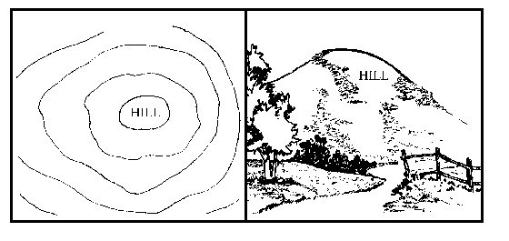

Ridge - A ridge is a series of hills that are connected to each other near the top. A ridge line may extend for many miles. It may be winding or quite straight. It may have a reasonably uniform elevation along its top or it may vary greatly in elevation
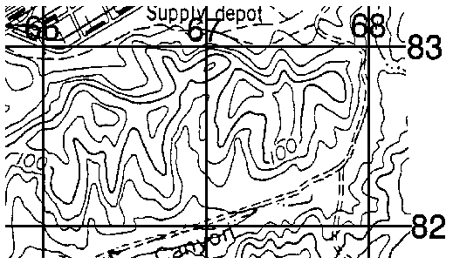

Saddle - This is a dip or low point between two areas of higher ground. A saddle is not necessarily the lower ground between two hilltops; it may be simply a dip or break along a level ridge crest. If you are in a saddle, there is high ground in two opposite directions and low ground in the other two directions. A saddle is normally represented as an hourglass or by figure-eight shaped contour lines.
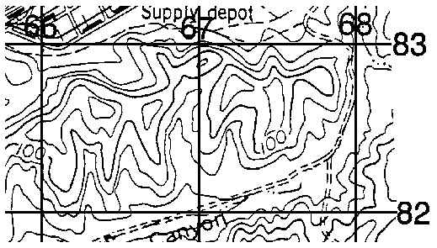

Finger/Spur - A finger is a short, continuous sloping line of higher ground, normally jutting out from the side of a ridge or hill. A finger is often formed by two roughly parallel draws. The ground slopes down in three directions and up in one. Contour lines on a map depict a finger with the U or V pointing away from high ground.
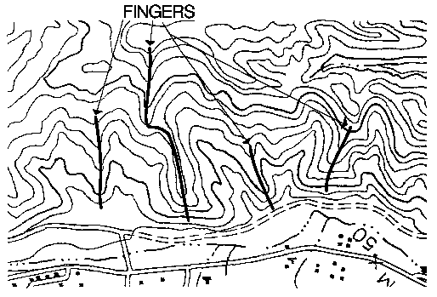

Draw - . A draw is a short, continuous sloping line of low ground, normally cut into the side of a ridge or hill. Often, there is a small stream running down the draw. In a draw, there is essentially no level ground. Therefore, little or no maneuver room exists within its confines. If you are standing in the middle of a draw, the ground slopes upward in three directions and downward in the other direction. Contour lines (see figure 1201-12) on a map depict a draw with the U or V pointing toward high ground.
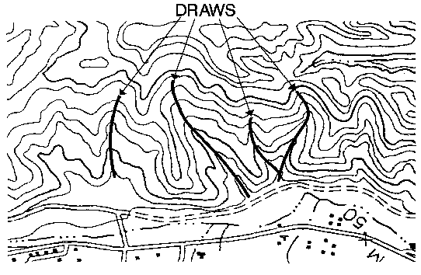

Depression - This is a low point in the ground or a sinkhole. It is an area of low ground surrounded by higher ground in all directions, or simply a hole in the ground. Usually only depressions that are equal to or greater than the contour interval will be shown. On maps, depressions are represented by closed contour lines that have tick marks pointing toward low ground
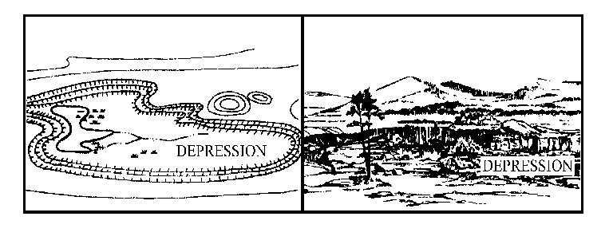

115 .6 Identify and explain the following as they relate to the lensatic compass:
[pp. 1201H-23, 1201H-24]

Cover - This protects the floating dial and the glass encasement. It contains the sighting wire and two luminous sighting dots for night navigation.

Base -
Floating Dial. This is mounted on a pivot so that it rotates freely when the compass is held level. It contains the magnetic needle. A luminous arrow and the letters "E" and "W" are printed on the dial. The arrow points to magnetic north. Letters fall at the east (E) 90 degrees and (W) 270 degrees. There are two scales: outer - denotes MILS (black); inner - denotes DEGREES (red).
NOTE: Mil, is another unit of measure. The mil (abbreviated m) is mainly used in artillery, tank, and mortar gunnery. The mil expresses the size of an angle formed when a circle is divided into 6,400 angles with the vertex of the angles at the center of the circle. A relationship can be established between degrees and mils. A circle equals 6400 mil divided by 360 degrees, or 17.78 mils. To convert degrees to mils, multiply degrees by 17.78.
Glass Encasement. This houses the floating dial and contains a fixed black index line.
Bezel Ring. This device that clicks when turned. It contains 120 clicks when rotated fully. Each click equals 3 degrees. A short luminous line is used in conjunction with the north-seeking arrow during night navigation.
Thumb Loop. This is attached to the base.

Rear Sight - This is used to lock the floating dial. The rear sight must be opened more than 45 degrees to allow the floating dial to float freely.
Lens. This is used to read the floating dial.
Rear Sight Slot: This is used in conjunction with the front sighting wire when aiming at objects.

115 .7 Explain how to convert a magnetic azimuth to a grid azimuth.
[pp. 1201H-26, 1201H-27]

Azimuths measured with a protractor are grid azimuths (measured from grid north), and azimuths determined with the compass are magnetic azimuths (measured from magnetic north). You cannot follow a grid azimuth with a compass, nor can you plot a magnetic azimuth with a protractor because of the angular difference between grid north and magnetic north. This angular difference (between grid north and magnetic north) is called the G-M ANGLE (Grid-Magnetic angle). The G-M angle varies for each map. Because of this angular difference (the G-M angle), before you can plot a magnetic azimuth on a map, you must convert it to a grid azimuth. Likewise, before you can use a grid azimuth to navigate, you must convert it to a magnetic azimuth. Declination diagrams display the difference between grid and magnetic north. A complete set of instructions is included in MOST declination diagrams for your use in converting azimuths. The G-M angle often is not expressed as a whole degree, such as 1/2 degrees or 7 degrees 15'. Since you will not need to work with such precise numbers as minutes, round the G-M angle off to the nearest whole degree. If the G-M angle is 1/2o or 30' then round the angle up to the next highest whole degree.
Conversion Notes. Refer to the conversion notes that appear with the declination diagrams explaining the use of the G-M angle. One note provides instructions for converting a magnetic azimuth to a grid azimuth. The other provides instructions for converting a grid azimuth to a magnetic azimuth. The conversion (addition or subtraction) is governed by the direction of magnetic north relative to grid north.
TO CONVERT A MAGNETIC AZIMUTH TO A GRID AZIMUTH ADD G-M ANGLE

115 .8 Discuss the technique used to orient a map using the following methods:
[pp. 1201H-32, 1201H-33]

Compass - When orienting a map with a compass, remember that compasses measure magnetic azimuths. Since the north-seeking arrow of the compass points to magnetic north, pay special attention to the declination diagram. Use the following technique to orient your map.
- With the map flat on the ground, place the straightedge (on the left side of the compass) along the magnetic north arrow on the declination diagram so that the cover of the compass is pointing toward the top of the map. This will put the fixed black index line of the compass parallel to the magnetic north arrow of the declination diagram
- Keeping the compass aligned as directed above, rotate the map and compass simultaneously until the north-seeking arrow is below the fixed black index line on the compass. Your map is now oriented.

Terrain Association - You can orient your map using terrain association when a compass is not available or when you have to make quick references as you move across country. Using this technique requires careful examination of the map and the features on the ground.
- Identify prominent terrain features on the map that you can find on the ground.
- Align terrain features with the map. If there is a tower to your right front, then orient the map so that the tower is to your right front. If there is a road off to your left, then ensure the road on the map is parallel to the road on the ground. Once all of the features are lined up, your map is oriented

115 .9 Discuss the technique for determining your position using the following methods: [pp. 1201H-33, 1201H-34]

Location by inspection - You are standing in the vicinity of several prominent features which can easily be located on the map. By orienting the map and estimating your relation to these features, you should have no difficulty in determining your location.

Location by One -Point – Resection - One-point resection is an accurate technique of determining your location when you are on or near a linear feature that you can identify both on the ground and on the map. You must also be able to identify another prominent feature, both on ground and on the map. To determine your location by one-point resection follow these steps
- Identify the linear terrain feature that you are located on or near in respect to the ground on your map.
- Identify a prominent feature on the ground and locate that feature on your map.
- Using the compass-to-cheek technique, sight in on the feature and read the magnetic azimuth
d) - Convert the magnetic azimuth to a grid azimuth.
- Convert this grid azimuth to a grid back azimuth.
- With your protractor, plot this grid back azimuth from the feature on the map and extend it until it crosses the linear feature.
- Conduct a map inspection to verify your resection.
- When selecting a terrain feature, choose one that is perpendicular to the axis of the linear terrain feature so that when you plot the back azimuth on the map, the line will cross the linear feature more or less at a right angle.

Location by Two -Point – Resection - Usually you will find that you are not located on or near a prominent linear feature. Since the accuracy of a one-point resection under these conditions depends on your ability to accurately estimate distance, it is better to use a two-point resection. The procedures for two-point resections are basically the same as for one-point resections except you must select two features instead of one. The back azimuths from each feature is determined and plotted on your map. You are located at the point where these lines cross. If you have a compass and a protractor then follow these steps.
- Select two prominent features on the ground whose positions can be located on the map. These features should be at least 30º but not greater that 150º apart.
- Using the compass-to-cheek technique, determine the magnetic azimuth to each object.
- Convert these magnetic azimuths to grid back azimuths.
- With your protractor, draw the respective back azimuths from these two points on your map.
- Extend the azimuth lines from these two points until they intersect. You are located at the point where these two lines cross.
- Conduct a map inspection to verify your position

