117 Ground Combat Element (GCE), Marine Artillery Fundamentals

References:

[a] MCRP 5-12D, Organization of Marine Corps Forces (PCN 14400005000)
[b] USMC Fact Files (http://www.hqmc.usmc.mil/factfile.nsf/AVE?openview&count=3000)

117.1 Discuss the mission and organization of an artillery regiment. [ref. a, p. 4-9]

The mission of artillery in the Marine division is to furnish close and continuous fire support by neutralizing, destroying, or suppressing targets that threaten the success of the supported unit. All artillery regiments have a headquarters battery. There are four artillery battalions in the 10th and 11th Marine Regiments and two in the 12th Marine Regiment. Each of these battalions is capable of performing the responsibilities associated with any of the four standard artillery tactical missions. Artillery regimental functions are discharged through a command group, which consists of the commander and executive staff, augmented by sufficient technical personnel. The staff is capable of integrating the efforts of any attached, reinforcing, or supporting units. The staff is capable of supporting a tactical, main, and rear command echelon during displacements and, when augmented, can operate as an alternate division COC for short periods of time. The basic means of ground mobility is organic vehicular transportation. All CEs and some fire support assets are helicopter transportable. With the M198 weapons system, helicopter borne mobility is severely limited

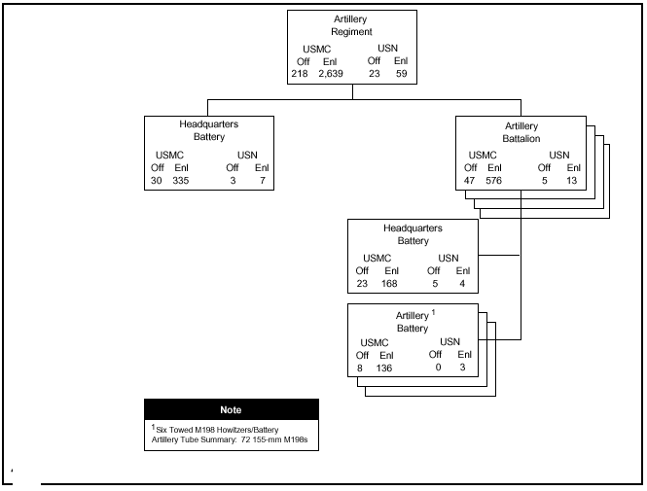
117.2 Discuss the mission and organization of an artillery battalion. [ref. a, pp. 4-10, 4-11]

The mission of the artillery battalion in the Marine division is to furnish close and continuous fire support by neutralizing, destroying, or suppressing targets that threaten the success of the supported unit. An artillery battalion consists of a headquarters battery and firing batteries. The headquarters battery provides the equipment and personnel to assist the battalion commander in controlling and supporting his battalion. Like the regiment, the battalion headquarters may be employed in a main or rear echelon configuration. Artillery battalions have three or four firing batteries of six howitzers. Marine artillery currently employs the M198, 155mm towed howitzer

117.3 Discuss the primary function of the M198 howitzer. [ref. b]

Provides field artillery fire support for all Marine Corps Air Ground Task Force organizations.

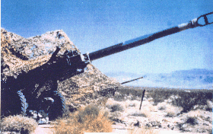

117.4 Discuss the following characteristics of the M198 howitzer: [ref. b]

Bore diameter - 155mm
Rate of fire - Maximum: 4 rounds per minute
Sustained: 2 rounds per minute
Crew: - 9 enlisted

117.5 Discuss the maximum effective ranges for the following munitions: [ref. b]

Conventional ammunition - 22,400 meters (13.92 miles)
Rocket assisted projectiles- 30,000 meters (18.64 miles)

117.6 Discuss the features for the M198 howitzer. [ref. b]

- The M198 Medium Towed Howitzer is a 155mm field artillery howitzer.
- It is constructed of aluminum and steel, and is air transportable by CH-53E helicopter, and C-130 or larger fixed-wing aircraft.
- The M198 provides increased range, and improved reliability and maintainability over the former standard towed 155mm howitzer.
- The use of rocket-assisted projectiles significantly extends the range, lethality, and counter-battery fires of the direct support artillery battalions.
- The M198 fires all current and developmental 155mm ammunition.

