119 Ground Combat Element (GCE), Assault Amphibian Battalion Fundamentals

References:

[a] MCRP 5-12D, Organization of Marine Corps Forces (PCN 14400005000)
[b] USMC Fact Files (http://www.hqmc.usmc.mil/factfile.nsf/AVE?openview&count=3000)

119.1 Discuss the mission and organization of the Assault Amphibian Battalion.
[ref. a, pp. 4-13, 4-14]

The mission of the assault amphibian battalion is to land the surface assault elements of the landing force and their equipment in a single lift from assault shipping during amphibious operations to inland objectives and to conduct mechanized operations and related combat support in subsequent operations ashore. The battalion is organized with an H&S company and four assault amphibian companies. The organization of the assault amphibian company permits independent deployment for limited operations.

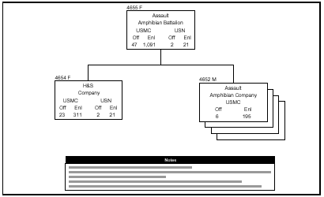

119 .2 Discuss the following for the Assault Amphibian Vehicle Personnel Model 7A1 (AAVP7A1): [ref. b]

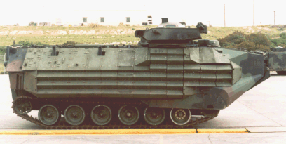

Primary mission - The AAVP7A1 is an armored assault amphibious full-tracked landing vehicle. The vehicle carries troops in water operations from ship to shore, through rough water and surf zone. It also carries troops to inland objectives after ashore.

Cruising ranges (land/water) - Land at 25 MPH: 300 Miles
Water at 2600 RPM: 7 Hours

Cruising speeds (land/water) - Land: 20 to 30 MPH
Water: 6 MPH

Maximum Speed Forward - Land: 45 MPH
Water: 8.2 MPH’

Maximum Speed Reverse - Land: 12 MPH
Water: 4.5 MPH

Crew - 3

Armaments - HBM2 Caliber.50 Machine Gun and MK 19 MOD3 40 MM Machine Gun

Troop Capacity - 21 Combat Equipped Troops (@ 285 Pounds

119 .3 Discuss the following for the Assault Amphibian Vehicle Command Model 7A1 (AAVC7A1): [ref. b]

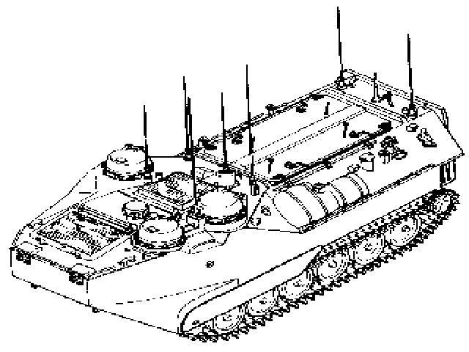

Primary mission - The AAVC7A1 is an assault amphibious full-tracked landing vehicle. The vehicle gives you a mobile task force communication center in water operations from ship to shore and to inland objectives after ashore.
Communication Center: The system consists of five radio operator stations, three staff stations, and two master stations. The command comm system contains equipment to provided external secure radio transmission between each the AAVC7A1 vehicle and other vehicles and radios. Internal communication between each crew station is provided

Cruising ranges (land/water) - Land at 25 MPH: 300 Miles
Water at 2600 RPM: 7 Hours

Cruising speeds (land/water) - Land: 20 to 30 MPH
Water: 6 MPH

Maximum Speed Forward - Land: 45 MPH
Water: 8.2 MPH

Maximum Speed Reverse- Land: 12 MPH
Water: 4.5 MPH

Crew - 3

Armaments - 7.62 Machine Gun

119.4 Discuss the following for the Assault Amphibian Vehicle Recovery Model 7A1 (AAVR7A1): [ref. b]

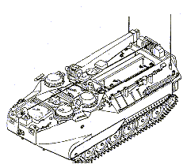

Primary mission - The AAVR7A1 is an armored assault amphibious full-tracked vehicle. The vehicle is designed to recover similar or smaller size vehicles. It also carries basic maintenance equipment to provide field support maintenance to vehicles in the field.

Cruising ranges (land/water) - Land at 25 MPH: 300 Miles
Water at 2600 RPM: 7 Hours

Cruising speeds (land/water) - Land: 20 to 30 MPH
Water: 6 MPH

Maximum Speed Forward - Land: 45 MPH
Water: 8.2 MPH

Maximum Speed Reverse- Land: 12 MPH
Water: 4.5 MPH

Crew - 5

Armaments - M60D Machine Gun

