120 Ground Combat Element (GCE), Combat Engineer Battalion Fundamentals

References:

[a] MCRP 5-12D, Organization of Marine Corps Forces (PCN 14400005000)

120.1 Discuss the mission and organization of a combat engineer battalion.
[pp. 4-14, 4-15]

The mission of the Combat Engineer Battalion is to enhance the mobility, counter-mobility, and survivability of the Marine division through close combat engineer support and to provide the limited general engineering support that is required for the functioning of the Marine division.

The Combat Engineer Battalion consists of an H&S company, an engineer support company, and four combat engineer companies. The H&S company consists of elements that provide the battalion commander with facilities for command and control functions and communications support for subordinate elements of the battalion. The engineer support company consists of a company headquarters, an engineer equipment platoon, a utilities platoon, and a motor transport platoon. Four combat engineer companies are included in the battalion organization to provide support to infantry regiments and other division units, as required. Each of the combat engineer companies consists of a company headquarters and three combat engineer platoons.

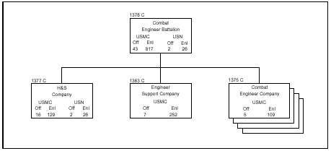

120.2 Discuss the six mobility tasks of a combat engineer battalion. [p. 4-15]

Conduct engineer reconnaissance and support intelligence collection within the division zone or sector. In areas not under division control, support will be required when conducting this reconnaissance. Provide personnel to augment other division elements conducting reconnaissance missions that include requirements for engineer intelligence.

Plan, organize, and coordinate the assault breaching of explosive and
nonexplosive obstacles from the high-water mark inland.

Employ assault bridge systems. When augmented, employ other standard bridge systems.

Provide expedient repair and reinforcement of existing bridges.

Construct expedient, short-span bridges from local materials in support of ground combat operations.

Provide temporary repair of existing roads and limited new construction of combat roads and trails, including the maintenance that is necessary to support combat operations of the division.

120.3 Discuss the three counter-mobility tasks of a combat engineer battalion. [p. 4-15]

Plan, organize, and coordinate the construction of simple and compound explosive and nonexplosive obstacle systems.

Plan and construct obstacles that require special engineering equipment and technical skills.

Perform specialized demolition missions that are beyond the capability of other division units

120.4 Discuss the survivability task of a combat engineer battalion. [p. 4-15]

The Combat Engineer Battalion should provide technical assistance and the necessary equipment for the development of temporary protective positions for personnel and equipment.

120.5 Discuss the three general engineering tasks of a combat engineer battalion.
[p. 4-15]

Provide essential construction support that is temporary and designed to meet minimum combat requirements.

Provide utility support, including mobile electric power equipment and potable water for essential troop consumption, bath services, and equipment operational and maintenance requirements.

Construct and improve expedient VTOL sites in support of division operations.
120.6 Discuss the mission and organization of the H & S Company, Combat Engineer Battalion. [pp. 4-16, 4-17]

The mission of the H&S company is to provide command, control, and administrative elements to supervise the operations of the battalion, including the provision of supply, food services, communications, chaplain services, administration, and medical support.

The H&S company consists of the battalion headquarters, which contains a headquarters section, an S-1/adjutant section, an S-2 section, an S-3 section, and an S-4 section; a supply platoon; a mess section; a communications platoon; a medical section; a chaplain section; and a company headquarters

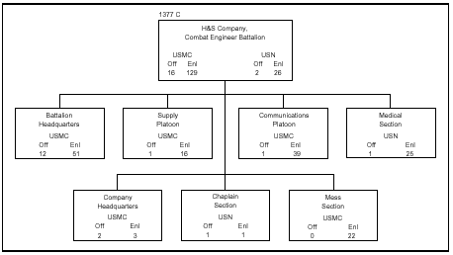

120.7 Discuss the mission and organization of the Engineer Support Company, Combat Engineer Battalion. [pp. 4-18, 4-19]

The mission of the engineer support company is to provide personnel, equipment, and appropriate task units to other elements of the battalion in support of operational requirements and to provide minimum potable water for the Marine division and electrical power for designated elements of the Marine division.

The engineer support company consists of a company headquarters, an equipment platoon, a motor transport platoon, and a utilities platoon. The functional support requirements of the company are provided by the three platoons, which are structured to permit task organization of the equipment and personnel as required

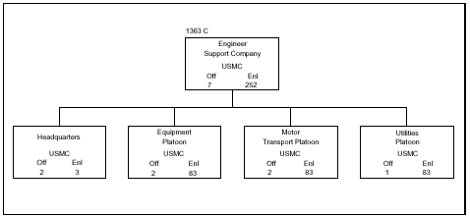
120.8 Discuss the four tasks of the Engineer Support Company, Combat Engineer Battalion. [p. 4-18]

Provide construction, materials handling and lifting equipment, and operators in
support of other battalion elements or to perform separate mission assignments within the battalion.

Provide potable water and hygienic services to the Marine division.

Provide electrical power to division organizations that are not authorized generators and provide backup power to the division, as required.

Provide motor transport equipment and operations, as required, to support all battalion elements.

120.9 Discuss the mission and organization of the Combat Engineer Company, Combat Engineer Battalion. [pp. 4-20, 4-22]

The mission of the combat engineer company is to provide close combat support of an engineering nature as necessary to meet the essential requirements of an infantry regiment and other division elements in combat operations.

The combat engineer company consists of a company headquarters and three combat engineer platoons. The company provides direct combat engineer support to infantry task groupings for operations. It can provide one combat engineer platoon for close support of each infantry battalion and associated task elements

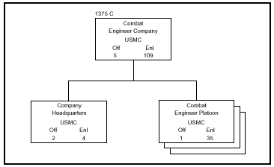
120.10 Discuss the thirteen tasks of the Combat Engineer Company, Combat Engineer Battalion. [p. 4-20]

- Provide engineer reconnaissance, as required.
- Provide assistance for the cross-country movement of tracked and light wheeled vehicles.
- Erect temporary engineer-type structures to assist in the movement of light vehicles and personnel across dry and wet gaps, subject to the availability of local materials.
- Construct and operate light rafts, subject to the availability of materials.
- Reinforce and repair existing bridges with local materials for the passage of light vehicles.
- Improve existing terrain for use as helicopter terminal points.
- Furnish technical assistance in the fabrication and positioning of light obstacles.
- Supervise the emplacement of minefields and booby traps.
- Furnish technical and mechanical assistance in the installation of temporary cut-and-cover type field fortifications.
- Perform specialized demolition missions that are beyond the capability of the infantryman.
- Provide specialized assistance in breaching obstacles, including mines, from the high-water mark inland.
- Supervise extensive or sensitive minefield clearance.
- Perform any combat engineer related tasks when augmented with the necessary elements of the engineer support company

