121 Ground Combat Element (GCE), Light Armored Reconnaissance (LAR) Battalion Fundamentals

References:

[a] MCRP 5-12D, Organization of Marine Corps Forces (PCN 14400005000)
[b] USMC Fact Files (http://www.hqmc.usmc.mil/factfile.nsf/AVE?openview&count=3000)

121.1 State the mission and organization of the Light Armored Reconnaissance Battalion. [ref. a, pp. 4-22, 4-23]

The mission of the LAR battalion is to conduct reconnaissance, security, and economy-of-force operations and, within capabilities, conduct limited offensive or delaying operations that exploit the unit’s mobility and firepower.

The LAR battalion consists of an H&S company and four LAR companies.

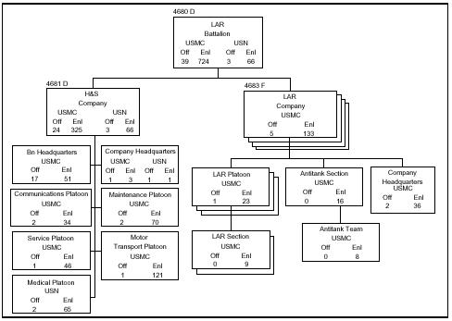

121.2 Discuss the following for the Light Armored Vehicle-25 (LAV-25): [ref. b]

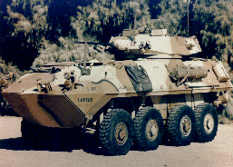

Primary function is to provide strategic mobility to reach and engage the threat, tactical mobility for effective use of fire power, fire power to defeat soft and armored targets, battlefield survivability to carry out combat missions.

Ranges – 410 miles (660.1 kilometers)

Speeds (land/water) – Land = 62 mph (99.2 km/hr)
Water = 6 mph (9.6 km/hr)

Crew / Troop Capacity – Driver, gunner, commander and 6 troops

Armaments – M242 25mm chain gun, M240 7.62mm machine gun mounted coaxial to the main gun

Features – The LAV-25 is an all-terrain, all-weather vehicle with night capabilities. It is air transportable via C-130, C-141, C-5 and CH-53 E. When combat loaded there are 210 ready rounds and 420 stowed rounds of 25 mm ammunition as well as 400 ready rounds and 1200 stowed rounds of 7.62mm. There are 8 ready rounds and 8 stowed rounds of smoke grenades. A supplementary M240E1 7.62mm machine gun can be pintle-mounted at the commander's station in the turret. The LAV-25 is fully amphibious with a maximum of 3 minutes preparation.
121.3 Discuss the following for the Light Armored Vehicle-Anti-Tank (LAV-AT): [ref. b]

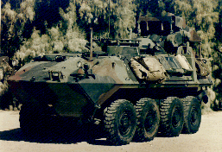

Primary function is to provide highly mobile, protected anti-armor fire support to light infantry and reconnaissance forces; provide capability to defeat heavy, armored targets at long ranges.

Armaments – M901A1 TOW II ATGM, and M240E1 7.62 machine gun

Features – The LAV-AT is an all-terrain, all-weather vehicle with night capabilities. It is air transportable via C-130, C-141, C-5 and CH-53 E. When combat loaded there are 2 ready and 14 stowed TOW II ATGMs as well as 200 ready rounds and 800 stowed rounds of 7.62mm ammunition. There are 8 ready rounds and 8 stowed rounds of smoke grenades. The missiles can be loaded under armor. The vehicle can be made fully amphibious within 3 minutesa.

121.4 Discuss the following for the Light Armored Vehicle-Command and Control
(LAV-C2): [ref. b]

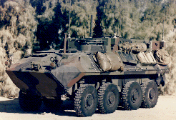

Primary function is a mobile command station providing field commanders with all necessary resources to control and coordinate light armored units in all assigned roles.

Armaments – M240E1 7.62mm machine gun

Features – The LAV-C2 is an all-terrain, all-weather vehicle with night capabilities. It is air transportable via C-130, C-141, C-5 and CH-53 E. When combat loaded there are 200 ready rounds and 800 stowed rounds of 7.62mm ammunition. There are 8 ready rounds and 8 stowed rounds of smoke grenades. The vehicle can be made fully amphibious within 3 minutes.

121.5 Discuss the following for the Light Armored Vehicle-Logistics (LAV-L): [ref. b]

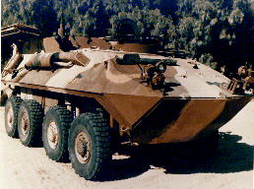

Primary function provides ammunition, rations and POL (petroleum, oil and lubricant) supplies required to sustain operations of first-line armored vehicles is a

Armaments – M240E1 7.62mm machine gun

Features – The LAV-L is an all-terrain, all-weather vehicle with night capabilities. It is air transportable via C-130, C-141, C-5 and CH-53 E. When combat loaded there are 200 ready rounds and 800 stowed rounds of 7.62mm ammunition. There are 8 ready rounds and 8 stowed rounds of smoke grenades. The vehicle can be made fully amphibious within 3 minutes.

121.6 Discuss the following for the Light Armored Vehicle-Mortar (LAV-M): [ref. b]

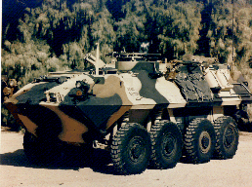

Primary function is to provide indirect fire support to light infantry and reconnaissance forces; providing high explosive area fire, covering smoke and illumination for first line-units.

Armaments – M252 81mm mortar, M240E1 7.62mm machine gun

Features – The LAV-M is an all-terrain, all-weather vehicle with night capabilities. It is air transportable via C-130, C-141, C-5 and CH-53 E. When combat loaded there are 5 ready and 94 stowed 81mm bombs as well as 200 ready rounds and 800 stowed rounds of 7.62mm ammunition. There are 8 ready rounds and 8 stowed rounds of smoke grenades. The base plate and bipod for ground mounted mortar is stowed on the vehicle. The vehicle can be made fully amphibious within 3 minutes.

121.7 Discuss the following for the Light Armored Vehicle-Recovery (LAV-R): [ref. b]

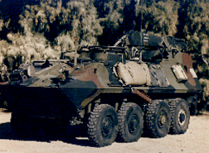

Primary function is a tactical mobility to reach and recover/support disabled
vehicles

Armaments –M240E1 7.62mm machine gun

Features -The LAV-R is an all-terrain, all-weather vehicle with night capabilities. It is air transportable via C-130, C-141, C-5 and CH-53 E. When combat loaded there are 200 ready rounds and 800 stowed rounds of 7.62mm ammunition. There are 8 ready rounds and 8 stowed rounds of smoke grenades. The vehicle can be made fully amphibious within 3 minutes

