122 Ground Combat Element (GCE), Amphibious Reconnaissance Battalion Fundamentals

References:

[a] MCI 03.32G, Reconnaissance Marine (http://www.doctrine.quantico.usmc.mil)

122.1 Discuss the primary mission of a reconnaissance battalion. [p. 1-4]

The primary mission of the reconnaissance battalion is to conduct ground reconnaissance and observation in support of the Marine division and its elements.

NOTE: There is a very basic mission difference between the two reconnaissance units. The force reconnaissance unit performs its mission farther behind enemy lines and is employed by the Marine Expeditionary Force. Battalion reconnaissance performs its mission closer to friendly lines and is employed by the division.

122.2 State the seven tasks performed by a reconnaissance battalion. [p. 1-4]

- Conduct pre-H-hour reconnaissance.
- Engage the enemy with supporting arms as directed or authorized by the division commander.
- Implant and monitor sensors.
- Capture selected prisoners.
- Conduct specialized terrain reconnaissance including beach, road/route, and HLZ/DZ reconnaissance missions.
- Conduct initial terminal guidance.
- Perform special missions

122.3 Discuss the organization of a reconnaissance battalion. [pp. 1-4, 1-5]

The reconnaissance battalion is an organic unit of the Marine division and is composed of a headquarters and service company and four reconnaissance companies. Each reconnaissance company includes a headquarters section and three platoons consisting of surface swimmers and as many inflatable boat handlers as necessary. A limited number are trained as underwater swimmers and parachutists.

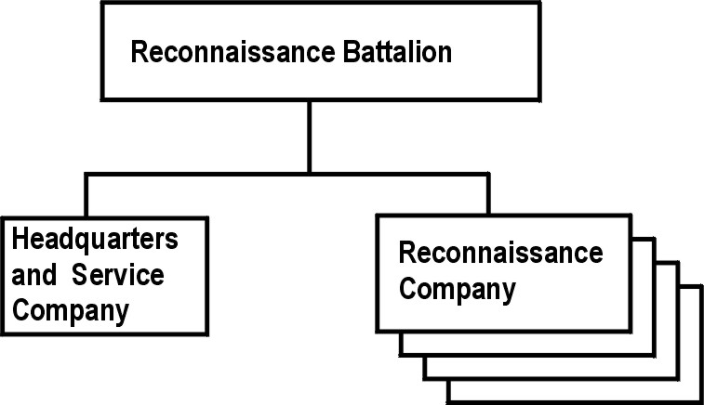
122.4 Discuss the sole objective of reconnaissance training. [p. 1-6]

The sole objective of reconnaissance training is successful execution of the reconnaissance combat mission. Successful employment of pre-assault and post-assault ground reconnaissance requires that training programs develop reconnaissance teams which are capable of conducting undetected activities on enemy ground under conditions of limited support from sources outside the teams. Such undetected activities include entry into a reconnaissance area of operations (RAO), patrol movement within the operating area, execution of information collection and terminal guidance tasks, submission of patrol reports from within the operating areas, debriefing, and submission of final reports. These training concepts are accomplished by stressing team integrity, balance, and realism throughout all phases of reconnaissance training

122.5 Explain the following progressive phases of reconnaissance training:
[pp. 1-6 thru 1-10]

Reconnaissance training progresses through four phases: basic individual training, advanced individual training, basic unit training and advanced unit training.

Basic Individual Training
Phase one – Basic Individual training provides the Marine with information in several areas:
Preparatory parachute training: Prior to assignment to Army airborne courses, marines should complete a concentrated parachute training course conducted by the reconnaissance unit. Completion of such a preparatory course ensures that the Marine will have no difficulty passing the actual airborne school.
Demolitions: Although reconnaissance units do not perform tasks requiring extensive use of demolitions, sometimes it may be necessary for them to carry out demolition assignments. Therefore, reconnaissance personnel should acquire basic training by attending demolition schools located throughout the Marine Corps.
Weapons training and requalification: Familiarization training for the reconnaissance Marine includes firing all infantry weapons and annual marksmanship requalification training with the service rifle and/or pistol. Also included is instruction in the identification and characteristics of foreign weapons.
Reporting routes of communication: Reconnaissance units are frequently assigned the task of reporting the natural and manmade characteristics of roads and bridges. Therefore, reconnaissance personnel must be familiar with basic road and bridge construction and classification.
Communications training: Basic communications training for reconnaissance personnel involves classroom training in the characteristics of organic communications equipment and in the way this equipment is used by a reconnaissance team.
Survival, evasion, resistance and escape training: In general, reconnaissance units are not capable of providing the level of training offered by a formal course in survival, evasion, resistance and escape training. However, this training is such a basic requirement for the reconnaissance Marine, that all newly assigned reconnaissance Marines should receive at least familiarization training prior to team assignment or shortly thereafter.
Intelligence training: It’s necessary that the reconnaissance Marine understands how his job pertains to intelligence production. Intelligence training for the reconnaissance Marine covers many subjects, including the following
- Intelligence functioning and intelligence planning
- Collection agencies and sources of information
- Landing force intelligence requirements/EEI’s
- Capabilities and limitations of combat support units and their peculiar intelligence requirements
- Counterintelligence
- Handling of enemy documents, materials, and prisoners
- Recognition of foreign uniforms, equipment, and weapons
Preliminary SCUBA training: Basic SCUBA diver qualifications may be acquired only at a formal Navy school. The reconnaissance Marine may or may not have had such training prior to his assignment to the reconnaissance unit. Therefore, local pre-SCUBA conditioning and familiarization training is conducted for reconnaissance Marines before their assignment to a formal SCUBA school. This training includes pool and open water instruction and is conducted according to Navy standards.

Advanced Individual Training
Phase two – The majority of the advanced individual training is conducted concurrently with basic training. Advanced individual training is designed to improve proficiency. Basic unit training typically combines several operating techniques into elementary exercises. Various subjects are covered by both advanced individual and basic unit training to include the following:
Physical training: both unit physical fitness and basic individual physical fitness should be maintained. The entire unit should perform daily training to maintain a desired level of unit physical fitness. To ensure overall physical fitness, vary and alternate the type of physical exercise as appropriate. Approximately one hour per day of scheduled physical training is considered ample.
Parachute training: Advanced individual parachute training consists of three weeks of formal airborne training, as prescribed by the Department of the Army. Subsequent parachute training covers several areas including familiarization with Navy and Marine aircraft normally used by reconnaissance units, preparation of individual equipment,, and execution of day and night jumps using complete combat equipment and static-activated steerable parachutes.
Swimmer equipment training: The reconnaissance team must be thoroughly familiar with all the equipment they will use in open water operations. Teams are familiarized and trained in the use of boats and related boat equipment.
SCUBA qualification training: Marine Corps Order 1500.16C contains information on the SCUBA qualifications and proficiency requirements.
Surf and Open Water training: As individuals and teams gain confidence and ability as swimmers, the training program expands to surf and open water swimming. The training emphasis is on endurance and concealment in both heavy surf and calm water by each team member.
Submarine training: Both day and night training should be conducted in the lock-out and lock-in techniques of leaving and entering a submerged submarine. Officers, SNCO’s, and NCO’s are trained in the operation of a submarine escape trunk.
Inflatable boat handling: Marines are assigned to boat teams for training in handling inflatable boats during motorized, towing, launch, and recovery operations. Marines should remain with the same boat team throughout training.
Reconnaissance patrolling: Teams are assigned missions which require the member to apply the skills they learned at basic individual training. This training emphasizes how the responsibilities and duties of the individual member contribute to the success of the team as a whole.
Initial terminal guidance training: Initial terminal guidance is conducted on both the platoon and the team level. The platoon or team provides initial terminal guidance to assault helicopters. Training consists primarily of reconnaissance techniques employed in the general area of the helicopter landing zone, including marking helicopter landing sites, using pyrotechnics, and clearing minor obstructions and obstacles within the landing zone.

Basic unit training
Phase three – Basic Unit Training is conducted to weld individuals into effective operating teams. Subject training, as mentioned previously, is conducted concurrently with advanced individual training.

Advanced unit training
Phase four – Advanced Unit Training may be conducted in support of landing exercises planned by other units or during exercises planned and executed soley by the reconnaissance unit

Note: Unit off base training: When the same general area is used for both training and exercises, the team members often gain an artificial sense of confidence and capability. To avoid this false security, conduct the majority of training exercises on different beaches, drop zones and other locations different from those used for the various exercises. Conduct at least half of the training and exercises at night. During this phase of training, teams should practice special landing, withdrawal, and recover techniques, as well as evasion, escape, survival and patrolling. The staff and service support elements should participate in training as appropriate

