 |  |  |  | 123
123 |  | Air Combat Element (ACE), Marine Corps Aviation Fundamentals
Reference:
[a] | MCRP 5-12D, Organization of Marine Corps Forces (PCN 14400005000)
123.1 |  | Define the primary mission of Marine Corps Aviation. [ref. a, p. 3-1]
 |  | The primary mission of Marine Corps aviation is to participate as the air component of the MAGTF in the seizure and defense of advance naval bases and to conduct such land operations as may be essential for the prosecution of a naval campaign.
.2 |  | Define the collateral mission of Marine Corps Aviation. [ref. a, p. 3-1]
 |  | A collateral mission is to participate as an integral component of naval aviation in the execution of such other Navy functions as the fleet commanders so direct.
.3 |  | Discuss the expeditionary aspects of Marine Corps Aviation. [ref. a, p. 3-1]
 |  | Marine Corps aviation is organized, trained, and equipped to function as the MAGTF ACE. The ACE must be prepared to operate from a variety of sea- and shore-based facilities (from naval shipping to austere forward operating bases (FOBs)) to support MAGTF expeditionary operations The focus of the ACE is to support the MAGTF during the assault landing and subsequent operations ashore. Initially, support could be furnished by Marine aircraft squadrons operating from FOBs within striking distance of the amphibious objective area or by V/STOL aircraft operating from amphibious shipping.
.4 |  | Define the following Marine Air/Ground Task Force (MAGTF) aviation functional areas and discuss their associated missions. [ref. a, pp. 3-1 to 3-3]
 |  | a. | OAS - Offensive Air Support- is “those air operations conducted against enemy installations, facilities, and personnel to directly assist the attainment of MAGTF objectives by the destruction of enemy resources or the isolation of his military force.”(MCRP 5-12C, Marine Corps Supplement to the DOD Dictionary of Military and Associated Terms). OAS includes the categories of close air support (CAS) and deep air support (DAS).
 |  | b. | AAW - Antiair Warfare- is “that action required to destroy or reduce to an  acceptable level the enemy air and missile threat. It includes such measures as the use of interceptors, bombers, anti-aircraft guns, surface-to-air and air-to-air missiles, electronic attack, and destruction of the air or missile threat both before and after it is launched. Other measures which are taken to minimize the effects of hostile air action are cover, concealment, dispersion, deception (including electronic), and mobility.” (Joint Pub 1-02) The primary purpose of AAW is to gain and maintain some degree of air superiority.
 |  | c. | Assault Support - Assault support is “the use of aircraft to provide tactical  mobility and logistic support for the MAGTF, the movement of high priority cargo and personnel within the immediate area of operations, in-flight refueling, and the evacuation of personnel and cargo.” (Fleet Marine Force  manual (FMFM) 5-30, Assault Support) The tasks of assault support fall within the following seven categories:  (1) Combat assault transport provides mobility and logistic support to the MAGTF. It can be used to rapidly deploy forces, bypass obstacles, or redeploy forces to meet the enemy threat, thus allowing for a rapid buildup of combat power at a specific time and location.
(2) Air Defense. Air defense includes all defensive measures designed to destroy attacking enemy aircraft or missiles in the earth’s atmosphere or to nullify or reduce the effectiveness of such attack. There are two forms of air
defense: active and passive.
(a) Active air defense is direct defensive action taken to destroy attacking enemy aircraft or missiles or to nullify or reduce the effectiveness of such an attack. Active air defense includes the use of aircraft, air defense weapons, supporting weapons (weapons not typically used in an air defense role), and EW.

(b) Passive air defense constitutes all measures, other than active defense, taken to minimize the effects of hostile air action. These include the use of
cover, concealment, camouflage, deception, dispersion, electronic protection, and protective construction. Passive air defense is a command responsibility of every unit commander.
(2) Aerial delivery operations transport equipment and supplies to FOBs or remote areas either by landing at the desired location or through air drop.
(3) Aerial refueling allows MAGTF aircraft to conduct flight-ferrying operations, extend time on station, and extend mission range. In addition, aerial refueling aids in the recovery of damaged or low-fuel aircraft by extending their time in the air, when required.
(4) Air evacuation provides transportation of personnel and equipment from FOBs or remote areas by using transport helicopters and fixed-wing aircraft.
(5) TRAP facilitates the recovery of personnel and equipment while preventing additional loss. The TRAP mission is an implied task associated with all MAGTF operations. Specially briefed aircrews are assigned to perform TRAP missions. TRAP missions are conducted when the tactical
situation prevents the use of traditional search and reserve techniques. TRAP is normally conducted only when survivors and their locations are confirmed.
(6) Air logistical support operations are conducted by using fixed-wing aircraft to provide assault support of MAGTF forces on the ground in much the same manner as helicopters. Air logistical support delivers troops, equipment, and supplies to areas beyond helicopter range and lift capability
or when surface transportation is slow or unavailable.
(7) Battle space illumination can be provided by both fixed-wing and
rotary-wing aircraft and is used to provide light in the battle space area.

 |  | d. | Air Reconnaissance - Air reconnaissance is “the acquisition of intelligence information by employing visual observation and/or sensors in air vehicles.” (FMFM 5-10, Air Recon- naissance)
 |  | e. | EW - Electronic Warfare-EW is “any military action involving the use of  electromagnetic and directed energy to control the electromagnetic spectrum or to attack the enemy.” (Joint Pub 1-02) The three major subdivisions of EW are electronic attack (EA), electronic protection, and EW sup- port.
 |  |  | (1) EA is “that division of electronic warfare involving the use of electromagnetic, directed energy, or antiradiation weapons to attack personnel, facilities, or equipment with the intent of degrading, neutralizing, or destroying enemy combat capability.” (Joint Pub 1-02)
(2) Electronic protection involves “actions taken to protect personnel, facilities, and equipment from any effects of friendly or enemy employment of electronic warfare that degrade, neutralize, or destroy friendly combat capability.”
(Joint Pub 1-02)

 |  |  | (3) EW support involves “actions tasked by, or under direct control of, an operational commander to search for, intercept, identify, and locate sources of intentional and unintentional radiated electromagnetic energy for the purpose of immediate threat recognition.” (Joint Pub 1-02)
 |  | f. | Control Of Aircraft And Missiles - The control of aircraft and missiles involves the coordinated employment of facilities, equipment, communications, procedures, and personnel that allows the ACE commander to plan, direct, and control the efforts of the ACE to support accomplishment of the MAGTF’s mission. Control of aircraft and missiles is executed through the Marine Air Command and Control System (MACCS). The control of aircraft and missiles function serves to integrate the activities of the other five functions of Marine  aviation into a coordinated effort.
.5 |  | Discuss the organizational structure of the following MAWs.  [ref. a, pp. 3-3 to 3-7]
 |  | a. | 1st MAW  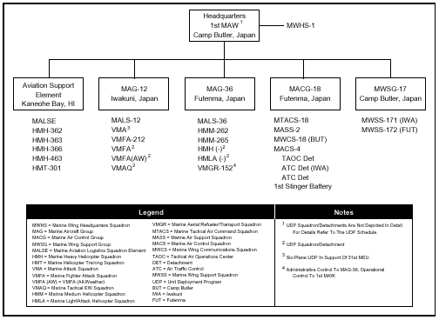
 |  | b. | 2nd MAW  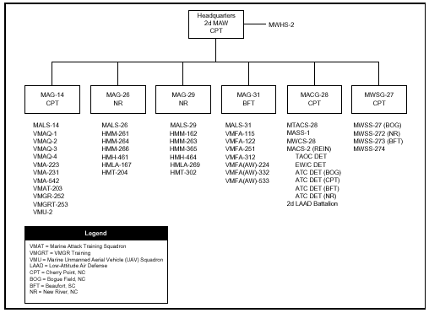
 |  | c. | 3rd MAW  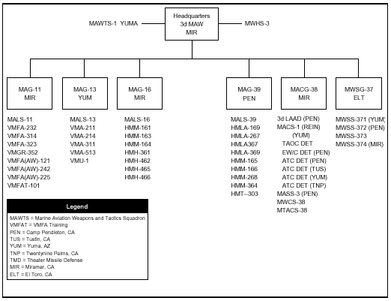
 |  | d. | 4th MAW  