125 Air Combat Element (ACE), Marine Air Control Group (MACG) Fundamentals

References:

[a] MCRP 5-12D, Organization of the Marine Corps Forces (PCN 144000050000)

125.1 Define the mission of a Marine Air Control Group (MACG). [p. 3-9]

The mission of the MACG is to provide, operate, and maintain the MACCS. The MACG contains subordinate units that provide the major facilities of the MACCS. It normally consists of a MTACS, a Marine air support squadron (MASS), one Marine air control squadron (MACS), a low-altitude air defense (LAAD) battalion, and an MWCS

125.2 Discuss the organizational structure of an MACG. [p. 3-10]

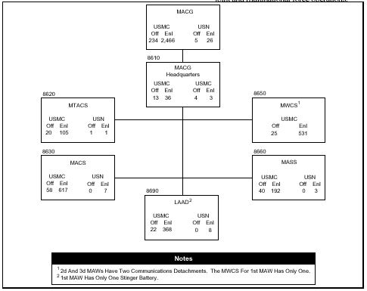

125.3 Define the mission of an MACG headquarters. [p. 3-10]

MACG headquarters coordinates all aspects of air command and control and air defense within the MAW. It provides the command and staff functions for the MACG commander when deployed as part of the MAGTF ACE.

125.4 Discuss the nine tasks of an MACG headquarters. [pp. 3-10, 3-11]

Provide the CE of the MACG or MACG detachment for the MAGTF ACE.
Plan and coordinate the operations, maintenance, and supply of the MACCS.

Plan and coordinate the air defense operations of the MAGTF.
Coordinate with appropriate commands to plan for the deployment and employment of the MACG and its separately deployable detachments as the MACCS of an ACE.

Coordinate with other U.S. Services and allies for planning and conducting MAGTF air operations in joint and multinational force operations.
Advise the ACE commander on applicable matters pertaining to the employment of agencies comprising the MACCS.

Perform command and staff functions associated with fulfilling the MACG’s mission.
Conduct operations while in a nuclear, biological, and chemical (NBC) and/or EW environment.
Maintain the capability for deploying independent units.

125.5 Define the mission of a Marine Tactical Air Control Squadron (MTACS). [p. 3-11]

The MTACS provides equipment, maintenance, and operations for the TACC of the ACE as a component of the MAGTF. It equips, mans, operates, and maintains the current operations section of the TACC. It also provides and maintains a facility for the TACC future operations and future planning sections and installs and maintains associated automated systems.

125.6 Discuss the nine tasks of an MTACS. [pp. 3-11, 3-12]

Provide the operational command post (CP) for the ACE commander of a MEF or the forward element of a MEF.
Assist in coordinating air operations to meet the operational requirements of the MEF.
Assist in planning air operations.
Maintain the capability to accomplish TACC functions while displacing.
Conduct operations while in an NBC and/or EW environment.
Assist in coordinating with other U.S. Services and allies for the conduct of MAGTF air operations in joint and multinational force operations.
Perform command and staff functions associated with fulfilling the MTACS mission.
Coordinate with the appropriate commands to plan for the deployment and employment of the squadron.
Provide logistical and supply support for the MACG headquarters.

125.7 Define the mission of a Marine Air Control Squadron (MACS). [p. 3-12]

The MACS provides air surveillance and control of aircraft and surface-to-air weapons for AAW; continuous all weather radar and non-radar ATC services and airspace management in support of a MAGTF.
125.8 Discuss the six tasks of an MACS. [p. 3-12]

Perform command and staff functions associated with fulfilling the MACS mission
Coordinate with appropriate commands to plan for the deployment and employment of the squadron and its separately deployable detachments.
Provide deployable detachments that are capable of air surveillance, airspace management, and control of aircraft and SAMs for AAW in support of the MAGTF.
Provide deployable detachments that are capable of providing ATC services at existing or expeditionary airfields and remote area landing sites.
When reinforced with a TMD detachment, provide SAM fires in assigned zones in defense of vital areas and installations therein against theater missile attack, and be prepared to engage surviving fixed-wing aircraft and helicopter threats.
Serve as the operational point of contact between the MACCS and national/international ATC agencies.

125.9 Discuss the organizational structure of the following: [pp. 3-13, 14]

MACS
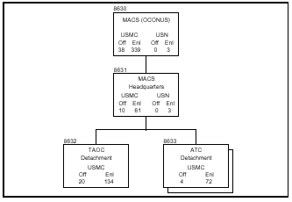

MACS (REIN)
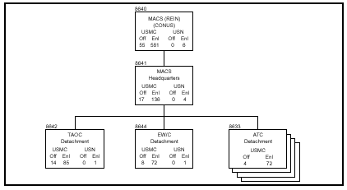
125 .10 Define the mission of a Marine Wing Communication Squadron (MWCS). [p. 3-14]

The MWCS provides expeditionary communications for the ACE of a MEF, including the phased deployment of task-organized elements thereof.

125.11 Discuss the twelve tasks of an MWCS. [pp. 3-14,15]

Provide for the effective command of subordinate detachments.
Assist in the systems planning and engineering of ACE communications. Install, operate, and maintain expeditionary communications for command and control of the MEF ACE.
Provide operational systems control centers, as required, to coordinate communication functions internally and externally to the ACE.
Provide calibration and repair facilities for all ground-common test measurement diagnostic equipment (TMDE) in the MAW.
Provide the digital backbone communications support for the ACE CE, FOBs, and MACCS agencies for up to two airfields per detachment.
Provide tactical automated switching and telephone services for the ACE CE and the TACC.
Provide electronic message distribution for the ACE CE, primary MACCS agencies, and tenant units.
Provide external single-channel radio and radio retransmission communications support for ACE operations as required.
Provide deployed wide area network (WAN) and deployed local area network (LAN) server support for the ACE CE and primary MACCS agencies
Provide the support cryptographic site for all ground-common and MACCS-assigned communications security equipment within the ACE.
Plan and coordinate individual and unit training as required to qualify subordinate detachments for tactical deployment and combat operations.
Provide maintenance support for ground-common communications equipment in the MAW.

125 .12 Define the mission of an Marine Air Support Squadron (MASS). [p. 3-16]

The MASS provides DASC capabilities for control and coordination of fixed-and rotary-wing aircraft operating in direct support of MAGTF forces.

125.13 Discuss the seven tasks of an MASS. [pp. 3-16, 17]

Provide operational planning for MAGTF air support operations.
Receive, coordinate, and process immediate requests for direct air support.
Provide equipment, facilities, and personnel for the operation of air support elements.
Conduct air support control as required to meet MAGTF operational requirements.
Maintain the ability to provide continuous control of direct air support while displacing by echelon.
Provide personnel and facilities for the simultaneous operation of the DASC and DASC (airborne).
Coordinate and integrate MAGTF direct air support operations with those of other Services, allies, and nations.
125.14 Define the mission of a Low Altitude Air Defense (LAAD). [p. 3-17]\

The LAAD battalion provides close-in, low-altitude, surface-to-air weapons ffires in defense of MAGTF assets defending forward combat areas, maneuver forces, vital areas, installations, and/or units engaged in special/independent operations.

125.15 Discuss the six tasks of an LAAD. [p. 3-17]

Provide for the effective command, administrative, communications, supply, and logistic support of subordinate batteries.
Maintain a primary capability as a highly mobile, vehicle-mounted, and man-portable surface-to-air weapons component of the MAGTF with the ability to rapidly deploy in the assault echelon of an expeditionary operation.
Provide surface-to-air weapons support for units engaged in special/independent operations
Provide for the separate deployment of subordinate batteries and platoons to accommodate special tactical situations and task organizations.
Plan and coordinate requirements for liaison and combinations with appropriate commands to ensure the most effective integration of LAAD units within the integrated air defense system
Provide early warning of hostile air threats to other elements of the air defense system.

125.16 Discuss the organizational structure of an LAAD. [pp. 3-17, 19]

The LAAD battalion is comprised of a battalion headquarters, a headquarters and service (H&S) battery, and two firing batteries. The H&S battery has been divided into an H&S battery (-) and an H&S battery detachment. This organization facilitates the logistical support of separately deployed firing batteries.

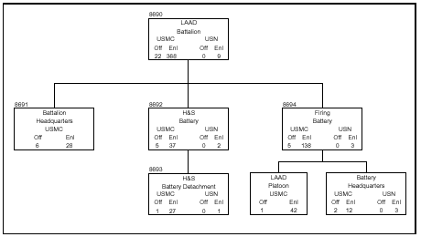

125.17 State the primary and secondary weapons of an LAAD. [p. 3-19]

Primary – Control central, battery, missile, guided, AVENGER AN/TWQ1
Secondary – Machine guns, 50 Cal M2, 7.62mm M60E3

