127 Air Combat Element (ACE), Marine Wing Support Group (MWSG) Fundamentals

References:

[a] MCRP 5-12D, Organization of the Marine Corps Forces (PCN 144000050000)

127.1 Define the mission of a Marine Wing Support Group (MWSG). [p. 3-32]:

The MWSG provides all essential ground support requirements to aid designated fixed- or rotary-wing components of a Marine FOB. The MWSG typically includes a headquarters and headquarters squadron (H&HS), two MWSSs (fixed wing), and two MWSSs (rotary wing). The group is organized to provide motor transport, engineering services, and organizational maintenance (motor transport and engineering) for units of the MAW. The MWSG is organized and equipped for employment as an integral unit in support of the MAW. It is structured to provide deployable elements in support of the garrison or deployed posture of the MAW.

127.2 Discuss the organizational structure of an MWSG. [p. 3-32] :

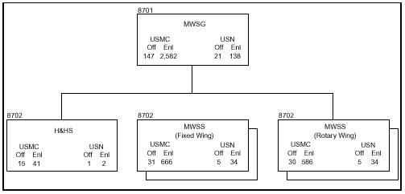

127.3 Define the mission of a Headquarters and Headquarters Service (H&HS) squadron.
[p. 3-32]:

The H&HS provides administrative support for the group and squadron headquarters.

127.4 Discuss the two tasks of an H&HS squadron. [p. 3-32]:

Provide command, control, administrative, and ecclesiastical support for assigned units.
Provide routine and emergency sick call functions.
127.5 Define the mission of a Marine Wing Support Squadron (MWSS). [p. 3-33]:

The MWSS provides all essential aviation ground support requirements to a designated fixed-wing/rotary-wing component of an ACE and all supporting or attached elements of the MACG.

127.6 Discuss the thirteen tasks of an MWSS. [p. 3-33]

Providing internal airfield communications, including tactical telephone service in and about the airfield as well as for tenant ACE units, communications for airfield security, communications for ground transportation management, and communications between an airfield and its adjacent facilities (i.e., ammunition dump and petroleum, oils, and lubricants sites).
Providing weather services.
Providing expeditionary airfield services, including maintaining M-21 aircraft recovery equipment, fresnel lens, communications, airfield lighting, and other related equipment necessary to support air operations.
Supplying crash/fire/rescue and structural firefighting equipment.
Providing aircraft and ground refueling.
Providing essential engineer services, including engineer reconnaissance/survey; repair, improvement, and maintenance of existing road nets within the ACE area of responsibility; construction and maintenance of expedient roads; construction (except for subsurface and surface preparation) improvement and maintenance of V/STOL facilities, not to exceed 900 feet; construction and maintenance of mission-essential base camp requirements, including tactical airfield fuel distribution systems and helicopter expeditionary refueling system installations, temporary bunkers, temporary aircraft revetments, and strong backs; technical and equipment assistance for erection of shelters; utilities support, including essential mobile electric power, water, and hygiene support; development, improvement, and maintenance of drainage systems; supervision of camouflage requirements; equipment and personnel required for rapid runway repair; materials handling equipment to support base operations; limited mine detection capability; and limited combat engineer services.
Providing motor transport for operations internal to the air base.
Providing messing facilities.
Providing routine and emergency sick call and aviation medical functions.
Providing individual and unit training or organic personnel and selected personnel of support units.
Providing organic NBC defense.
Providing security and law enforcement services including security of flight line and critical airfield facilities; traffic control/enforcement, convoy escort, and traffic accident investigations; straggler collection and refugee control and criminal investigation, physical security surveys, and related activities.
Provide air base commandant functions.

