131 Combat Service Support Element (CSSE), Maintenance Battalion Fundamentals

References:

[a] MCRP 5-12D, Organization of Marine Corps Forces (PCN 14400005000)
[b] MCWP 4-11.4, Maintenance Operations (PCN 14300001700)

131.1 Define the mission and organization of the Maintenance Battalion of the Force Service Support Group (FSSG). [ref. a, pp. 5-15, 5-16]

Mission: The maintenance battalion provides general support and intermediate (3d and 4th echelon) maintenance support for Marine Corps-furnished tactical ordnance, engineering, motor transport, communications electronics, and general support equipment of the MEF.

Organization: The battalion is structured to provide command and control for centralized coordination and decentralized execution of maintenance efforts to sustain the combat power of the MEF. Subordinate companies are organized along functional area lines to provide maintenance support in commodity areas that are critical to the warfighting capability of the MEF.

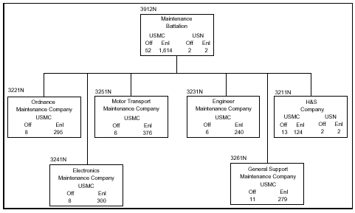

131.2 Discuss the eight tasks of the Maintenance Battalion of the FSSG.
[ref. a, pp. 5-15, 5-16]

Provide 3d echelon maintenance on end items by means of component/subassembly replacement or repair.
Provide intermediate (4th echelon) maintenance in support of the secondary repairable program, including repairing and rebuilding components and subassemblies of end items.
Provide a tracked-vehicle evacuation capability.
Provide calibration services for electronic and mechanical TMDE.
Provide organizational (2d echelon) and intermediate (3d and 4th echelon) maintenance on end items.
Provide technical assistance and overflow organizational (2d echelon) maintenance for supported units as directed by higher headquarters.
Provide intermediate maintenance and modification applications on in-stock equipment.
Provide technical inspection services, as required, in support of equipment maintenance programs of the MEF.

131.3 Define the mission and organization of H&S Company of the Maintenance Battalion. [ref. a, pp. 5-17, 5-18]

Mission: The H&S company provides command and control, administration, and command support functions for the maintenance battalion.

Organization: The company is organized to plan, coordinate, and supervise the logistic/CSS functions of the subordinate elements of the battalion with assistance from the battalion supply and motor transport sections. It is structured to facilitate task organization for maintenance operations in support of the MEF or any combination of smaller MAGTFs.

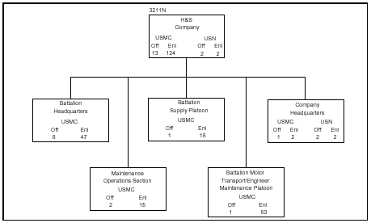
131.4 Define the mission and organization of the Ordnance Maintenance Company of the
Maintenance Battalion. [ref. a, pp. 5-19, 5-20]

Mission: The ordnance maintenance company provides intermediate (3d and 4th echelon) maintenance support for Marine Corps-furnished ordnance equipment of a MEF.

Organization: The company is structured to provide the appropriate technical and supervisory personnel and equipment, plus ordnance maintenance support, for a MEF or MAGTFs smaller than a MEF. It is organized to facilitate the task organization of ordnance maintenance assets for support of a MEF or up to four MEUs deployed in widely separated geographical areas.

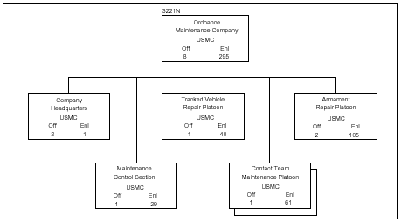
131.5 Define the mission and organization of Engineer Maintenance Company of the
Maintenance Battalion. [ref. a, pp. 5-21, 5-22]

Mission: The engineer maintenance company provides intermediate (3d and 4th echelon) maintenance support for Marine Corps-furnished engineering equipment of a MEF.

Organization: The company is structured to provide the appropriate technical and supervisory personnel and equipment to provide engineering maintenance support for a MEF or MAGTFs smaller than a MEF. It is organized to facilitate the task organization of engineering maintenance assets for support of a MEF or up to four MEUs deployed in widely separated geographical areas.

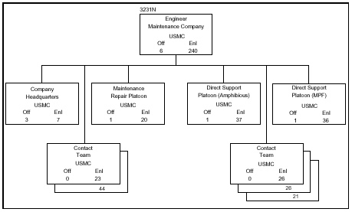
131.6 Define the mission and organization of Electronics Maintenance Company of the
Maintenance Battalion. [ref. a, pp. 5-23, 5-24]

Mission: The electronics maintenance company provides intermediate maintenance (3d and 4th echelon) support for the Marine Corps-furnished ground communications-electronics equipment of a MEF.

Organization: The company is structured to provide the appropriate technical and supervisory personnel and equipment to provide communications-electronics maintenance support for a MEF or MAGTFs smaller than a MEF. It is organized to facilitate the task organization of communications-electronics maintenance assets for support of a MEF or up to four MEUs deployed in widely separated geographical areas.

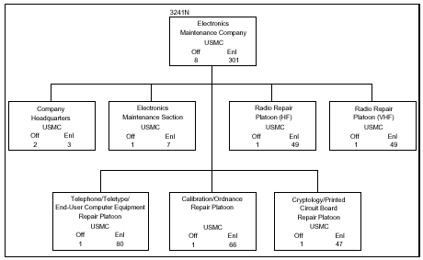

131.7 Define the mission and organization of Motor Transport Maintenance Company of the Maintenance Battalion. [ref. a, pp. 5-25, 5-26]

Mission: The mission of the motor transport maintenance company is to provide intermediate (3d and 4th echelon) maintenance support for the motor transport equipment of the MEF.

Organization: The company is structured to provide the appropriate technical and supervisory personnel and equipment to provide motor transport maintenance support for a MEF or MAGTFs smaller than a MEF. It is organized to facilitate the task organization of motor transport maintenance assets for support of a MEF or up to four MEUs deployed in widely separated geographical areas.

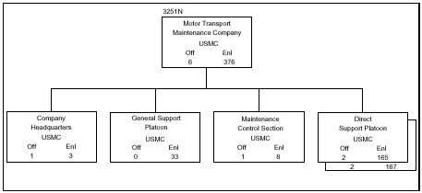
131.8 Define the mission and organization of General Support Maintenance Company of the Maintenance Battalion. [ref. a, pp. 5-27, 5-28]

Mission: The general support maintenance company provides general support intermediate (3d and 4th echelon) maintenance support, including component rebuilding for Marine Corps-furnished ground equipment of a MEF, except for communications-electronics equipment and fire control components.

Organization: The company is structured to provide the appropriate technical and supervisory personnel and equipment to augment the maintenance elements of a CSSE with a general support intermediate maintenance capability. It is organized to facilitate the task organization of general support maintenance assets for support of a MEF or up to four MEUs deployed in widely separated geographical areas.

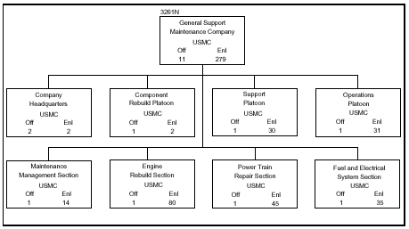
131.9 Discuss each echelon/level of ground equipment maintenance:
[ref. b, pp. 1-3 thru 1-5]:

Three categories of maintenance exist within the Marine Corps’ ground equipment maintenance system: organizational, intermediate, and depot. Within these three categories are five echelons of maintenance. Each category and echelon is authorized to perform certain maintenance functions on certain commodity area items of equipment (e.g., communications, ordnance, motor transport). This capability is normally listed in a unit’s table of organization (T/O) mission statement. Maintenance units are not restricted to per-forming only one echelon of maintenance. For example, a unit may be authorized to perform first and second echelon maintenance or even third or fourth. To manage maintenance effectively, commanders must understand their maintenance responsibilities and the maintenance responsibilities of those units in support.

Organizational maintenance: The using unit performs organizational maintenance on its assigned equipment. All units within the Marine division, force service support group (FSSG), and aircraft wing possess the organizational capabilities to maintain their organic equipment. Organizational maintenance focuses on the operator and crew preventive/corrective measures required by technical publications, equipment failure, and service schedules. Organizational maintenance phases normally consist of inspecting, servicing, lubricating, adjusting, and replacing parts, minor assemblies, and subassemblies. Organizational maintenance includes first and second echelon maintenance responsibilities.
First echelon maintenance is performed by the user or equipment operator. This maintenance includes the proper care, use, operation, cleaning, preservation, lubrication, adjustment, minor repair, testing, and parts replacement prescribed by appropriate technical publications. Collection of Marine Integrated Maintenance Management System (MIMMS) information is not required for first echelon maintenance.
Second echelon maintenance includes the performance of scheduled maintenance, diagnosis and isolation of previously identified and traced equipment malfunctions, replacement of major assemblies/modular components that can be readily removed/installed and do not require critical adjustment, and replacement of easily accessible piece parts not authorized at first echelon. Second echelon maintenance is performed by specially trained personnel in the organization. Specific publications authorize second echelon, maintenance-capable units to hold additional tools, supplies, and test equipment that support a higher echelon of maintenance.

Intermediate maintenance: Intermediate maintenance is the responsibility of and performed by designated maintenance activities in direct support of using organizations. Intermediate maintenance phases normally consist of calibration, repair, or replacement of damaged or unserviceable parts, components, or assemblies; the emergency manufacture of non-available parts; and providing technical assistance to using organizations. Intermediate maintenance includes third and fourth echelon maintenance.

Note: Some elements of third and fourth echelon maintenance can be performed at either the intermediate or organizational levels dependent on the capability assigned in the T/O mission statement of certain commodity-peculiar organizations (e.g., tank battalion, communications battalion, light armored reconnaissance battalion).

Third echelon maintenance is performed by specially trained personnel and can include:
- Diagnosing and isolating equipment/modular malfunctions.
- Adjusting and aligning modules using test, measurement, and diagnostic equipment (TMDE)
- Replacing modular components and piece parts that do not require extensive post maintenance testing or adjustment.
- Cleaning modular components and performing limited repair if needed
- Installing replacement seals
- Applying external parts
- Installing repair kit pieces
- Performing minor body work
- Evaluating emissions of internal combustion engines

Fourth echelon maintenance is normally associated with semi-fixed or permanent shops of intermediate maintenance activities. It is frequently associated with organizational shops of units that have a commodity-peculiar mission. Fourth echelon can include:
- Diagnosing, isolating, adjusting, calibrating, aligning, and repairing malfunctions to internal piece/part levels
- Replacing defective modular components not authorized at lower echelons.
- Repairing major modular components by grinding and adjusting items such as valves, tappets, and seats.
- Replacing internal and external piece parts to include solid-state integrated circuits and printed circuit boards/cards
- Performing heavy body, hull turret, and frame repair

Depot maintenance: Depot maintenance is performed on materiel that requires a major overhaul or a complete rebuilding of parts, assemblies, subassemblies, and end items. This level of maintenance includes the manufacture of parts, modifications, testing, and reclamation, as required. Depot maintenance supports lower categories of maintenance by providing technical assistance and by performing maintenance that exceeds the lower categories level of responsibility. Depot maintenance also provides stocks of serviceable equipment that are not available in lower echelon maintenance activities. Depot maintenance includes the fifth echelon of maintenance.

Note: Fifth echelon maintenance can be performed at intermediate maintenance activities if specifically authorized by the Commandant of the Marine Corps.
Fifth echelon maintenance includes:
- Overhauling or rebuilding end items or modular components.
- Performing repairs that exceed the assigned capability of lower echelons of maintenance (special environmental facilities or specific tolerances are required)
- Performing nondestructive testing
- Performing special inspection/modification that requires extensive disassembly or elaborate test equipment.
- Manufacturing items not provided or available
- Providing wholesale direct exchange support.

131.10 Define the following maintenance terminologies: [ref. b, pp. D-7 thru D-9]

Overhaul: The restoration of an item to a completely serviceable condition as prescribed by maintenance serviceability standards.

Preventive maintenance: The care and servicing by personnel for the purpose of maintaining equipment and facilities in satisfactory operating condition by providing for systematic inspection, detection, and correction of incipient failures either before they occur or before they develop into major defects.

Rebuild: The restoration of an item to a standard as nearly as possible to its original condition in appearance, performance, and life expectancy.

Repair: The restoration of an item to serviceable condition through correction of a specific failure or unserviceable condition.

Unserviceable: An item in a condition unfit for use, but which can be restored to a serviceable condition after repair, rework, or overhaul.

