132 Combat Service Support Element (CSSE), Supply Battalion Fundamentals

References:

[a] MCRP 5-12D, Organization of Marine Corps Forces (PCN 14400005000)
[b] MCWP 4-1, Logistics Operations (PCN 14300005800)
[c] MCWP 4-11.1, Health Service Support Operations (PCN 14300004000)

132.1 Define the mission and organization of the Supply Battalion of the Force Service Support Group (FSSG). [ref. a, pp. 5-29, 5-30]

Mission: The supply battalion provides general support supply support, except for bulk fuel and Navy-funded stock/ programs, for sustaining MAGTF operations.

Organization: The battalion is organized to provide commodity-oriented, task-organized detachments for the sustainment of MAGTF operations.

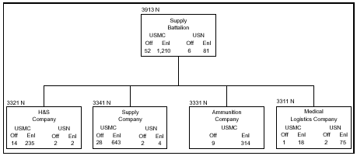

132 .2 Discuss the twelve tasks of the Supply Battalion of the FSSG. [ref. a, pp. 5-29, 5-30]

Provide supply support management, for the FSSG and other MEF elements beyond organic capabilities of supported units, including the following stock control functions:
- Management of the MEF’s special allowance training pool items and initial issue provisioning assets
- Management of the MEF’s secondary repairables through the maintenance float
- Technical management, data research, customer service, and general assistance to the MEF for supply matters
- Supplying status management reports for the MEF, as required
- Interface for the MEF with financial and maintenance management systems.
Provide contracting support and cross servicing services for supported units, as required.
Provide a warehousing capability in support of the MEF.
Provide accounting for classes I, II, IV, VII, VIII, and IX supplies, initial issue provisioning assets, and authorized levels of war reserve.
Provide subsistence support to the MEF, including operation of class I subsistence dumps and storage, issue, and accounting for subsistence items.
Provide receipt, storage, and forwarding of class III (packaged) supplies.
Provide receipt, storage, issue, and accounting functions for class V items.
Provide technical assistance in receipt, storage, assembly, and provision of nuclear ordnance.
Provide for the receipt, storage, issue, and organizational (2d echelon) and intermediate (3d and 4th echelon) maintenance support for class VIII supplies and equipment
Provide intermediate-level shop stores issue points for the MEF.
Provide procurement services for the MEF for items decentralized by the integrated materiel manager
Provide packing, preservation, and packaging (PP&P) services.

132.3 Define the mission and organization of the H&S Company of the Supply Battalion. [ref. a, pp. 5-31, 5-32]

Mission: The H&S company of the supply battalion provides command and control administration, and command support functions for the supply battalion and general support subsistence supply support to the MEF.

Organization: The company is organized to plan, coordinate, and supervise the command support functions of the battalion and to provide specified general support supply functions for MAGTFs. It is structured to facilitate task organization of detachments for operations conducted by the battalion in support of MAGTF operations.

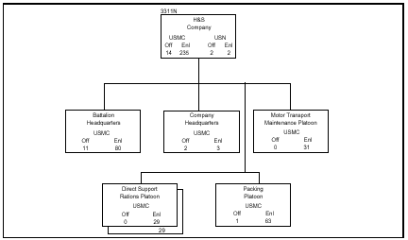

132 .4 Define the mission and organization of the Supply Company of the Supply Battalion. [ref. a, pp. 5-32 thru 5-34]

Mission: The supply company provides general support supply support, including supply management and control, to sustain the operations of the MEF.

Organization: The company is organized to facilitate the task organization of detachments that are capable of providing control and management of supply support to elements of the MEF or MAGTFs smaller than a MEF.

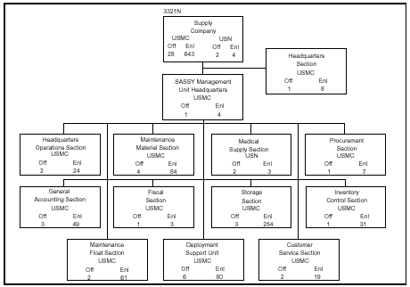

132 .5 Define the mission and organization of the Ammunition Company of the Supply Battalion. [ref. a, pp. 5-35, 5-36]

Mission: The ammunition company provides general support, class V supply support to the MEF.

Organization: The company is organized to plan, coordinate, and supervise class V support functions. It is structured to facilitate task organization of detachments for operations conducted by the supply battalion in support of the MEF and any combination of smaller MAGTFs.

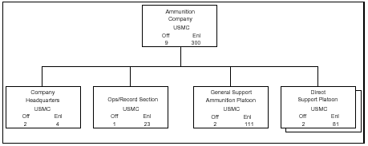
132 .6 Define the mission and organization of the Medical Logistics Company of the Supply Battalion. [ref. a, pp. 5-37, 5-38]

Mission: The medical logistics company provides general supply and maintenance support for class VIII materiel of the MEF.

Organization: The company is organized to plan, coordinate, and supervise the command support functions of the battalion. It is structured to facilitate task organization of detachments in support of MAGTF operations.

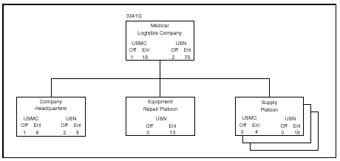

132.7 Name and define the ten classes of supply. [ref. b, p. 1-7]

I Subsistence - includes gratuitous health and welfare items and rations.
II Clothing - individual equipment, tentage, organizational tool sets and tool kits, hand tools, administrative and housekeeping supplies, and equipment.
III Petroleum - oils, and lubricants (POL), which consists of petroleum fuels, lubricants, hydraulic and insulating oils, liquid and compressed gases, bulk chemical products, coolants, de-icing and antifreeze compounds, preservatives together with components and additives of such products, and coal.
IV Construction - includes all construction material; installed equipment; and all fortification, barrier, and bridging materials.
V Ammunition - of all types, which includes, but is not limited to, chemical, radiological, special weapons, bombs, explosives, mines, detonators, pyrotechnics, missiles, rockets, propellants, and fuses.
VI Personal - demand items or nonmilitary sales items.
VII Major end items - are the combination of products assembled and configured in their intended form and ready for use (e.g., launchers, tanks, mobile machine shops, vehicles).
VIII Medical/dental material - which includes medical-unique repair parts, blood and blood products, and medical and dental material.
IX Repair parts - (less class VIII), including components, kits, assemblies, and subassemblies (reparable and non-reparable), required for maintenance support of all equipment.
X Material - to support nonmilitary requirements and programs that are not included in classes I through IX. For example, materials needed for agricultural and economic development
132 .8 State the six functions of supply. [ref. b, p. 1-7]

The six functions of supply are:
- Requirements determination: routine, pre-planned, or long-range.
- Procurement
- Distribution
- Disposal

- Storage
- Salvage

132 .9 Define AMAL and ADAL. [ref. c, p. B-1]:

HSS authorized medical allowance lists (AMALs) and authorized dental allowance lists (ADALs) are configured in assemblages such as equipment and supply. The equipment assemblage contains equipment and reusable materiel required to establish the basic function of the assemblage (e.g., an operating room). The supply assemblage contains consumable material to support the function in treating a designated number of casualties or to perform a specific task. For readiness purposes, an equipment module may be stored in combination with its corresponding supply module. The materiel listed in each AMAL/ADAL is the minimum amount to be maintained. Marine Corps Order 4400 series contains AMAL and ADAL procurement policies and procedures. Policies and procedures include assembly, maintenance, levels of supply, and distribution of materiel. AMALs and ADALs are maintained and resupplied by the medical logistics company, supply battalion, FSSG.

