133 Combat Service Support Element (CSSE), Engineering Support Battalion Fundamentals

References:

[a] MCRP 5-12D, Organization of Marine Corps Forces (PCN 14400005000)

133.1 Define the mission and organization of the Engineering Support Battalion of the Force Service Support Group (FSSG). [p. 5-38]

Mission: The engineer support battalion provides general engineering support of an expeditionary nature to the MEF, including survivability, countermobility, and mobility enhancements; EOD; and general support supply support incident to the handling, storage, dispensing of bulk class I (water) and bulk class III and III (A) items.

Organization: The battalion is organized to plan, coordinate, and supervise the general engineering and supply support functions of the battalion. It is structured to facilitate task organization for operations conducted by the battalion in support of the MEF or combinations of smaller MAGTFs.

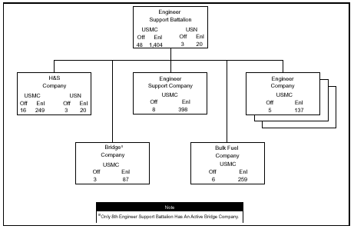

133 .2 Discuss the fifteen tasks of the Engineering Support Battalion of the FSSG.
[pp. 5-38, 5-39]

Conduct engineering reconnaissance that is necessary to support the battalion’s mission or other engineering needs of the MEF.
Construct, improve, and maintain airfields, including expeditionary airfields.
Construct, improve, and maintain encampments, CSSAs, and other MEF-required support facilities by using available material or pre-engineered structures.
Conduct mobility enhancement operations, including the construction, improvement, and maintenance of lines of communications and main supply routes.
Provide bulk class III and III(A) fuel support, including receipt, storage, and dispensing of bulk fuel products.
Provide utilities support, including mobile electric power beyond supported units’ capabilities and electrical power distribution within camps and CSSAs.
Provide water purification and bulk class I (water) storage and dispensing for the FSSG and other elements of the MEF when requirements exceed supported units’ capabilities.
Provide survivability enhancements, including the construction of protective structures.
Install and/or supervise other units in the installation of standard and nonstandard, fixed-panel and floating bridging, including planning and controlling bridging operations in support of MEF mobility requirements.
Provide bath and laundry services beyond supported units’ capabilities.
Provide EOD support, as required, to the MEF.
Construct field-expedient deception devices.
Conduct countermobility operations through installation of obstacles and barriers, including explosive and nonexplosive obstacles.
Conduct mobility operations, including breaching, reducing, and removing explosive or nonexplosive obstacles.
Provide specialized demolition operations beyond supported units’ capabilities.

133 .3 Define the mission and organization of H&S Company of the Engineering Support Battalion. [pp. 5-40, 5-41]

Mission: The H&S company provides command and control, administration, and command support functions for the engineer support battalion and EOD support to the MEF.
Organization: The company is organized to plan, coordinate, and super-vise the command support functions for the battalion. It is structured to facilitate task organization for operations conducted by the battalion in support of MAGTF operations

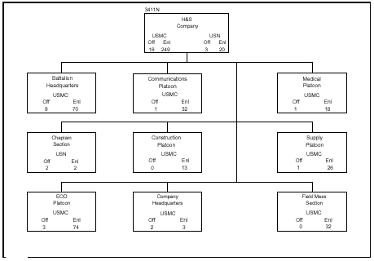
133 .4 Define the mission and organization of the Engineer Support Company of the Engineering Support Battalion. [pp. 5-42, 5-43]

Mission: The engineer support company provides direct support maintenance support for specified equipment that is organic to the battalion, direct support transportation and services support to the battalion, and general support/reinforcing augmentation, as required, to the engineer companies of the battalion in support of the MEF operations.

Organization: The company is organized to plan, coordinate, and supervise the command support functions for the company and to facilitate task organization for engineer maintenance support for operations conducted by the battalion in support of MAGTF operations.

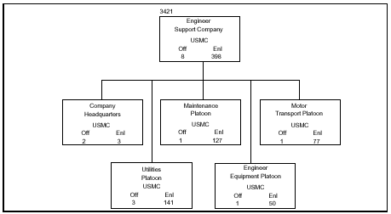

133 .5 Define the mission and organization of Bridge Company of the Engineering Support Battalion. [pp. 5-44 thru 5-46]

Mission: The bridge company provides general support standard tactical bridging support to enhance the tactical mobility of the MEF.

Organization: The company is organized to plan, coordinate, and supervise bridging support operations of the battalion. It is structured to facilitate task organization for bridging operations conducted by the battalion in support of the MEF or any combination of smaller MAGTFs.

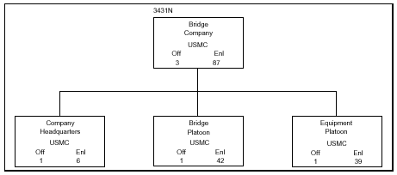

133 .6 Define the mission and organization of Bulk Fuel Company of the Engineering Support Battalion. [pp. 5-46 thru 5-48]

Mission: Provide general support, class III supply support to the MEF, including distribution to, but not within, air bases in support of MEF operations.

Organization: The company is organized to plan, coordinate, and supervise the bulk fuel support functions of the battalion. It is structured to facilitate task organization for bulk fuel operations conducted by the battalion in support of the MEF or any combination of smaller MAGTFs.
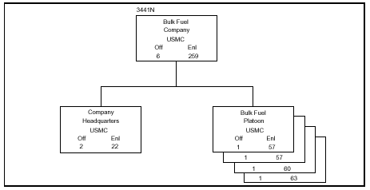

133.7 Define the mission and organization of Engineer Company of the Engineering Support Battalion. [pp. 5-48 thru 5-50]

Mission: The engineer company provides general engineering support of an expeditionary nature to the MEF.

The company is organized to plan, coordinate, and supervise the engineering support functions of the battalion. It is structured to facilitate task organization for operations conducted by the battalion in support of the MEF or any combination of smaller MAGTFs.

