134 Combat Service Support Element (CSSE), Motor Transport and Landing Support Battalions Fundamentals

References:

[a] MCRP 5-12D, Organization of Marine Corps Forces (PCN 14400005000)
[b] MCWP 4-11.3, Transportation Operations (PCN 14400008300)
[c] FMFM 4-1, Combat Service Support Operations

134.1 Discuss the differences between the Motor Transport/Landing Support Battalions of 1st and 2nd Force Service Support Groups (FSSGs) as compared to the Transportation Support Battalion of 3rd FSSG. [ref. a, p. 5-3]

1st and 2nd FSSG’s 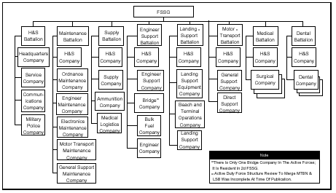

3rd FSSG 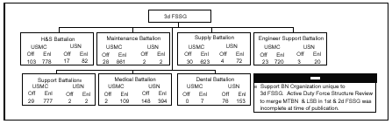
134 .2 Define the mission and organization of the Landing Support Battalion of the FSSG. [ref. a, pp. 5-51, 5-52]

Mission: The LSB provides general support, including support of the ship-to-shore movement during amphibious operations and of terminal operations during subsequent operations ashore, t o permit required throughput of supplies, equipment, and personnel for sustainment in support of MEF operations. (Note: The Active Duty Structure Force Review's changes that will merge LSB and motor transportation battalions were not finalized at the time..

Organization: The battalion is organized to provide landing support and throughput support for amphibious operations conducted by the MEF during amphibious assaults and subsequent operations ashore.

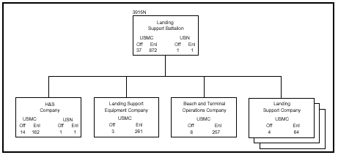

134 .3 Discuss the six tasks of the Landing Support Battalion of the FSSG.
[ref. a, pp. 5-51, 5-52]

Provide centralized control and coordination of landing support and throughput capabilities, including port and terminal operations, as well as material-handling and air delivery support, in support of operations conducted by the MEF or MAGTFs smaller than a MEF.
Provide a nucleus from organic assets for the task organization of a landing force support party (LFSP) to provide the command and control structure to effect landing support and initial CSS for the assault echelon (AE) of the MEF in support of amphibious operations.
Provide port and terminal operations at ports, beaches, railheads, air heads, and cargo terminals, including specialized MHE and management of freight/passenger and break bulk/container cargo throughput.
Provide air delivery support equipment and rigger personnel beyond organic capabilities of supported units, in support of MEF operations.
Perform the basic engineer tasks that are required for landing support operations, including austere site preparation, construction/removal of obstacles and barriers, and establishment of routes of egress from the beach, when properly augmented.
Provide local security for numbered/colored beaches as required
134 .4 Define the mission and organization of H&S Company of the Landing Support Battalion. [ref. a, p. 5-53]

Mission: The H&S company of the LSB provides command and control, administration, and command support functions for the LSB in support of MEF operations.

Organization: The company is organized to plan, coordinate, and supervise the command support functions for the battalion. It is structured to facilitate task organization for landing support and throughput operations conducted by the battalion in support of MAGTF operations.

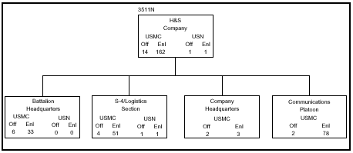

134 .5 Define the mission and organization of Landing Support Equipment Company of the Landing Support Battalion. [ref. a, pp. 5-54, 5-55]

Mission: The landing support equipment company provides MHE and container-handling support, as well as general support, organizational maintenance support for throughput support equipment (engineer and motor transport assets) of the battalion in support of MAGTF throughput operations.

Organization: The company is organized to plan, coordinate, and supervise the command support functions for the battalion. It is structured to facilitate task organization for throughput operations conducted by the battalion in support of MAGTF operations.

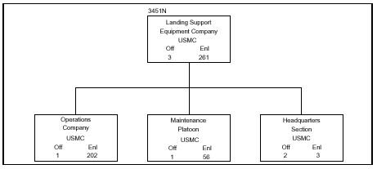
134.6 Define the mission and organization of Beach and Terminal Operations Company of
the Landing Support Battalion. [ref. a, pp. 5-56, 5-57]

Mission: The beach and terminal operations company provides general support transportation support in coordinating throughput operations of the MEF.

Organization: The company is organized to facilitate throughput operations in support of MAGTF operations. It provides management and operation of ports, airheads, railheads, and other cargo/passenger terminal operations, as well as air delivery support, as required.

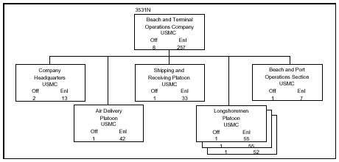

134 .7 Define the mission and organization of Landing Support Company of the Landing Support Battalion. [ref. a, pp. 5-58, 5-59]

Mission: The landing support company provides command and control for throughput operations in support of surface and/or helicopter assault operations conducted by the MEF.

Organization: The company is organized to provide the nucleus of personnel and equipment that are required to task organize an LFSP, composed of MAGTF and naval units, for the initial logistics/CSS of the MEF in amphibious and helicopter-borne operations.

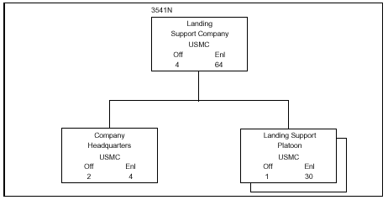
134.8 Define the mission and organization of the Motor Transport Battalion of the FSSG.
[ref. a, p. 5-60]

Mission: The motor transport battalion provides direct and general support, medium-lift and heavy-lift transportation support for the MAGTF, including motor transport support to the FSSG for its support mission.

Organization: The battalion consists of a H&S company, a general support motor transport company, and two direct support motor transport companies. The battalion is equipped and organized to provide logistic and tactical cargo vehicle support and petroleum transporter support.
(Note: The Active Duty Structure Force Review's changes that will merge LSB and motor transportation battalions were not finalized at the time. This paragraph depicts the notional functions in their current organization.

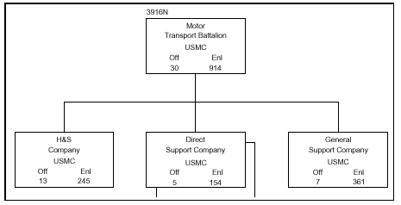

134 .9 Discuss the four tasks of the Motor Transport Battalion of the FSSG. [ref. a, p. 5-60]

Provide medium- and heavy-lift transport and distribution of bulk dry/water cargo, class III and III(A), and class V and V(A) supplies.
Provide line haul and unit/supply point distribution of bulk liquids, with motor transport augmentation as required from supported unit(s).
Provide heavy equipment lift augmentation, including evacuation of tracked vehicles, to supported units of the MEF.
Provide personnel lift augmentation to supported units of the MEF.
134 .10 Define the mission and organization of H&S Company of the Motor Transport
Battalion. [ref. a, p. 5-62]

Mission: The H&S company of the motor transport battalion provides command, control, administration, and command support functions for the battalion.

Organization: The company is organized to provide the motor transport battalion with command and control, organic communications, and organizational (2d echelon) maintenance support. Intermediate maintenance (3d and 4th echelon) is performed by the maintenance battalion.

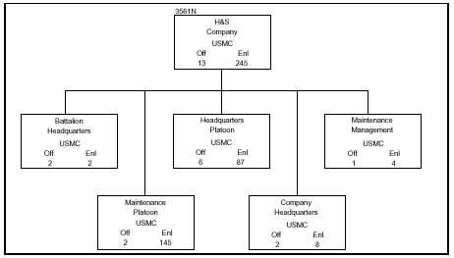

134 .11 Define the mission and organization of the General Support Company of the Motor Transport Battalion. [ref. a, pp. 5-63 thru 5-65]

Mission: Provide general support, medium- and heavy-lift transportation support for throughput and sustainment operations in support of the MAGTF.

Organization: The company is organized into a company headquarters, two transportation platoons, a heavy equipment transport platoon, a bulk fuel transport platoon, and a bulk water transport platoon. It is structured to facilitate task organization for operations conducted by the battalion in support of sustained MAGTF operations.

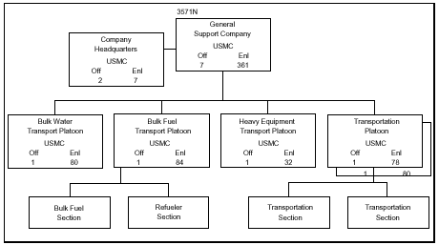

134 .12 Define the mission and organization of Direct Support Company of the Motor Transport Battalion. [ref. a, pp. 5-65, 5-66]

Mission: Provide direct and general support, medium- and heavy-lift transportation support and supply support for throughput and sustainment operations of the FSSG in support of the MEF.

Organization: The company is organized to plan, coordinate, and supervise the command supply and transportation support functions for the company in support of the FSSG’s mission. There is a company headquarters, three truck platoons, and a liquid-transport platoon. The platoons are capable of being task organized and attached to other organizations.

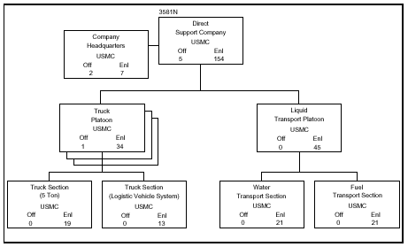

134.13 Define the following terminologies: [ref. b, pp. F-4, F-7]

Beachhead - A designated area on a hostile or potentially hostile shore that, when seized and held, ensures the continuous landing of troops and materiel, and provides maneuver space requisite for subsequent projected operations ashore.
Beach Support Area (BSA) - In amphibious operations, the area to the rear of a landing force or elements thereof, established and operated by shore party units, which contains the facilities for the unloading of troops and materiel and the support of the forces ashore; it includes facilities for the evacuation of wounded, enemy prisoners of war, and captured materiel.
Beach master Unit - A commissioned naval unit of the naval beach group designed to provide to the shore party a naval component known as a beach party which is capable of supporting the amphibious landing of one division (reinforced).
Commander Amphibious Task Force (CATF) – The Navy officer designated in the order initiating the amphibious operation as the commander of the amphibious task force.
Commander Landing Force (CLF) - The officer designated in the order initiating the amphibious operation as the commander of the landing force.
Debarkation - The unloading of troops, equipment, or supplies from a ship or aircraft.
Embarkation - The process of putting personnel and/or vehicles and their associated stores and equipment into ships and/or aircraft.
Helicopter Support Team (HST) - A task organization formed and equipped for employment in a landing zone to facilitate the landing and movement of helicopterborne troops, equipment and supplies, and to evacuate selected casualties and enemy prisoners of war. It may be built around a nucleus of shore party and helicopter landing zone control personnel.
Landing Beach - (DOD, NATO) That portion of a shoreline usually required for the landing of a battalion landing team. However, it may also be that portion of a shoreline constituting a tactical locality (such as the shore of a bay) over which a force larger or smaller than a battalion landing team may be landed.
Landing Force Control Party (LFCP) - (DOD, NATO) Personnel specially trained and equipped to establish and operate communications devices from the ground for traffic control of aircraft/helicopters for a specific landing zone.
Landing Zone (LZ) – (DOD, NATO) Any specified zone used for the landing of aircraft.
Shore Party - A task organization of the landing force, formed for the purpose of facilitating the landing and movement off the beaches of troops, equipment, and supplies; for the evacuation from the beaches of casualties and enemy prisoners of war; and for facilitating the beaching, retraction, and salvaging of landing ships and craft. It comprises elements of both the naval and landing forces.

134 .14 State the sequence of events for each of the following phases of amphibious operations: [ref. c, pp. 13-6 thru 13-8]

Planning Phase begins with the receipt of the initiating directive or the issuing of the LF/MAGTF activation order. It ends when the operation ends. Primary responsibility for overall planning rests with the CATF. However, CATF and CLF are coequals at this point. If they cannot resolve a disagreement, they refer the matter to their common superior for decision.From a CSS viewpoint, planning begins at the LF/MAGTF command element but quickly becomes concurrent at all levels of the LF/MAGTF. There must be a constant exchange of information to enable subordinate elements to identify specific CSS requirements and complete detailed planning. The LF/MAGTF concept of operations ashore is the basis for detailed CSS planning. This planning generally proceeds in the following sequence for each successive stage of the operation:
- Determination of requirements
- Statement of requirements to higher authority
- Allocation of resources and assignment of priorities
- Preparation of detailed plans and orders
Embarkation Phase
Embarkation planning begins on receipt of the initiating directive or LF/MAGTF activation order. It contines at all levels of command through the planning phase. It ends with completion of embarkation. The embarkation phase is the period during which the forces, with their equipment and supplies, move to staging areas and embark in assigned shipping. The landing plan determines how the LF embarks. Ideally, the landing plan should be complete before preparing the embarkation plan. To help embarkation planning, the LF/MAGTF commander attaches landing support elements to support tactical units for embarkation and landing.

Rehearsal Phase is the period when the CATF and CLF Test the adequacy of plans, the timing of operations, and the combat readiness of participating forces make sure that all elements are familiar with plans test and communications.

Types of Rehearsals
Separate Force Rehearsal. – ATF elements whose tasks are not intimately associated with the main body conduct separate rehearsals. Normally, these do not involve CSS units in less the operation includes a landing by a separate force.
Staff Rehearsal – Staffs scheduled to participate in an amphibious operation conduct command post or similar exercises. These may include computer-based simulations of the operation.
Integrated Rehearsal – At least two integrated rehearsals are desirable for the assault phase of second rehearsal tests the actual plan.
Considerations Planners must consider that
- Rehearsals should use the same equipment and supplies that the LF will use for the operation. If CSS requirements for rehearsals are extensive, planners must adjust overall requirements.
- The LF should not use equipment in rehearsals, which it cannot readily replace, or repair.
- The LF must plan for the possible loss of equipment and supplies during rehearsals.
- The LF must plan for maintenance of the equipment, which they use in rehearsals, which involve wet landings.
- A rehearsal is without value unless a comprehensive critique and adjustments to plan follow it.
- Secrecy, time, or costs may dictate that the rehearsal be a manual or computer assisted simulation.

Movement Phase is the period during which the elements of the ATF move from the POE’s to the AOA. The Navy provides much of the required underway support. However, the LF must plan for the administrative and maintenance requirements for the embarked forces. Three types of activity occur during the movement phase:

Continuation of planning – the LF should review plans to detect errors or flaws. Any of the following factors may cause a revision of plans:
- Result of rehearsals
- New intelligence information
- Losses or damage sustained while at sea.
- Changes in mission of the LF or one of its subordinate elements. CATF and CLF must be careful in directing changes to the plans, which will affect the scheme of maneuver, and landing support plan. Once CSS units have loaded their personnel, supplies, and equipment, they have little flexibility until they land.

Care and Maintenance of Material – Units can perform organizational maintenance on vehicles and equipment. Daily, if not more frequently, they should inspect all cargo.
Preparation for the Assault – Other preparations by the LF include:
- Having correct loading documents. The Navy and LF control organizations need correct loading documents in order to conduct the ship-to-shore movement properly during the assault phase.
- Training Marines (ship’s platoons) participating directly in the unloading
- Preparing equipment for unloading to include:
- Readying helicopters and check slings and hooks
- Checking waterproofing of vehicles and equipment
- Checking all weapons
- Running vehicle engines and check loads.
- Issuing prescribed loads to troops.
- Staging and checking prepositioned emergency supplies.

Assault Phase

The assault phase has two parts: The ship-to-shore movement and subsequent operations ashore. The assault phase is the period of time between the arrival of the major assault forces of the amphibious task force in the objective area and the accomplishment of the amphibious task force mission.
The assault phase is the most critical phase of the amphibious operation. Conducting the assault is the responsibility of the CATF. From the CSS viewpoint, the provision of landing support during the assault is the most critical task. Landing support is the help needed to land personnel, supplies, and equipment during the assault. It includes control of the flow of personnel and material across the beach and into helicopter landing zones, (HLZ’s). The CLF provides landing support and other CSS through the task-organized LFSP.
The supported tactical units are responsible for embarking and landing the landing support elements. To insure the required coordination, the CLF attaches landing support elements to the supported tactical units for embarkationand landing purposes. LFSP elements are the primary source of CSS during the assault phase of the operation. Planners must be sure that advance elements of shore party teams and HST’s land in scheduled waves of assault units.
CSS in the assault phase - To sustain the assault, CSS operations must support tactical operations. Therefore, the buildup of CSS capability ashore must parallel the tactical buildup. Landing support operations begin with the landing of LFSP advance parties. They continue until the operation ends. CSS early in the amphibious operation is limited to the provision of essential supplies and services; eg., rations, water, ammunition, fuel, and medical support.
Until the CSSE is established ashore, non aviation-peculiar CSS operations focus on the LFSP and its shore party and HST’s.
At the LF/MAGTF level, there is always an LFSP commander to coordinate the efforts of shore party and HST’s.

