135 Combat Service Support Element (CSSE), Medical Battalion Fundamentals

References:

[a] MCRP 5-12D, Organization of Marine Corps Forces (PCN 14400005000)
[b] MCWP 4-11.1, Health Service Support Operations (PCN 14300004000)

135.1 Describe the mission and organization of the Medical Battalion of the Force Service Support Group (FSSG). [ref. a, p. 5-67]

Mission: The medical battalion provides direct and general support medical support to the MEF.

Organization: The medical battalion is organized to plan, coordinate, and supervise the medical support functions of the MEF. It is structured to facilitate task organization for operations conducted by the battalion in support of the MEF or any combination of smaller MAGTFs operating in widely separated geographical areas.

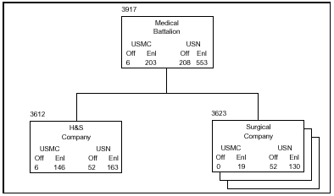

135 .2 Discuss the six tasks of the Medical Battalion of the FSSG. [ref. a, p. 5-67]

Provide health care through the 2d echelon of medical care, including initial resuscitative care, resuscitative surgery, and temporary hospitalization of casualties, to the MEF.
Provide medical regulating services for the MEF.
Provide preventive medicine support to the MEF.
Assist in the collection, analysis, and dissemination of medical intelligence.
Provide the medical elements for the establishment of casualty decontamination and treatment stations.
Provide medical support for management of mass casualties and combat stress casualties.

135 .3 Define the mission and organization of H&S Company of the Medical Battalion.
[ref. a, pp. 5-68, 5-69]

Mission: The H&S company provides command, control, and command support functions for the medical battalion.

Organization: The company is organized to plan, coordinate, and supervise the command support functions for the battalion. It is structured to facilitate task organization for operations conducted by the battalion in support of MAGTF operations.

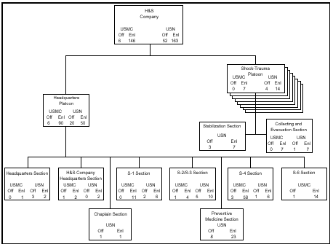

135 .4 Discuss four tasks of the H&S Company. [ref. a, p. 5-69]

Provide administrative, organic supply, light motor transportation, and maintenance support to the battalion.
Provide limited medical evacuation for the battalion.
Provide medical data coordination for the battalion.
Provide medical department personnel, as required, to the headquarters elements of CSSDs .
135 .5 Define the mission and organization of Surgical Support Company of the Medical
Battalion. [ref. a, pp. 5-70, 5-72]

Mission: The company provides general medical support to the MEF, including medical treatment facilities for medical and surgical care and temporary casualty holding.

Organization: The company is organized to plan, coordinate, and supervise assigned functions of medical support for the battalion. It is structured to facilitate task organization for operations conducted by the battalion in support of the MEF, the MEF (FWD), or any combination of smaller MAGTFs. The company consists of a headquarters platoon, a triage/evacuation platoon, a surgical platoon, a holding platoon, a combat stress platoon, and an ancillary service platoon. The surgical platoon consists of three surgical sections that support one operating room for 24-hour operations. The holding platoon contains three ward sections, each containing 20 medical/surgical beds. The ancillary services platoon contains two laboratory sections, two pharmacy sections and two X-ray sections.

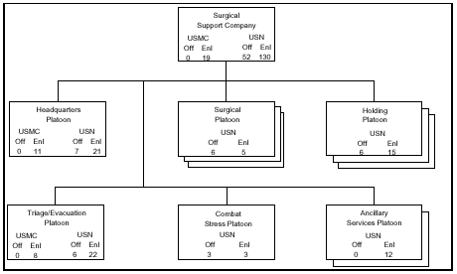

135 .6 Discuss six tasks of the Surgical Support Company. [ref. a, pp. 5-70, 5-71]

Establish medical treatment facilities for resuscitative surgery, medical treatment, and temporary hospitalization of casualties.
Be prepared to receive casualties from the next forward medical treatment echelon in the evacuation chain.
Establish medical treatment facilities for resuscitative surgery, medical treatment, and temporary holding of casualties from supported forces.
Prepare for evacuation casualties whose medical requirements exceed the established theater evacuation policy.
Provide and coordinate medical evacuation for the landing force.
Provide medical support to personnel of other Services and nations as provided in applicable regulations and agreements, and provide humanitarian care as required by international law.
135 .7 Define the mission and organization of the Shock-Trauma Platoon of the Medical Battalion. [ref. a, pp. 5-73, 5-74]

Mission: The shock-trauma platoon provides direct medical support to the MEF, including collecting, clearing, and evacuating casualties from supported MEF elements, and provides medical treatment facilities for resuscitative treatment care and temporary holding of casualties.

Organization: The shock-trauma platoon is the smallest mobile medical support element of the medical battalion and is the first medical treatment facility of the MAGTF in support of the BAS. The eight shock-trauma platoons are structured to facilitate task organization for operations conducted by the battalion in support of the MEF, the MEF (FWD), or any combination of smaller MAGTFs. The platoon consists of a stabilization section and a collecting and evacuation section. Each collecting and evacuation section has two tactical ambulances for collecting casualties from the next forward medical support echelon, and the stabilization section has 5-ton trucks to move the shock-trauma platoon personnel and equipment.

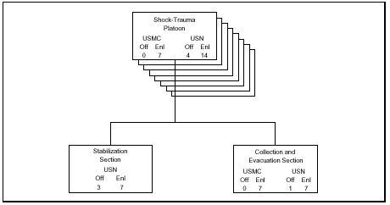

135.8 Discuss four tasks of the Shock Trauma Platoon. [ref. a, p. 5-73]

Establish and operate clearing stations, as required.
Establish medical treatment facilities for resuscitative treatment and temporary holding of casualties.
Provide and coordinate medical evacuation.
Provide medical support to personnel of other services and nations as provided in applicable regulations and agreements and provide humanitarian care as required by international law.

135 .9 Define the following terms: [ref. b, pp. C-1 thru C-4]

BAS - battalion aid station
BDC - blood donor centers
CRTS - casualty receiving and treatment ship
FMC - field medical card
HSS - health service support
MAP - Medical Augmentation Program
MTF - medical treatment facility
STP - shock trauma platoon
TMIP - theater medical information program

