136 Combat Service Support Element (CSSE), Dental Battalion Fundamentals

References:

[a] MCRP 5-12D, Organization of Marine Corps Forces (PCN 14400005000)

136.1 Define the mission and organization of the Dental Battalion of the Force Service Support Group (FSSG). [pp. 5-75, 5-76]

Mission: The dental battalion provides general support dental health care to the MEF.

Organization: The battalion is organized to plan, coordinate, and supervise dental health care for the MEF. It is structured to facilitate task organization for operations conducted by the battalion in support of the MEF, or any combination of smaller MAGTFs operating in widely separated geographical areas.

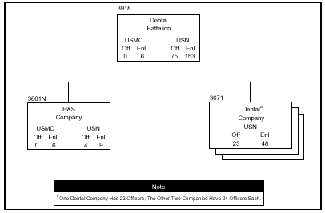

136 .2 Discuss the four tasks of the Dental Battalion of the FSSG. [p. 5-75]

Provide a comprehensive program of dental health care for the MEF.
Coordinate MEF dental health care support requirements.
Provide dental detachments, as required, to support MAGTFs smaller than a MEF
Supervise implementation of dental health care delivery programs for the MEF.
136 .3 Define the mission and organization of H&S Company of the Dental Battalion.
[pp. 5-76, 5-77]

Mission: The H&S company of the dental battalion provides command, control, and command support functions.

Organization: The company is organized to plan, coordinate, and supervise command support functions for the battalion. It is structured to facilitate task organization for operations conducted by the battalion in support of MAGTF operations.

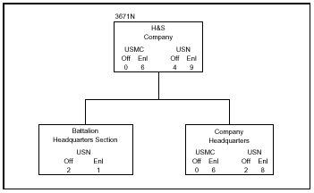

136 .4 Discuss two tasks of the H&S Company of the Dental Battalion. [pp. 5-76, 5-77]

Provide command support functions for the operation of the battalion.
Assist with and coordinate professional matters such as quality assurance, infection control, dental readiness, the dental information retrieval system, and professional and in-service training for the battalion.

136 .5 Define the mission and organization of the Dental Company of the Dental Battalion. [p. 5-78]

Mission: The dental company provides general support dental health care to the major subordinate elements of the MEF.

Organization: Dental companies are organized to provide support to each of the major subordinate elements of the MEF and to facilitate task organization as detachments in support of MAGTFs smaller than a MEF.
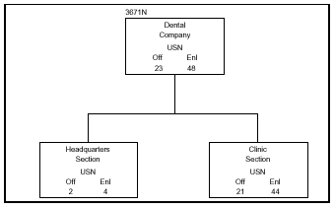

136 .6 Discuss two tasks of the Dental Company of the Dental Battalion. [p. 5-78]

Maintain MAGTF units in an acceptable state of dental readiness.
Provide a comprehensive dental program for the MEF, including emergency dental treatment and specialty disciplines with the exception of maxillofacial surgery.

